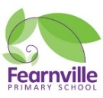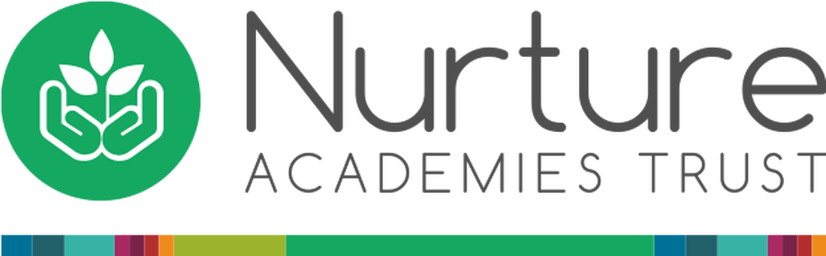

EYFS Information Sheet

Spring 2022

**Food around the world and People who help us**

## **Reception**

**Teachers:** Miss Khan and Miss Mobeen

**Early Years Practitioners**: Mrs Dickerson, Mrs Scott, Ms Latz



Fearnville Primary School

Fearnville Drive

Bradford

BD4 8DX

Tel: 01274 664661

**Reminders:**

* Don’t forget to give us your email address so you can access Tapestry observations.
* Make sure to wash your child’s hands and keep social distance where possible at all times!
* Please write your child’s name on all their belongings

**Our themes this term are…** 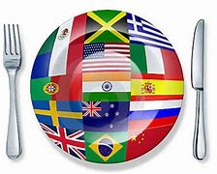

**Physical Development**

IMPORTANT INFORMATION!

Our outdoor area has been taken over by the villains. Can you help us protect our outdoors and save it from being destroyed?

Can you cross the enchanted path into the dessert safely to battle the baddies or can you use your super powers to invent a magical potion?

Or maybe you could make something delicious for our villains to eat and trick them!

The powers in your hands!

**Understanding the World**

Help! Help! Who can help me? Is it going to be a doctor? Is it going to be a dentist? Or will it be a superhero?

Talk to your children about ways in which people can help us in our community and how you can help them?

**\*Brain challenge\***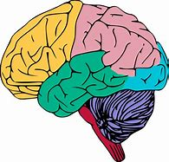

I wonder what I would eat in China, do all people eat the same food? Speak to your children about different food items you may see all around the world!

**Expressive Arts & Design**

Zoom! Zap! Pow! Kaboom!

I’m loving it! 

We will be superheroes, revealing our powers, making capes, masks, medicines, making glasses as not all superheroes need magical powers.

You can be your own hero

As well as being superheroes we will also have our very own Street café, so be ready to serve some burgers!

**Diary Dates**

**Maths**

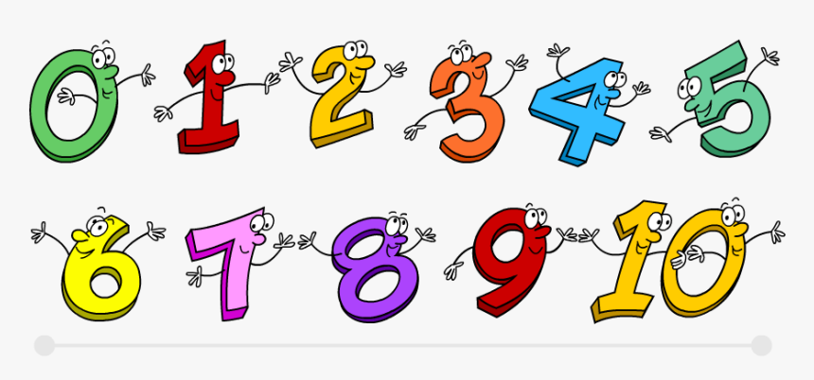

In Maths children will be exploring the composition of numbers from 1-10 and will be identifying one more and less. This will deepen their understanding of number bonds. Children will also become effective time keepers and shop keepers as they will be buying and selling different items in our street café.

**Personal, Social and Emotional**

Nee Naw, Woo Woo, Beep Beep! 

Watch out! As this term we are learning all about how people help us and foods around the world! Children will be exploring different occupations, superheroes and how they help us in everyday life as well as tasting different foods. This will show children the diversity of people in a variety of ways.

**Literacy**

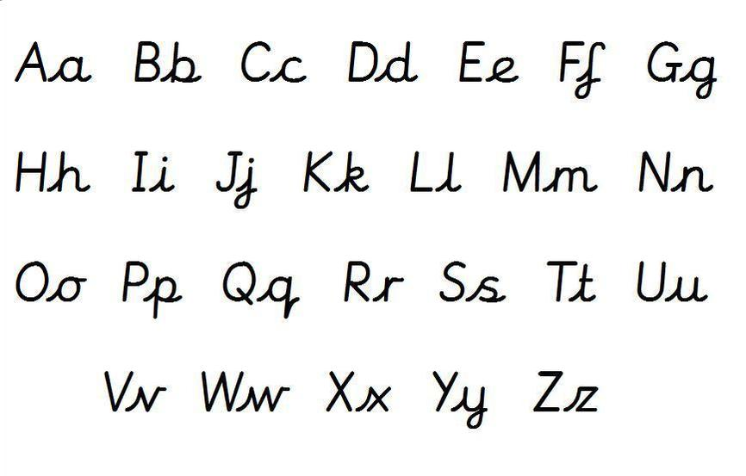

We are continuing to look at phase 2 phonics. This will always link into our core themes. It would be really appreciated if you could support your child with this and practice letter formation and the high frequency words at home.

**Communication and Language**

**What makes you safe?**

Although your super and have amazing powers it is vital for you to make sure you are always safe. How do we do this in school and home? What would you like to do when you are older? How can you help others and the environment?

**What do you like eating?**

Burgers, sandwiches, kababs and noodles, so many different options from all around the world….Which is your favourite?