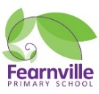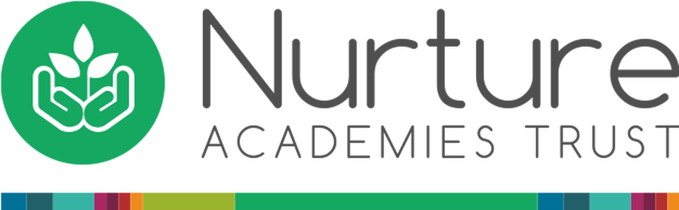

EYFS Information Sheet

Summer 2022

**Under The Sea And Dinosaurs**

## **EYFS**

**EYFS Lead:** Miss Khan

**Teachers:** Miss Khan and Mrs Dickerson

**Early Years Practitioners**: Miss Lawrence, Mrs Scott, Mr Khan, Mrs Kauser, Mrs Wright



Fearnville Primary School

Fearnville Drive

Bradford

BD4 8DX

Tel: 01274 664661

**Reminders:**

* Don’t forget to give us your email address so you can access Tapestry observations.
* Make sure to wash your child’s hands and keep social distance where possible at all times!
* Please write your child’s name on all their belongings

**Our themes this term are…** 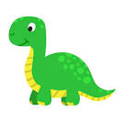

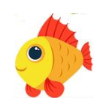

**Physical Development**

Ready for our dinosaur egg hunt!

Can you find the hidden dinosaurs in our garden?

Are they in the sand? The muddy kitchen or are they hiding on the climbing frame? Will you be able to avoid all the obstacles?

**Warning! Do not disrupt the sharks!**

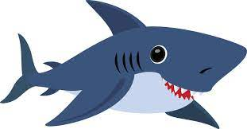

**Understanding the World**

This summer our children will be looking at different habitats for different animals. We have our very own Aquarium filled with different creatures. Children will develop their understanding through enjoyment and active adventures. We also have a fun trip planned for our children where they will be able to see more animals from around the world! Many exciting opportunities ahead!

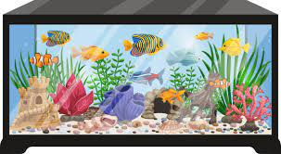

**Expressive Arts & Design**

Help! Our food for the animals had finished! Can you help us make some food for our animals to eat? Just remember not to get too close to the animals!

Will you be making a T-Rex, sword fish or an octopus because we have lots of materials and tools for you to use.



**Diary Dates**

**Maths**

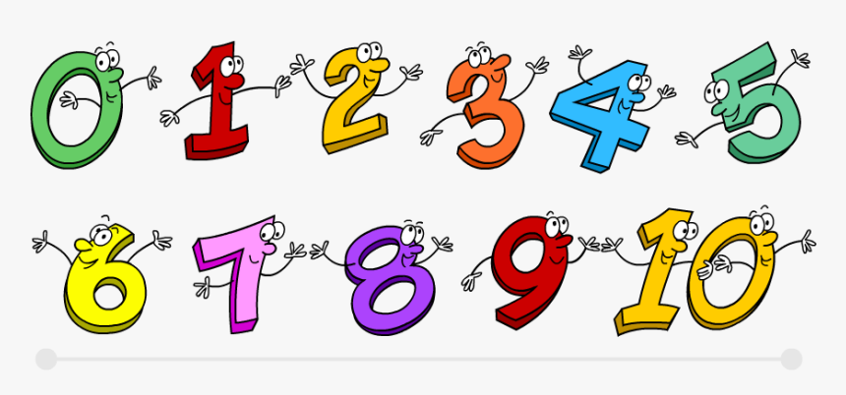

In maths children will be exploring patterns and shapes as well as increasing their awareness of addition and subtraction sums. Children will investigate the similarities and differences between different animals and creatures, exploring patterns, prints and sizes as well as become effective time-keepers. Ensuring our Aquarium is opened and closed on time!

**Personal, Social and Emotional**

**Roar! Gulp! Gulp!**

Make sure to wear your goggles and don’t forget your swimming costumes!

Watch out! As this term we are learning all about under the sea animals and dinosaurs. Children will be role-playing and taking turns in our different role-play areas including managing our school aquarium.

**Literacy**

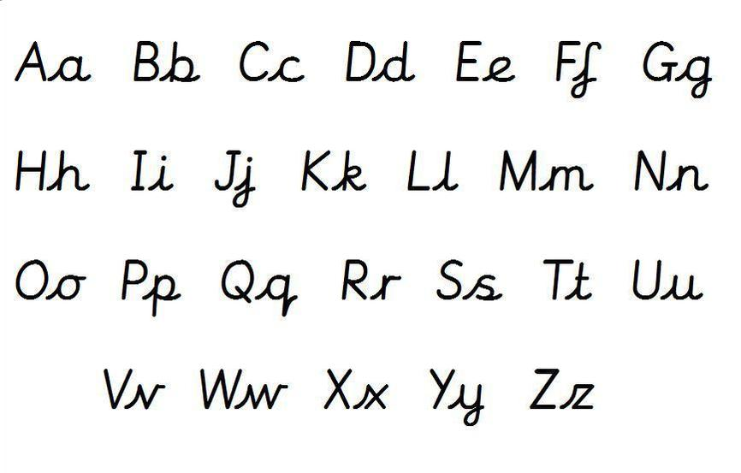

We are continuing to look at phase 3/4 phonics. This will always link into our core themes. It would be really appreciated if you could support your child with this and practice letter formation and the high frequency words at home.

**Communication and Language**

**What animals live under the sea?**

Children will be discovering animals from all around the world that may live under the sea. They will share these facts with their peers and explore similarities and differences.

**T-Rex, Stegosaurus which is your favourite, were they even real?**

Get ready to play with Fearnville’s dinosaurs through play, fun and enjoyment!