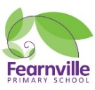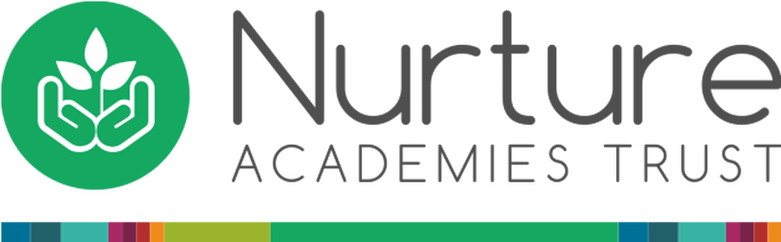

EYFS Information Sheet

Autumn 2022



**Reminders:**

* Don’t forget to give us your email address so you can access SeeSaw observations.
* Please write your child’s name on all their belongings.
* Please remember to bring bookbags in every day.
* Please can you send your children with small objects no bigger than 1cm long (shells, coins, pebbles, toys etc..) for our ‘Resin Art Project’.

## **Reception**

**Teachers:** Miss Khan and Mr Fawcett

**Early Years Practitioners**: Mrs Rubery, Mrs Scott, Miss Wright, Mrs Kauser

Fearnville Primary School

Fearnville Drive

Bradford

BD4 8DX

Tel: 01274 664661



**This Is Me!**

**Our theme this half term is…**

**Physical Development**

Outdoor learning is essential during this pandemic and with a new outdoor area like ours, not to worry your child will not only be learning but will also have fun. Children will explore different ways of travelling whilst successfully negotiating space.

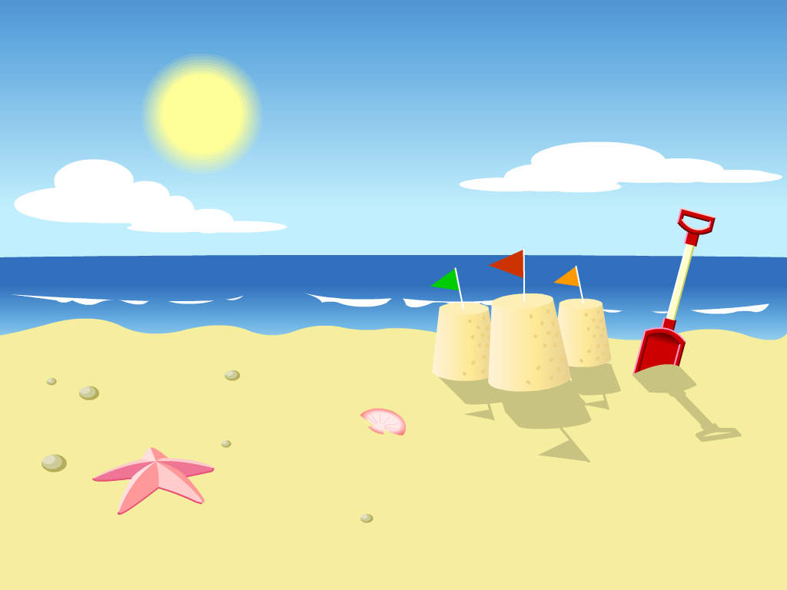

**Diary Dates**

**Expressive Arts & Design**

Our focus to begin with will be colour mixing to match our skin tones, enhancing creativity to enable your child to use their own ideas in ways in which to represent their family. For example through stick puppets, body printing etc… Your children will become mini artists and they can share these skills with you at home!

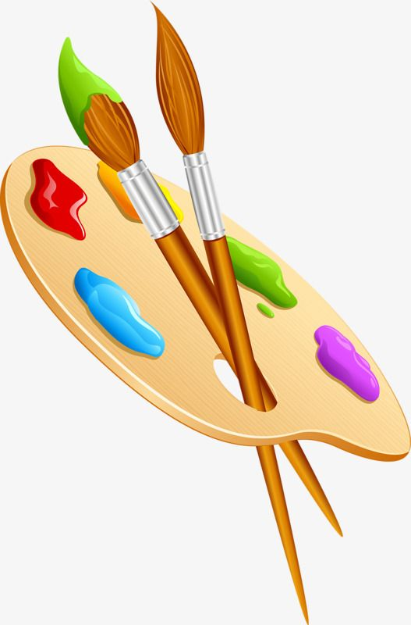

**Understanding the World**

Learning through our senses is vital in early years, hence we will be going on sound walks, identifying different food through taste and smell, looking at mirrors to draw self-portraits etc… Children will be able to compare different areas around the world as well as the community they live in as well as will be given the opportunity to learn with their peers across the whole phase!



**Personal, Social and Emotional**

Are you ready to make new friends? Well be prepared because in Early years we are all friends and will be playing lots of games where we will learn about each other and what makes us happy - other than eating chocolate cake ☺! In our small world area you can build and role play and share your ideas with your peers. Not to mention we have our very own circus, don’t forget your mask!



**Communication and Language**

Through fun and adventurous activities, children will discover the similarities and differences between all people and how it is ok to be diverse. We’ll be discussing our routines, special occasions and what is important to us.

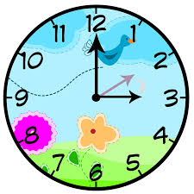

**Literacy**

Your child will be given many opportunities to explore phases 1/ 2/ 3 phonics using a scheme called ‘Little Wandles’. Children will be learning how everyone is special and unique. This will often link to our core stories such as ‘Funny bones’. Children will be encouraged to promote letter recognition using the correct cursive font in different areas of our setting, including mark making with chalk, paint etc.. We would really appreciate if you continue this at home. If you are struggling with phonics Alphablocks on YouTube is a great tool to assist you. 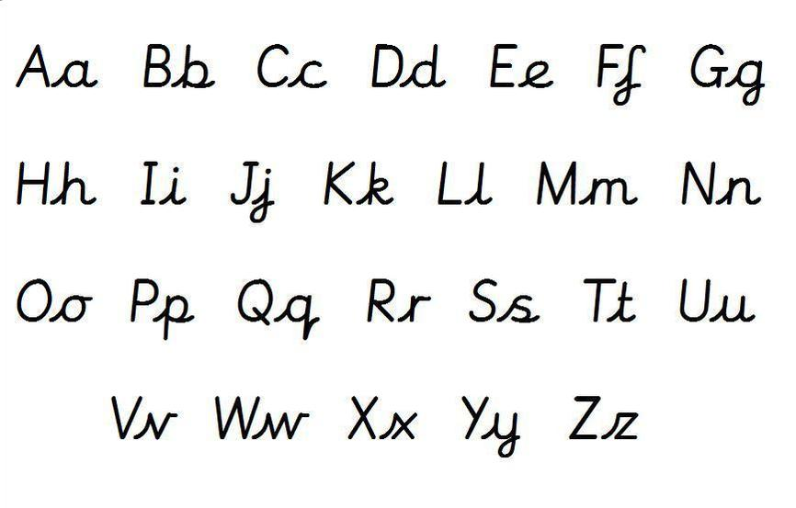

**Maths**

In Maths we will be saying and using number names in order along with counting objects reliably and recognising numbers. We’ll be doing this through a lot of singing. To link in with our theme, we will order house numbers and talk about the different shapes in our homes and how many people are in our family. Within the Shape, Space & Measure area of learning, we will compare feet and hand sizes and use non-standard units to measure these. We will also be doing some simple data handling activities where we look at our features, e.g. hair colour, eye colour etc…



  
  
  