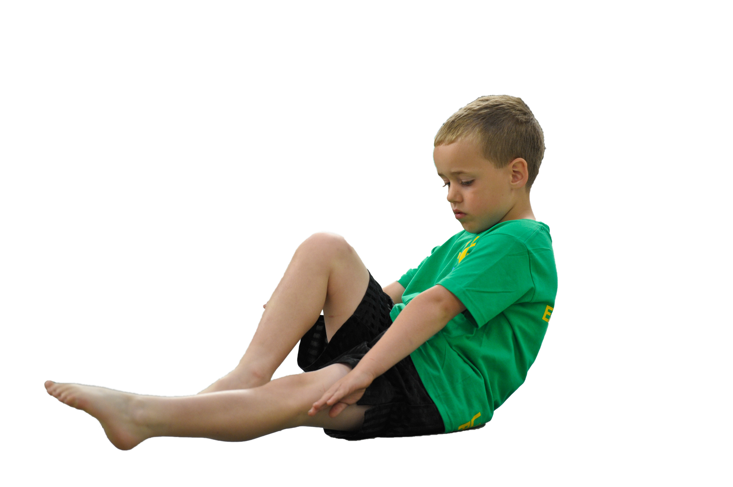
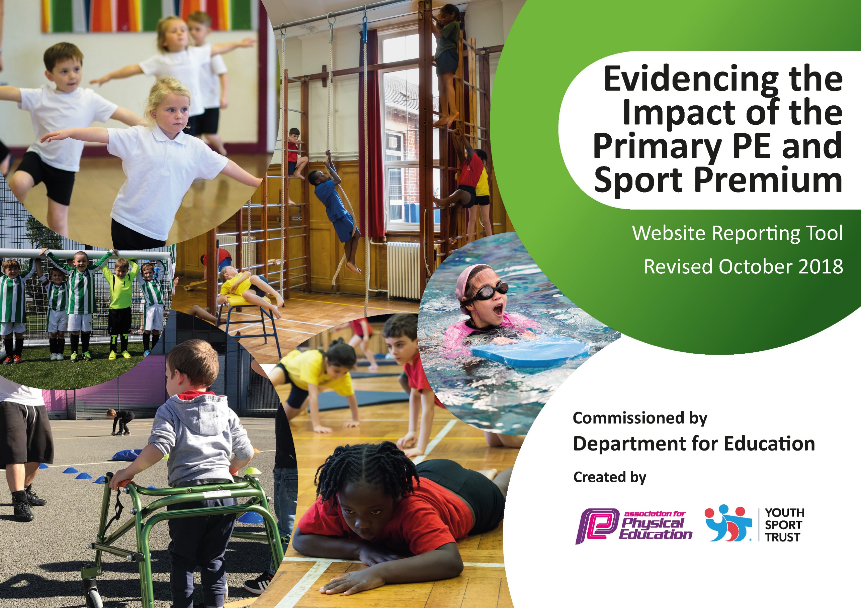
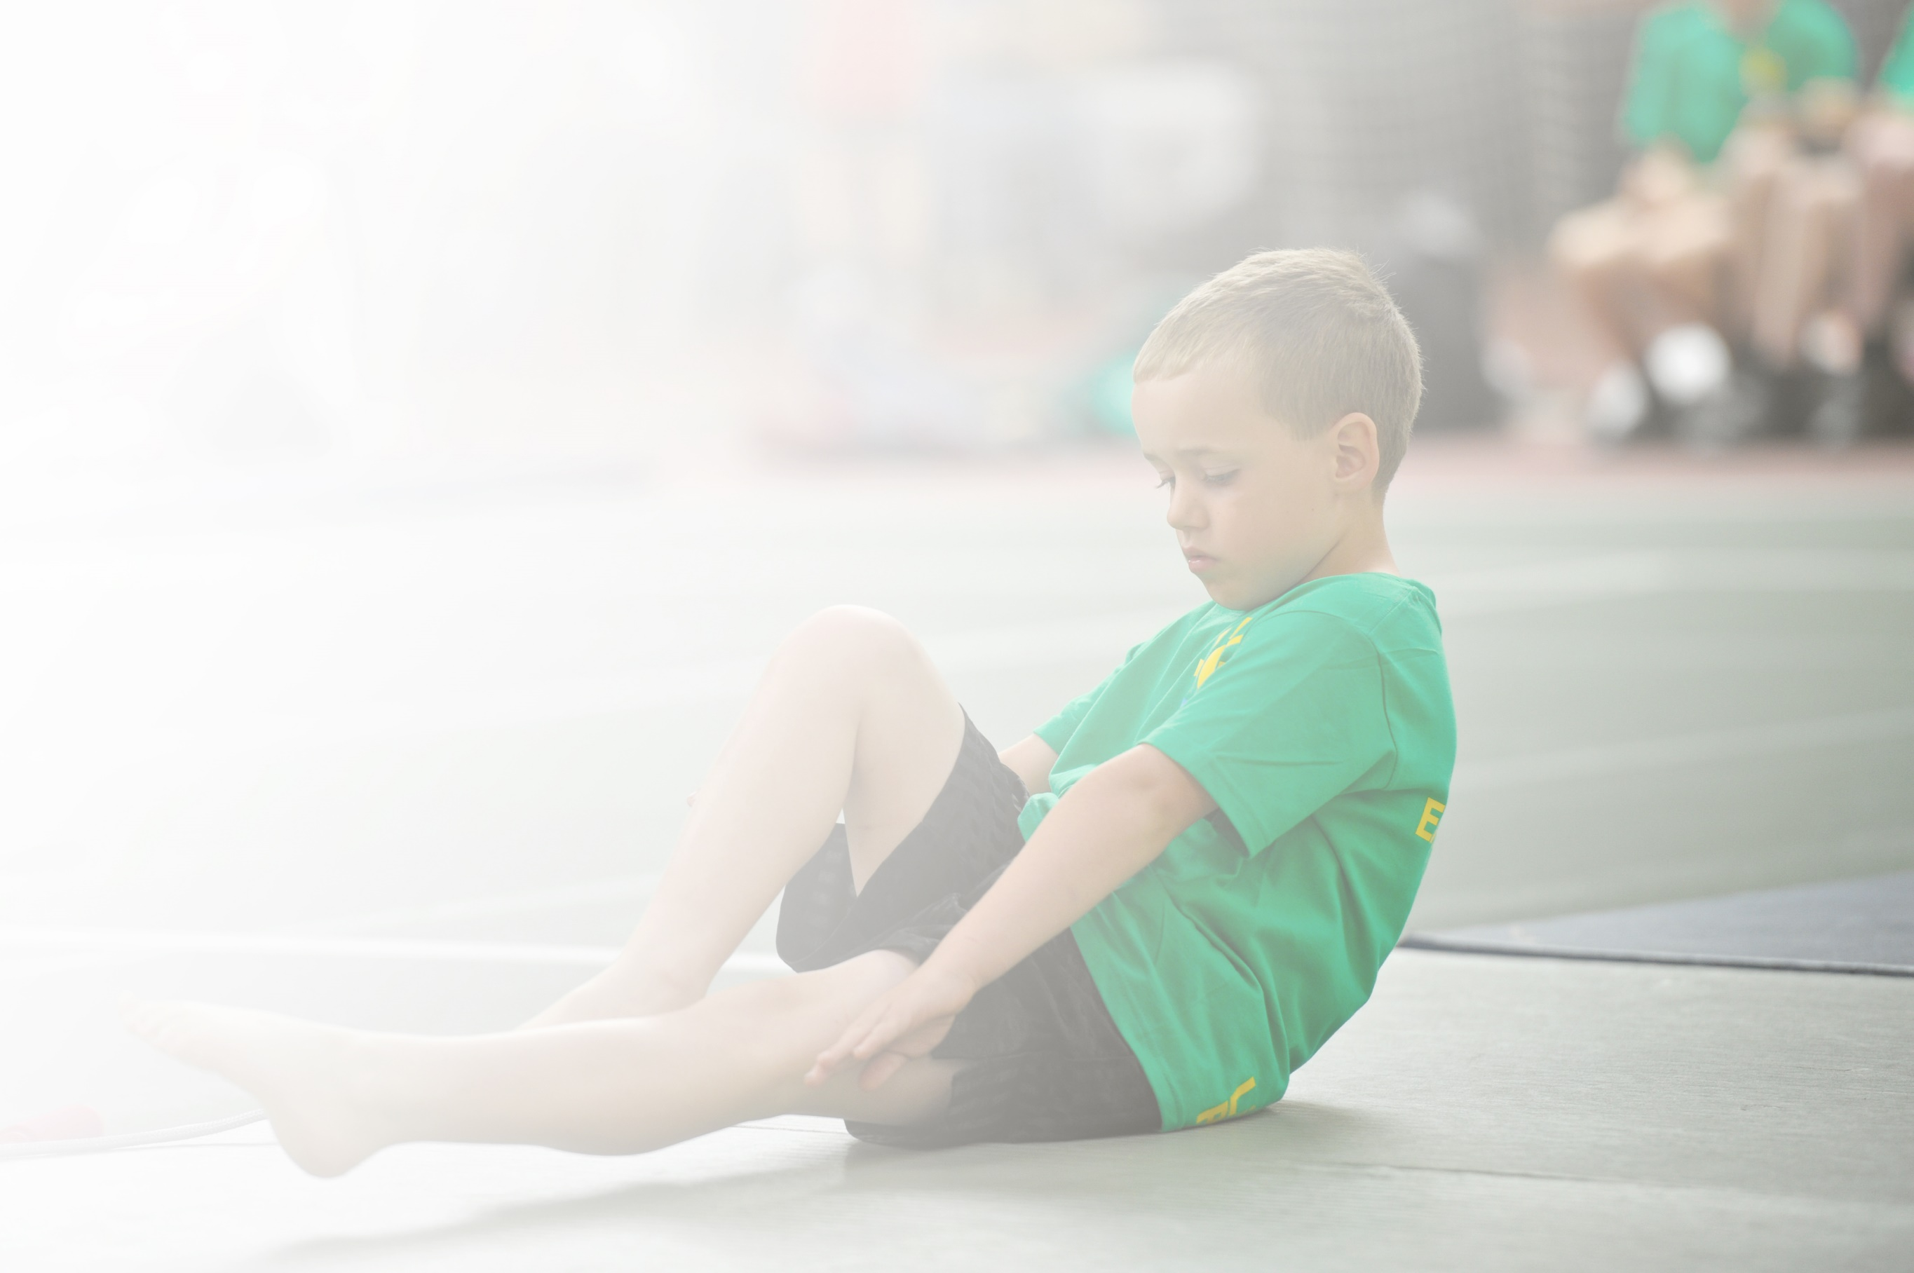
Schools must use the funding to make additional and sustainable improvements to the quality of Physical Education, Sport and Physical Activity (PESPA) they offer. This means that you should use the Primary PE and Sport Premium to:

- Develop or add to the PESPA activities that your school already offer
- Build capacity and capability within the school to ensure that improvements made now will benefit pupils joining the school in future years

Please visit gov.uk for the revised DfE guidance including the 5 key indicators across which schools should demonstrate an improvement. This document will help you to review your provision and to report
your spend. DfE encourages schools to use this template as an effective way of meeting the reporting requirements of the Primary PE and Sport Premium.

We recommend you start by reflecting on the impact of current provision and reviewing the previous
spend. Under the Ofsted Schools Inspection Framework, inspectors will assess how effectively leaders use the Primary PE and Sport Premium and measure its impact on outcomes for pupils, and how effectively governors hold them to account for this.

Schools are required to publish details of how they spend this funding as well as on the impact it has on pupils’ PE and sport participation and attainment by the end of the summer term or by 31 July 2019 at the
latest.
We recommend regularly updating the table and publishing it
on your website throughout the year, as evidence of your
ongoing review into how you are using the money to
secure maximum, sustainable impact. To see an
example of how to complete the table please
click HERE.

Support for review and reflection - considering the 5 key indicators from DfE, what development needs are a priority for your setting and your students now and why? Use the space below to reflect on previous spend, identify current need and priorities for the future.

Meeting national curriculum requirements for swimming and water safety | Please complete all of the below:
What percentage of your current Year 6 cohort swim competently, confidently and proficiently over a distance of at least 25 metres?  N.B. Even though your children may swim in another year please report on their attainment on leaving  primary school. | 45 %
What percentage of your current Year 6 cohort use a range of strokes effectively [for example, front crawl, backstroke and breaststroke]? | 40%
What percentage of your current Year 6 cohort perform safe self-rescue in different water-based situations? | 0 %
Schools can choose to use the Primary PE and Sport Premium to provide additional provision for swimming but this must be for activity over and above the national curriculum requirements. Have you used it in this way? | No

Action Plan and Budget Tracking
Capture your intended annual spend against the 5 key indicators. Clarify the success criteria and evidence of impact that you intend to measure to evaluate for students today and for the future.

Academic Year: 2018/19 | Total fund allocated: £15883 |  |  | Date Updated:
Key indicator 1: The engagement of all pupils in regular physical activity – Chief Medical Officer guidelines recommend that primary school children undertake at least 30 minutes of physical activity a day in school |  |  |  |  |  |  | Percentage of total allocation:
 |  |  |  |  |  |  | %
School focus with clarity on intended impact on pupils: | Actions to achieve: |  |  | Funding allocated: |  | Evidence and impact: | Sustainability and suggested next steps:
Children to have a session on daily mile track on the days where no other PE is timetabled | Playground marked with a running/walking track to facilitate daily mile |  |  | £3220.50 |  | Track only completed in Summer 2019 but timetable up and track in use by all children on a daily basis. | Continue to develop the 5 minute challenge ensuring increased activity for all children.
Key indicator 2: The profile of PESSPA being raised across the school as a tool for whole school improvement |  |  |  |  |  |  | Percentage of total allocation:
 |  |  |  |  |  |  | %
School focus with clarity on intended impact on pupils: | Actions to achieve: |  |  | Funding allocated: |  | Evidence and impact: | Sustainability and suggested next steps:
Children build a positive impression of the merits of physical activity. | Purchase and display a range of posters and images to promote the benefits and enjoyment from sports, P.E. and physical activity |  |  | £500 |  | PE display visible and updated regularly by PE specialist support from local football club. | Continue with PE having a high priority within the school to continue to develop positive approaches to wellbeing.
Key indicator 3: Increased confidence, knowledge and skills of all staff in teaching PE and sport |  |  |  |  |  |  |  | Percentage of total allocation:
 |  |  |  |  |  |  |  | %
School focus with clarity on intended  impact on pupils: |  | Actions to achieve: | Funding  allocated: |  | Evidence and impact: |  |  | Sustainability and suggested  next steps:
Children to have high quality PE sessions that develop skills across the PE curriculum |  | HLTA to work alongside Bradford City coach acquiring skills in PE delivery.  HLTA to be mentored by PE teacher from trust school | £7875 |  | This has been an extremely successful initiative and means the HLTA is now able to take on more responsibility for PE development within the school, with Bradford City staff still continuing to support where required.  Also received support from a specialist PE teacher within the MAT to develop the Dance curriculum in school. |  |  | Further develop the role of the HLTA and begin to include the school in inter school competitions.  Inviting a range of professionals into school to target any areas which require further development e.g. Dance specialisms
Key indicator 4: Broader experience of a range of sports and activities offered to all pupils |  |  |  |  |  |  |  | Percentage of total allocation:
 |  |  |  |  |  |  |  | %
School focus with clarity on intended  impact on pupils: |  | Actions to achieve: | Funding  allocated: |  | Evidence and impact: |  |  | Sustainability and suggested  next steps:
Pre and after school sports activities including Football, boxing and multiskills.  Additional achievements: |  | Contact relevant coaches to arrange timetable. | £2287 |  | Boxing coach has been a very successful initiative in particular in developing the social and emotional welfare of a target group.  Bradford City Youth Development Officer has developed both football and multiskills programmes for Key Stage 2 children. |  |  | Lessons to continue  Classes to be continued and opened up to a wider age range of pupils.
Key indicator 5: Increased participation in competitive sport |  |  |  |  |  |  |  | Percentage of total allocation:
 |  |  |  |  |  |  |  | %
School focus with clarity on intended  impact on pupils: |  | Actions to achieve: | Funding  allocated: |  | Evidence and impact: |  |  | Sustainability and suggested  next steps:
Children to take part in trust and LAP wide competitions. |  | Liaise with PE teacher from trust to open opportunities for children to join in LAP and trust competitions.  Availability of staff to transport children to venues for competitive sport. | £2000 |  | This is still in the Early Stages of development. |  |  | Links made with local Secondary School in organising support for competitions in a range of sports.  MAT competitions to be further developed.

