# school logoFEARNVILLE PRIMARY SCHOOL



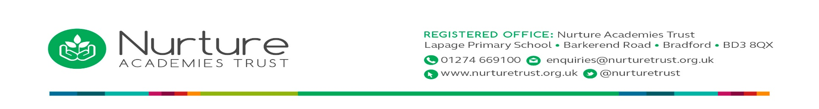 **KS2 Pupil Acceptable Use Agreement**

*These rules will keep me safe, keep my information private, and help me to be fair to others.*

* I will only use the school’s computers for schoolwork and homework.
* I will not attempt to read any personal information on paper or in a computer file unless that information is meant for me.
* I will only edit or delete my own files and not look at, or change, other people’s files without their permission
* I will keep my logins and passwords secret.
* I will not attempt to learn logins and passwords that belong to other people
* I will not bring files into school without permission or upload inappropriate material to my workspace.
* I am aware that some websites and social networks have age restrictions and I will respect this.
* I will not attempt to visit Internet sites that I know the school has banned.
* I will only e-mail the people I know, or those a responsible adult has approved.
* The messages I send, or information I upload, will always be polite and sensible.
* I will not open an attachment, or download a file, unless I know and trust the person who has sent it.
* I will maintain my data and personal security: I will not give my home address, phone number, send a photograph or video, or give any other personal information that could be used to identify me, my family or my friends, unless a trusted adult has given permission. I will *never* arrange to meet someone I have only ever previously met on the Internet, unless my parent/carer has given me permission and I take a responsible adult with me.
* If I see anything I am unhappy with or I receive a message I do not like, I will not respond to it but I will show a teacher / responsible adult.
* I will not bring a mobile phone into school except in exceptional circumstances and when specifically allowed by the Head Teacher.

*I have read and understand these rules and agree to them.*

*Signed: ………………………………………… Date: ………………………*