LI: I know my number bonds to 20

- 4 + 6 = ____ 6) 10 = 1 + ____
- 5 + ____ = 10 7) 7 + ____ = 10
- 8 + ____ = 10 8) 2 + ____ = 10
- 3 + _____ = 10 9) 10 = 6 + _____
- 0 + _____ = 10 10) 10 = 9 + _____
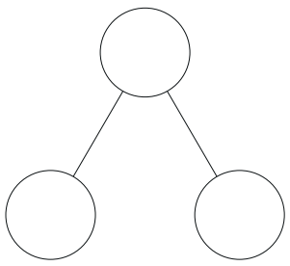
Now try:
10
10
10

______ + _______ = 10
______ + _______ = 10
______ + _______ = 10

Now that you know your number bonds to 10, you will know your number bonds to 20.
8 + 2 = 10
18 + 2 = 20
28 + 2 = 30

- 15 + _____ = 20 6) 11 + ___ = 20
- 20 + _____ = 20 7) 20 = 8 + _____
- 6 + ______ = 20 8) 7 + ____ = 20
- 3 + _____ = 20 9) 20 = 16 + ____
- 20 = 17 + _____ 10) 2 + _____ = 20

Challenge:

22
46
16
50
30
20

16 + ________ = 20
_______ + 46 = 50
22 + _______ = 30

- 65 + _____ = 70 6) 71 + ___ = 80
- 22 + _____ = 30 7) 90 = 8 + _____
- 6 + ______ = 40 8) 7 + ____ = 80
- 3 + _____ = 80 9) 50 = 6 + ____
- 60 = 57 + _____ 10) 2 + _____ = 80

