How do I access the online learning from Oak Academy?
Go to: www.thenational.academy/

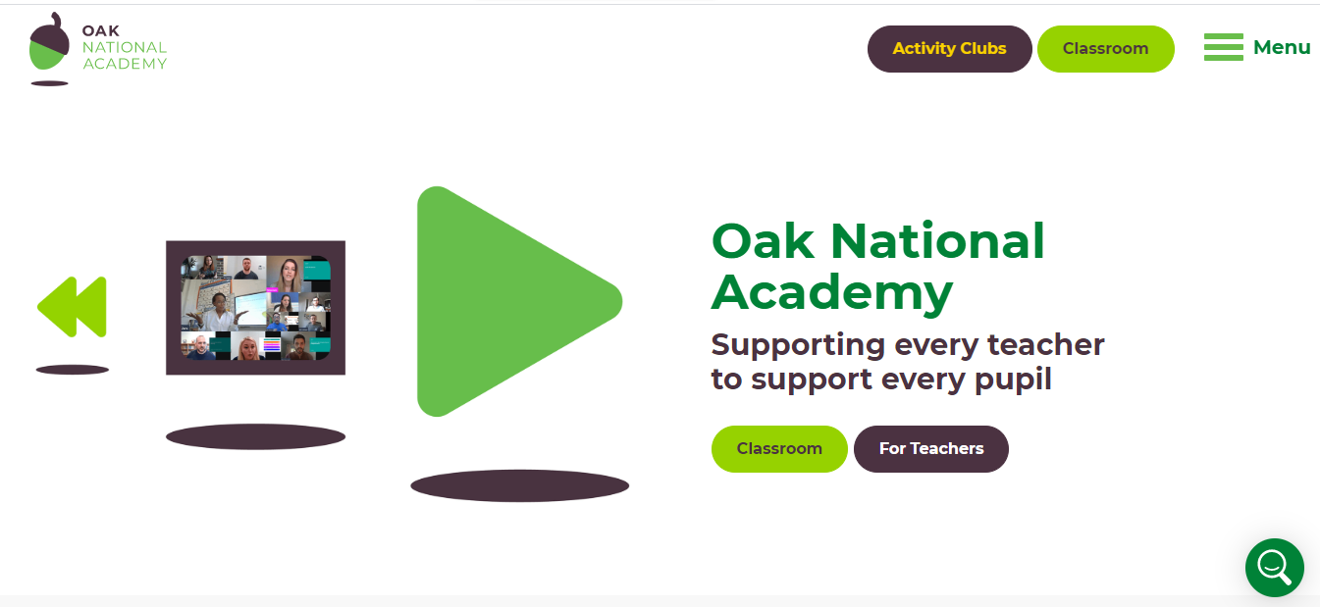
Click on classrooms
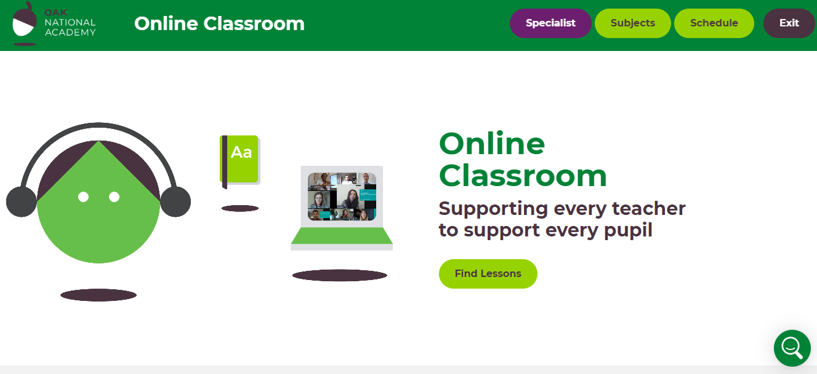
Here you can choose to look at specialist activities for children with particular needs (for example speech and language therapy or communication and language)
The second option is subjects
Here you can select the year group of your child and the areas you would like to work on with your child.
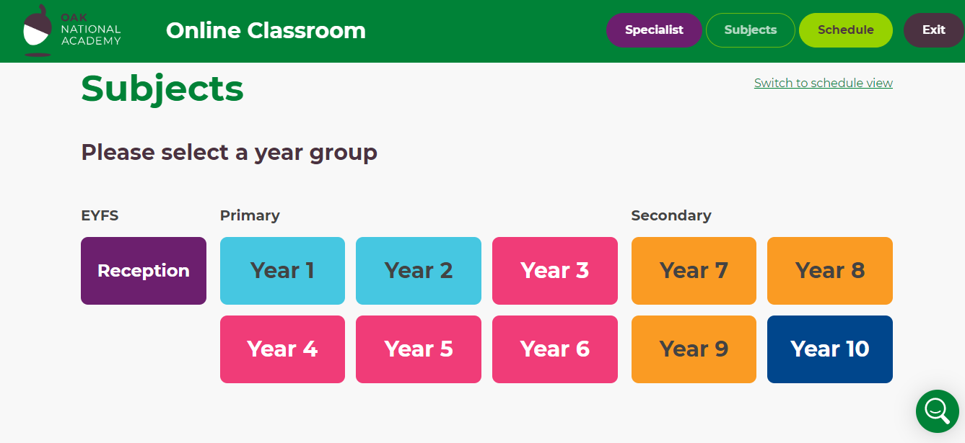
Within each year group are a range of lessons for different subjects and then again within each subject there are a range lessons on different topics. For example Y1 contains 5 lessons on instructions, 10 on fiction writing, 5 on character description, 5 on information texts and 5 on poetry.
Some of the lessons include a quiz and worksheets. This is an example from Y3
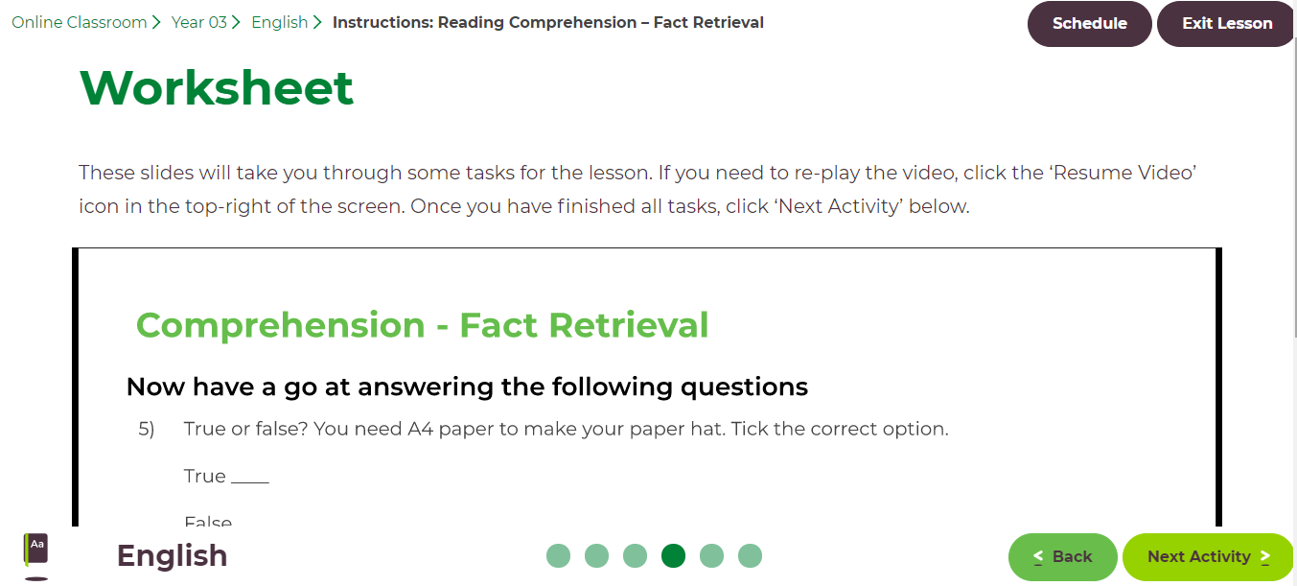

The third option you can click on is schedule
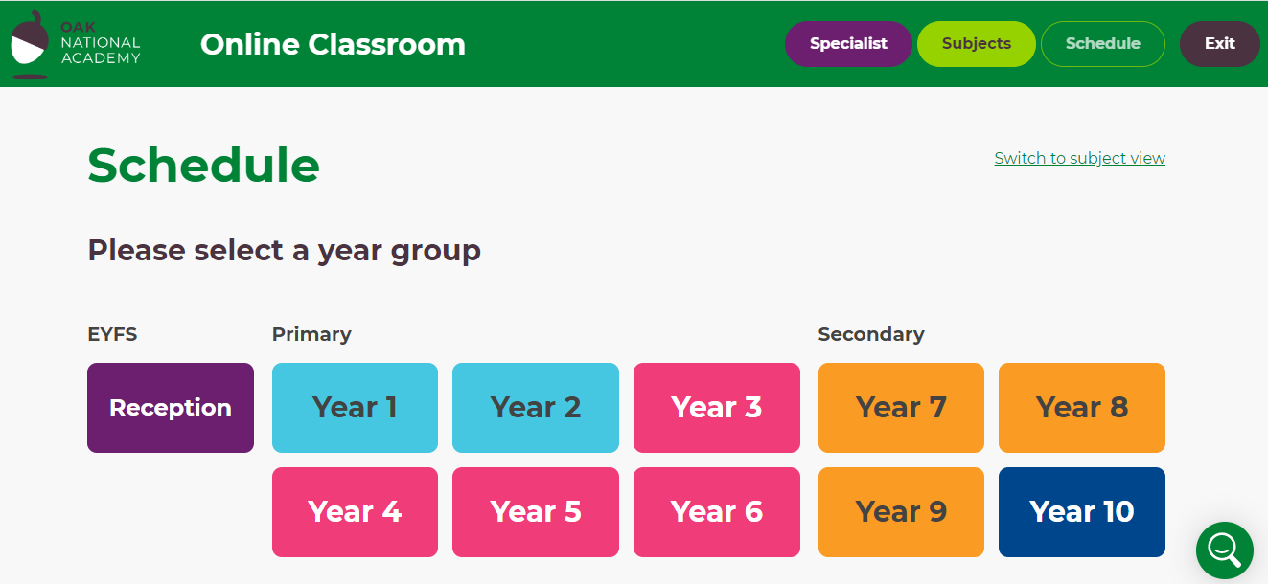
This contains the same content as the ‘subjects’ option but it is organised into suggested tasks for each day. If you want to use the schedule section you will need to scroll down and start at week one rather than the current date.
