

15th December 2021

Fearnville Newsletter

**Arbor App**

Please make sure you download the Arbor app as we will be using it more and more in the new Year. We will not be accepting cash and all payments will have to be made through the app.

**Attendance** has been dropping this term and we will be asking parents of children with low attendance to meet with the Senior Leaders to ensure that we support you to improve this. Children are rewarded if their class gets 100% attendance across the course of a week and some classes have been so close but were let down by children not attending on a Friday.

**Staffing**

We have had a couple of changes to staffing this half term.

Mrs Jackson has resigned and therefore no longer will be a teacher in Y3 Oslo. As such, we have taken the decision to appoint Mrs Khaira as the full-time class teacher in Y3 Oslo so the children have consistency throughout the week. Mrs Rashid will continue to work alongside Mrs Khaira for some of the time she is in school.

We would also like to thank our fantastic Student Teachers who have done a wonderful job this term. They will be missed!

## **Fearnville Primary School**

## Fearnville Drive

## Bradford

## BD4 8DX

Tel: 01274 664661

Email: [office@fearnville.bradford.sch.uk](mailto:office@fearnville.bradford.sch.uk)

Website: www.fearnville.bradford.sch.uk



**Thank You!**

Thank you for your support this term. We have had plenty of trips, residentials and exciting learning going on. Please stay safe over the festive period and we look forward to welcoming you back in January.

We wish you a Merry Christmas and a Happy New Year!





**Christmas**

The children have performed fantastically this week in their respective Carol Concerts and Nativities. They have been recorded and will be uploaded onto the website on Friday 17th December. You will receive your access code via text on this date.

All children will have their Christmas Craft Day/ Christmas Party Day on **Thursday 16th December,** children can wear a Christmas jumper/Christmas non-uniform. Please speak to your child’s class teacher if you would like your child to bring something in for the party.

**Friday 17th December – break up for holidays -Return Tuesday January 4th 2022**

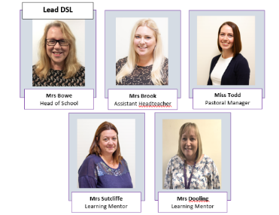

**Safeguarding**

If you have any concerns about a child in our school, please ensure you report this to one of our friendly Designated Safeguarding Leaders who deal with the concern accordingly.