

16th December 2022

Fearnville Newsletter

**Arbor App**

Please make sure you download the Arbor app as we will be using it more and more in the new Year. All payments will have to be made through the app.

**Attendance** has been dropping this term and we will be asking parents of children with low attendance to meet with the Senior Leaders to ensure that we support you to improve this. Children are rewarded if their class gets 100% attendance across the course of a week and some classes have been so close but were let down by children not attending on a Friday.

Please support us with this.

**Staffing**

We have had a couple of changes to staffing this half term.

Mr Booth will be relocating over the Christmas period and will no longer be a teacher at Fearnville from January. We wish him all the best in his move to Cumbria and thank him for all of his hard work over this past term. Mr Masoof will be Y5B’s class teacher until we find a permanent replacement.

We will also be welcoming Mr Khan back as a teaching assistant and a number of student teachers in January. We’re sure you’ll give them a warm welcome.

## **Fearnville Primary School**

## Fearnville Drive

## Bradford

## BD4 8DX

Tel: 01274 664661

Email: [office@fearnville.bradford.sch.uk](mailto:office@fearnville.bradford.sch.uk)

Website: www.fearnville.bradford.sch.uk



**Thank You!**

Thank you for your support this term. We have had plenty of trips, residentials and exciting learning going on. Please stay safe over the festive period and we look forward to welcoming you back in January.

We wish you a Merry Christmas and a Happy New Year!





**Christmas**

Thank you to everyone who came to support our Christmas performances this past week. I’m sure you’ll agree, we have some very talented children in our school and we were so proud watching how confidently and brilliantly they performed.

The children enjoyed their Christmas craft day yesterday and you should be seeing their masterpieces at home time today! They also enjoyed their Christmas parties on Wednesday and a big thank you to all parents/carers who donated food.

**Friday 16th December – break up for holidays -Return Tuesday January 3rd 2023**

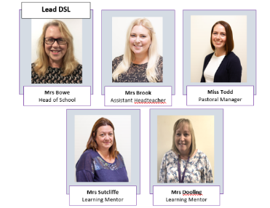

**Safeguarding**

If you have any concerns about a child in our school, please ensure you report this to one of our friendly Designated Safeguarding Leaders who deal with the concern accordingly.