

2nd February 2023

Fearnville Newsletter

**Attendance**

We are still monitoring attendance closely. There is fierce competition for which class can be the best at 100% attendance so thank you for supporting us with this. Let’s keep it going!!

If children are later than 9.30 that counts as an absence. Make sure your children are here on time ready to learn!

Gates continue to be open from 8.40-9.00.

**OPAL**

The children are beginning to enjoy more practical activities outside at playtimes and will soon be doing that at lunchtimes. We still need donations of wellies. We have had lots of useful donations from local businesses. Thanks!

## **Fearnville Primary School**

## Fearnville Drive

## Bradford

## BD4 8DX

Tel: 01274 664661

Email: [office@fearnville.bradford.sch.uk](mailto:office@fearnville.bradford.sch.uk)

Website: www.fearnville.bradford.sch.uk



**Twitter**

Don’t forget to follow us on Twitter to see all the exciting learning we are doing!

@FearnvilleP

**Job Vacancy**

|  |  |
| --- | --- |
| **Post Title:** | **SITE SUPERVISOR** |
| **Post Ref:** | **Fearnville Primary School** |
| **Grade:** | **Band 6** |

Full job description, person specification and application form can be found on our website or from the school office.

Closing Date: Thursday 9th February at 12pm

**Dates for your diary…**

Friday 3rd February- Rockstar Day!

Wednesday 8th February- Young Voices

**Monday 13th February- Friday 17th February- Half Term Holidays**

Monday 20th February- School reopens

Monday 20th February- Wednesday 22nd February-

Y4 Ingleborough Residential

Wednesday 1st March- EYK Visit Parkwood

Thursday 2nd March- World Book Day

Thursday 2nd March- Y5KR Leeds City Museum

Friday 3rd March- Y5M Leeds City Museum

Tuesday 7th March- Y3A Eureka

Tuesday 7th March- Parents Evening (3.30-5.30)

Thursday 9th March- Parents Evening (3.30-5.30)

**Healthy Eating**

We have noticed that some unhealthy food choices are coming into school. We are planning a healthy eating programme for the children after half term and would really appreciates your support by sending them healthier choices in lunchboxes and drinks. More information to follow.

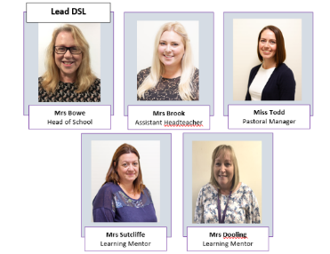

**Safeguarding**

If you have any concerns about a child in our school, please ensure you report this to one of our friendly Designated Safeguarding Leaders who deal with the concern accordingly.