

11th November 2022

Fearnville Newsletter

**Uniform**

Please can we remind everyone that our uniform consists of black trousers, a white polo top, a purple jumper and black shoes.

**Children are not permitted to wear a PE kit to school, and this rule has now been in place since February.**

**PE kits are to be brought into school in a bag and left here for half a term.**

Bookbags should also be brought to school each day so we can change reading books weekly.

Thank you for your support in this matter.

**Attendance**

Our attendance has improved over this term and the children are very excited to keep this going! There is fierce competition for which class can be the best at 100% attendance so thank you for supporting us with this. Let’s keep it going!!

If children are later than 9.30 that counts as an absence. Make sure your children are here on time ready to learn!

Gates continue to be open from 8.40-9.00.

## **Fearnville Primary School**

## Fearnville Drive

## Bradford

## BD4 8DX

Tel: 01274 664661

Email: [office@fearnville.bradford.sch.uk](mailto:office@fearnville.bradford.sch.uk)

Website: www.fearnville.bradford.sch.uk



**OPAL**

We are part of a project called OPAL which stands for Outdoor Play and Learning. We want to make playtimes and lunchtimes as exciting as the learning that takes place in the classroom.

To do this we need to make the most of our outside space.

If you have any old Wellies or waterproofs that you could donate to school, that would be great.

We will also need ‘stuff’ to build with outside e.g. drainpipes, natural resources, pallets etc so if you have any contacts who could provide these- please let us know. See pictures above for examples.

If any parents have any skills in building/ assembling, it would be great to hear from you too!

We will send more information out in the coming weeks.

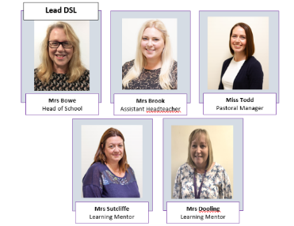

**School Trips and Residentials**

Our creative curriculum is full of enrichment opportunities which include trips, workshops and residentials.

As a school, we are aware of how important these experiences are for our children and as a result subsidise the cost of them as much as we can. We ask that if you child’s class is going on a school trip, you pay the amount requested as failure to do so could result in the visit being cancelled as school cannot cover the full cost. We are cautious to spread these trips out across the year so we are not asking for a lot of money all at once.

Our residentials are optional but provide children with an amazing opportunity to build resilience, independence and try something totally out of their comfort zone. For your information, Y4 will be the next year group offered a residential which will take place in February followed by Y6 in May followed by Y5 in June. More information will be provided nearer the time.

**Parents Evening Feedback**

Thank you to everyone who took attended Parents Evening. The feedback was overwhelmingly positive, and we appreciate all the contributions. If there are ever any issues you wish to discuss with a member of staff, we are always happy to facilitate this. Just phone the office for an appointment.

Thank you 😊

**World Cup**

We will be following the World Cup in school as part of out learning. The children can come in Sports Kit or Football shirts on Monday 21st November.

**Events**

Next week is Anti-Bullying week so the children will be taking part in lots of activities around calling out bullying. We do not tolerate bullying at Fearnville and are proud that our children speak out against it. Children can wear odd socks on Monday to begin anti-bullying week.

Friday 18th November is **Children in Need.** The theme this year is Spots! If you do not have anything spotty it is fine to send the children in non-uniform. The cost is £1 and all money raised goes to Children in Need. Let’s all do our bit!

We will be inviting parents to watch the Christmas performances this year. Details and dates will follow in the next few weeks.

We finish for Christmas on Friday December 16th. We will send out the full timetable for Christmas events.

**Safeguarding**

If you have any concerns about a child in our school, please ensure you report this to one of our friendly Designated Safeguarding Leaders who deal with the concern accordingly.