

25th November 2022

Fearnville Newsletter

**Parking**

Please can we remind people to park legally outside of school. It is becoming increasingly dangerous for our children during drop off/pick up times.

**Please do not park on the pavement.**

**Please do not park on the zig zags.**

**Please do not park on the double yellow lines.**

**Please do not park on the grass verges.**

Your children’s safety depends on it.

**Parents Evening**

Thank you to all parents for attending our parents evenings a couple of weeks ago. It was the best turn out we’ve had for a long time. Another thanks to parents for completing our survey. It is really helpful to get parents views on school.

Don’t forget, our curriculum offer is available on the website alongside what themes are being covered across school and the skills that are being taught. Just click on the School Curriculum tab at the top of the website.

## **Fearnville Primary School**

## Fearnville Drive

## Bradford

## BD4 8DX

Tel: 01274 664661

Email: [office@fearnville.bradford.sch.uk](mailto:office@fearnville.bradford.sch.uk)

Website: www.fearnville.bradford.sch.uk



**Thank You!**

Thank you for your support this year so far. We have had plenty of trips, residentials and exciting learning going on and really appreciate your ongoing support.

**Office Opening Times**

Our school office is open from 8.00am until 4.00pm term time only. If you call outside of these hours, your call will not be answered.





**Christmas Performances**

We are very excited that this year we will be welcoming families back into school to watch our Christmas performances. As space is limited, parents have been given 2 tickets per child for each performance which are available from the class teacher from Monday 28th November. The tickets will need to be signed for and cannot be replaced if lost.

|  |  |  |  |
| --- | --- | --- | --- |
| 12/12/2022 | UKS2 Carol Concert (Y5 & Y6) | Hall | 2.00pm |
| 13/12/2022 | KS1 Nativity (Y1 & Y2) | Hall | 9.45am |
| 13/12/2022 | LKS2 Carol Concert (Y3 & Y4) | Hall | 2.00pm |
| 14/12/2022 | EYFS Sing and Crafts (Nursery & Rec) | EYFS Building | 9.00am |

Doors will open 15 minutes before the start time advertised.



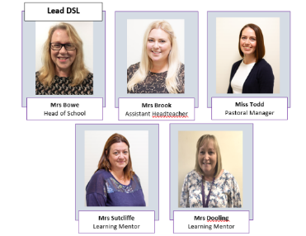

**Safeguarding**

If you have any concerns about a child in our school, please ensure you report this to one of our friendly Designated Safeguarding Leaders who deal with the concern accordingly.