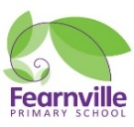

Reception Information Sheet

Autumn 2020

## **Reception**

**Teachers:** Miss Khan and Mr Wright

**Early Years Practitioners**: Mrs Dickerson, Mrs Scott, Mrs Rubery



Fearnville Primary School

Fearnville Drive

Bradford

BD4 8DX

Tel: 01274 664661

**Reminders:**

* Don’t forget to give us your email address so you can access Tapestry observations.
* Make sure to wash your child’s hands and keep social distance where possible at all times!
* Please write your child name on all their belongings



**Our theme this half term is…**

**This Is Me!**

**Diary Dates**

**Physical Development**

Outdoor learning is essential during this pandemic and with a new outdoor area like ours, not to worry your child will not only be learning but will also have fun. Children will explore different ways of travelling whilst successfully negotiating space.

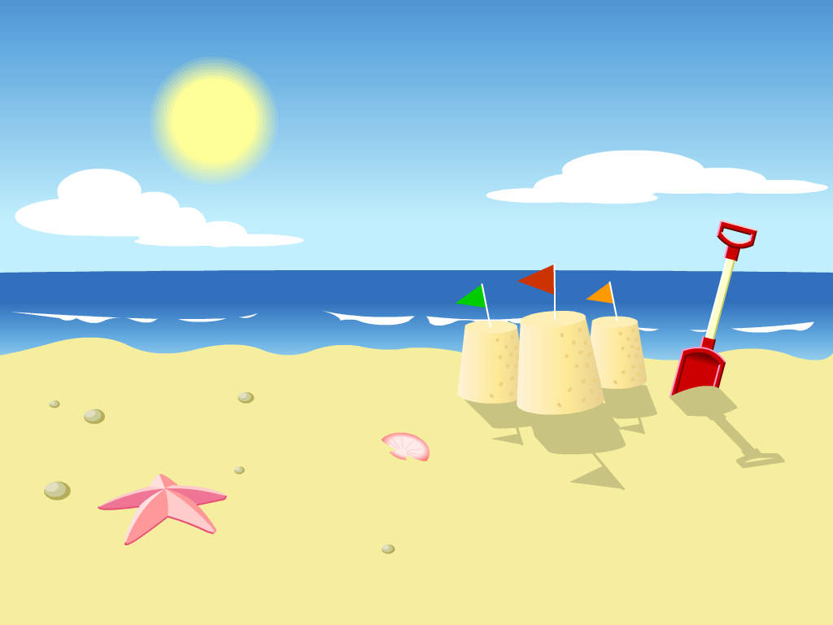

**Understanding the World**

Learning through our senses is vital in early years, hence we will be going on sound walks, identifying different food through taste and smell, looking at mirrors to draw self-portraits etc… We understand you have many concerns regarding the coronavirus but not to worry your child will be in safe hands and will learn about all the different ways in which we can prevent the virus. Be prepared for extra handwashing! You can help with this by encouraging your child to wash their hands properly at home.

**Expressive Arts & Design**

Our focus to begin with will be colour mixing to match our skin tones, enhancing creativity to enable your child to use their own ideas in ways in which to represent their family. For example through stick puppets, body printing etc… Your children will become mini artists and they can share these skills with you at home!



**Maths**

In Maths we will be saying and using number names in order along with counting objects reliably and recognising numbers. We’ll be doing this through a lot of singing. To link in with our theme, we will order house numbers and talk about the different shapes in our homes and how many people are in our family. Within the Shape, Space & Measure area of learning, we will compare feet and hand sizes and use non-standard units to measure these. We will also be doing some simple data handling activities where we look at our features, e.g. hair colour, eye colour etc…

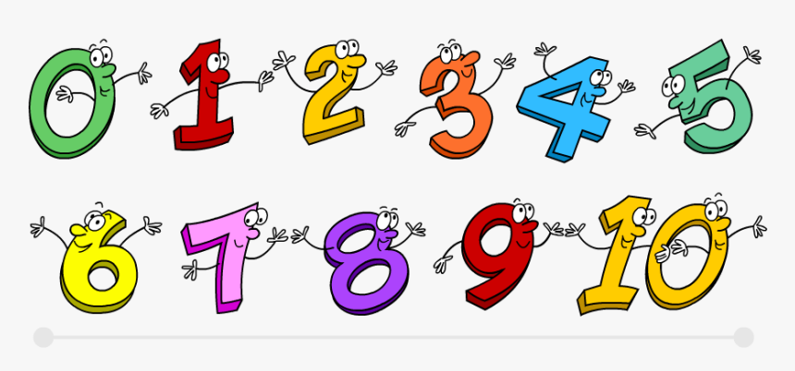

|  |
| --- |
|  |

**Communication and Language**

Through fun and adventurous activities, children will discover the similarities and differences between all people and how it is ok to be diverse. We’ll be discussing our routines, special occasions and what is important to us. Not to forget we will definitely be talking about the coronavirus and how to stay safe! If you could practice this at home it would be great!



**Personal, Social and Emotional**

Are you ready to make new friends? Well be prepared because in reception we are all friends and will be playing lots of games where we will learn about each other and what makes us happy - other than eating chocolate cake ☺! In our small world area you can build and role play and share your ideas with your peers. Not to mention we have our very own circus and mini shop, don’t forget your purse!



**Literacy**

Your child will be given many opportunities to explore phase 2 phonics and how everyone is special and unique. This will often link to our core stories such as ‘Funny bones’. Children will be encouraged to promote letter recognition using the correct cursive font in different areas of our setting, including mark making with chalk, paint etc.. We would really appreciate if you continue this at home. If you are struggling with phonics Alphablocks on YouTube is a great tool to assist you. 