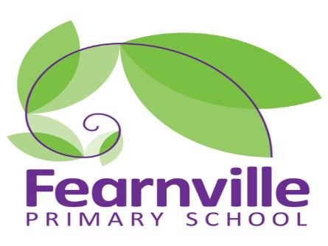 | Autumn Term 1 | Autumn Term 2  Fearnville Primary Nursery Long Term Planning | Spring Term 1 | Spring Term 2 | Summer Term 1 | Summer Term 2
Theme | This is me | Festivals and Celebrations | Traditional tales | Mini-beasts | Under the Sea | People who help us/Superheroes
Ed. visits, trips, visitors | Walk around our community | Christmas celebration in nursery | Visit with the story teller | Looking at our pets at home- images / Vets visit | Visit local aquarium | Trip to Eureka
Core Texts | Maisie goes to nursery  Monkey puzzle  Dear zoo  Head to toe | It’s my birthday  Dipal’s Diwali  Chinese New Year  Dear Santa  Aliens Love Panta Claus | 3 Little pigs  Gingerbread man  Goldilocks  Jack and the beanstalk  3 billy goat gruff  Little Red Riding Hood | The very hungry caterpillar  Slugs for breakfast  Creepy crawly calypso  Best bug parade | Sharing a shell  Tiddler  The rainbow fish  At the beach  The snail and the whale  Billy’s bucket  Fun at the Sea | Supertato  Superworm  Max  Franklin goes to the hospital  Supertato (the evil pea)  Police Officers on Patrol  Jobs people do
Learning Challenges | How are we different?  Why are we not the same?  What do you enjoy?  Who is your friend?  What is your favourite food?  Do we all enjoy the same things?  Do we all live in houses?  What does your house look like?  Who lives in your house?  Can you talk about your family?  Can you share special events from your family celebrations? | What kind of festivals and celebrations have you seen?  What do you celebrate at home?  What kind of things do we do to celebrate?  Can you make invitations for a party in nursery?  Can you make decorations?  What foods do we eat in different festivals? Have we ever tried any of these before?  What are your favourite kinds of foods?  Can you make a diva lamp, Chinese lantern and Christmas bauble? | Are mythical creatures real?  Which is your favourite princess or character?  Does good always win?  How can you be a hero?  Where do the different characters live for example princesses, dragons etc..?  What did you learn?  Can you build a castle?  How are stories structured, one upon a time…?  What do you think it is like to live in a castle? | What different mini-beasts do we know?  Where do mini-beasts live?  What can we identify about different kinds of mini-beasts?  Can we practice our counting using mini-beasts? How many legs, wings etc.  Can we make a mini-beast hotel? | What is a holiday?  Where have you been on holiday? Can you tell us about it? (Postcards)  Can you pack a suitcase for different holidays? (Winter holiday/summer holiday/under the sea)  Who could you take on holiday?  Where would you like to go on holiday this year? (How to get there, what food would you eat, who could help you arrange it, what animals might you see?)  What animals may you find under the sea?  Which is your favourite fish?  How are sea animals different?  What might sea animals eat?  Do you have any water pets?  How do sea animals live? | How does your family help you?  How do our friends help us?  Who at school can help you?  Who helps us when we are ill?  Who can we call when there is a fire?  What special powers do superheroes have?  What do you need to be a superhero?  Can anyone be a superhero?  What superpowers would you like to have?  Who is your favourite superhero and why?  What makes superheroes different?
RE Links | Harvest  Rosh Hashanah (9th – 18th Sept)  Jewish | Bonfire Night (5th Nov)  Diwali (14th Nov)  Hindu  Christmas (advent in Dec)  Christian  Hanukkah (10th – 18th Dec)  Jewish | New Year  Chinese New Year  (5th Feb – Year of the Pig)  Valentine’s Day (14th Feb) | Mothering Sunday (14th March)  Holi Festival (28th March)  Hindu  Shrove Tuesday (5th March)  Christian | Father’s Day (20th June)  Eid (12th May)  Islam | Eid (19th July)  Islam

