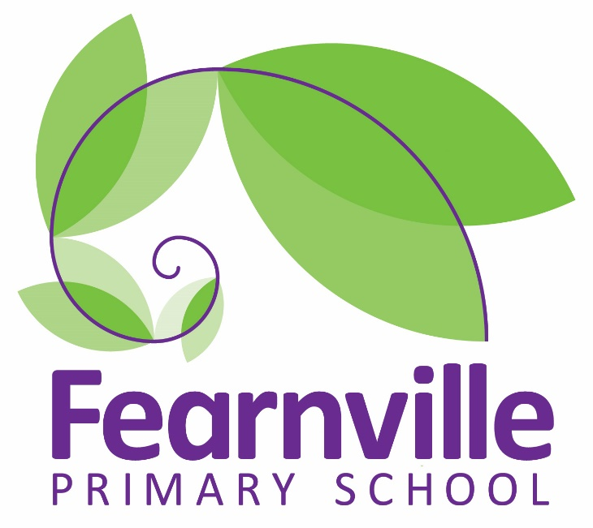

Relationships Education Policy

Adopted by the Governors DRAFT

Date: May 2021 DRAFT

Date of approval:

Review date:

Contents
- Aims .......................................................................................................................................................... 2
- Policy development .................................................................................................................................. 2
- Statutory requirements ............................................................................................................................ 2
- Links to other policies and curriculum areas ............................................................................................ 2
- Delivery of relationships education .......................................................................................................... 3
- Roles and responsibilities ......................................................................................................................... 5
- Parents’ right to withdraw........................................................................................................................ 5
- Training .................................................................................................................................................... 5
- Monitoring arrangements ....................................................................................................................... 6

- Aim
The aim of relationships education at our school is to help pupils develop self-respect, confidence and empathy. Pupils will learn about what makes healthy relationships, focusing on family and friendships, in a way that is age appropriate and sensitive to their faith and culture. This will include online relationships, and how to seek help if they feel unsafe. Teaching will respect the diversity of families in our community.
Relationships education is not about sexual relationships.
This fits in with the school’s moto of Championing out children and in line with our values of generosity, resilience, opportunity and wisdom.

Policy Development
This policy has been developed in consultation with staff, pupils and parents as required by the Department for Education. We are committed to on-going consultation with families and stakeholders throughout the evolution of our school’s relationships education programme. This process involved the following steps:

- Review – a working group pulled together all relevant information including national and local guidance
- Staff consultation – staff had the opportunity to look at the policy and make recommendations
- Parent/stakeholder consultation – parents and any interested parties were invited to work with us on the policy, look at examples of resources, and make recommendations
- Pupil consultation – we spoke to pupils about the skills they would like to learn
- Ratification – once amendments were made, the policy was shared with governors and ratified

Statutory Requirements
Relationships education is compulsory in primary schools from 2020, so all pupils must take part in these lessons.
Sex education is not compulsory for primary schools. Pupils will learn about puberty from Years 5-6. Other aspects of sex education will not be covered unless safeguarding concerns determine otherwise. Parents will be informed in advance if that happens.

Links to other policies and curriculum areas
4a Curriculum
At Key Stage 2, the science curriculum includes teaching about changes to the human body as it grows from birth to old age, including puberty. This remains statutory. Pregnancy is taught about in animals other than humans.
Religious education links to relationships education by looking at family, values and morals, and the celebration of marriage in different traditions.
Health education, which is statutory in state funded schools from September 2020, includes teaching on feelings as they relate to mental wellbeing, the importance of friends and family, the impact of bullying, and how children can seek help if they have worries. It also requires schools to teach about the emotional and physical changes that take place during puberty.

4b Policies
The content of relationships education is supported by our anti-bullying policy, equality and diversity policy, and safeguarding policy.

Delivery of relationships education
Relationships education will be inclusive for all pupils, sensitive to all family and faith backgrounds and pupils’ own identities. It will be respectful of all protected characteristics under the Equality Act 2010. Protected characteristics are age, disability, gender reassignment, race, religion or belief, sex, sexual orientation, marriage and civil partnership and pregnancy and maternity.

Across all Key Stages, pupils will be supported to develop the following skills as appropriate to their age:
- Communication skills
- Forming positive relationships including self-respect as well as respect and empathy for others
- Recognising and assessing potential risks
- Assertiveness and managing conflict and difficult emotions
These skills are taught within the context of family life and friendships, in an age appropriate way. The school environment will reflect, value and celebrate the diversity of friendships and relationships. Lessons will be delivered by school staff and school Nurses.
Children will sometimes ask questions pertaining to relationships, sex or sexuality that go beyond what is set out in the curriculum. If questions go unanswered by school staff, children may turn to inappropriate sources of information including the internet. We will answer any questions in a way that is sensitive to children’s family and faith backgrounds, appropriate to their age and understanding, and consistent with the relationships education policy and scheme of work. This may necessitate discussion on a one-to-one basis or in small groups, as not every child in a class will have the same type of questions. We may contact parents if we need guidance about a child’s needs or if we think a child would benefit from their parents’ input around a particular issue.
The Department for Education (DfE) has set out guidance on what children must learn by the end of year 6, under a series of themes. The statutory content as written by the DfE is set out below. Some themes will recur throughout school while others will be taught in the most appropriate years.

Families and people who care for me

- Families are important for children growing up because they can give love, security and stability
- Characteristics of healthy family life, commitment to each other, including in times of difficulty, protection and care for children and other family members, the importance of spending time together and sharing each other’s lives
- Others’ families, either in school or in the wider world, sometimes look different from their family, but that they should respect those differences and know that other children’s families are also characterised by love and care
- Stable, caring relationships, which may be of different types, are at the heart of happy families, and are important for children’s security as they grow up
- Marriage represents a formal and legally recognised commitment of two people to each other which is intended to be lifelong
- How to recognise if family relationships are making them feel unhappy or unsafe, and how to seek help or advice from others if needed

Caring friendships

- How important friendships are in making us feel happy and secure, and how people choose and make friends.
- Characteristics of friendships, including mutual respect, truthfulness, trustworthiness, loyalty, kindness, generosity, trust, sharing interests and experiences and support with problems and difficulties.
- Healthy friendships are positive and welcoming towards others, and do not make others feel lonely or excluded
- Most friendships have ups and downs, and that these can often be worked through so that the friendship is repaired or even strengthened, and that resorting to violence is never right
- How to recognise who to trust and who not to trust, how to judge when a friendship is making them feel unhappy or uncomfortable, managing conflict, how to manage these situations and how to seek help or advice from others, if needed

Respectful relationships

- The importance of respecting others, even when they are very different from them (for example, physically, in character, personality or backgrounds), or make different choices or have different preferences or beliefs
- Practical steps they can take in a range of different contexts to improve or support respectful relationships
- The conventions of courtesy and manners
- The importance of self-respect and how this links to their own happiness
- In school and in wider society they can expect to be treated with respect by others, and that in turn they should show due respect to others, including those in positions of authority
- Different types of bullying (including cyberbullying), the impact of bullying, responsibilities of bystanders (primarily reporting bullying to an adult) and how to get help
- What a stereotype is, and how stereotypes can be unfair, negative or destructive
- The importance of permission-seeking and giving in relationships with friends, peers and adults

Online relationships

- People sometimes behave differently online, including by pretending to be someone they are not
- The same principles apply to online relationships as to face-to-face relationships, including the importance of respect for others online including when we are anonymous
- Rules and principles for keeping safe online, how to recognise risks, harmful content and contact, and how to report them
- How to critically consider their online friendships and sources of information including awareness of the risks associated with people they have never met
- How information and data is shared and used online

Being safe

- What sorts of boundaries are appropriate in friendships with peers and others (including in a digital context)
- Privacy and the implications of it for both children and adults; including that it is not always right to keep secrets if they relate to being safe
- Each person’s body belongs to them, and the differences between appropriate and inappropriate or unsafe physical, and other, contact
- How to respond safely and appropriately to adults they may encounter (in all contexts, including online) whom they do not know
- How to recognise and report feelings of being unsafe or feeling bad about any adult
- How to ask for advice or help for themselves or others, and to keep trying until they are heard
- How to report concerns or abuse, and the vocabulary and confidence needed to do so, where to get advice e.g. family, school and/or other sources

Roles and responsibilities

The governing board
The governing board will approve the relationships education policy, and hold the head teacher to account for its implementation.

The head teacher
The head teacher is responsible for ensuring that relationships education is taught consistently across the school, and for managing requests to withdraw pupils from non-statutory sex education lessons, if applicable.

Staff
Staff are responsible for:
- Delivering relationships in a sensitive way, taking account of pupils’ family and faith backgrounds
- Modelling positive attitudes to relationships education, as with any other subject
- Monitoring children’s learning in order to ensure they make progress
- Responding to the needs of individual pupils
- Responding appropriately to pupils whose parents wish them to be withdrawn from the nonstatutory sex education lessons, if applicable.
Staff do not have the right to opt out of teaching relationships education. Staff who have concerns about teaching this subject are encouraged to seek support. Staff will only teach within the parameters of this policy.

Pupils
Pupils are expected to engage fully in relationships education lessons and treat others with respect and sensitivity, as we expect all the time in school.

Parents’ right to withdraw their children from lessons
Parents have the right to withdraw their children from sex education lessons taught as part of the relationships education or PSHE curriculum.
Requests for withdrawal should be put in writing and addressed to the head teacher. A copy of withdrawal requests will be placed in the pupil’s file so that parents’ wishes are on record. Alternative work will be given to pupils who are withdrawn from sex education.
Primary schools are required to teach the elements of sex education contained in the science curriculum and there continues to be no right to withdraw from these lessons.

Training
Staff are trained on the delivery of relationships education as part of their induction and it is included in our continuing professional development calendar.
The head teacher will also invite visitors from outside the school, such as school nurses or sexual health professionals, to provide support and training to staff teaching RSE. The sessions delivered by outside visitors will be consistent with our policy on relationships education.

Monitoring arrangements
The delivery of RSE is monitored by the PHSE subject leader and senior leadership team through planning, books scrutiny, learning walks and pupil voice.
Pupils’ development in RSE is monitored by class teachers as part of our internal assessment systems.
This policy will be reviewed by PHSE leader and senior leadership team on a two year- cycle
At every review, the policy will be scrutinized and ratified by the governing board.

