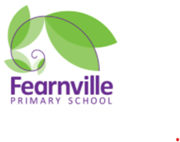
Fearnville Primary
‘’Today a reader tomorrow a leader.’’
At Fearnville Primary School, we aim to create a life-long love of reading. It is our belief at Fearnville Primary School that every child should be able to read for pleasure and to a high standard. We aim to develop independence and fluency in all readers to ensure a life-long love of reading so all can achieve their full potential across all areas of the curriculum.
We approach reading in three different ways; reading for pleasure, reading across the curriculum and teaching reading skills explicitly.
We believe that every child should be given the tools to develop into an enthusiastic and confident reader both at home and at school. Reading improves language and vocabulary, inspires imagination and gives everyone the opportunity to develop and foster new interests.

Phonics
Early readers have daily phonics lessons, which give children the stepping-stones to break down unknown words into readable chunks. Phonics is a very useful tool for children trying to make sense of texts that they do not understand.
Reading
Early readers read decodable books matched to their phonic ability. All other children access a home reading scheme. There are clear classroom routines for checking and changing home readers. Parents use home reading records to communicate with school. Children are rewarded for reading. When phonics is secure, when reading is fluent and automatic, comprehension is taught during whole-class reciprocal reading sessions. Comprehension skills are checked further through the reading element of the English cycle.
Things we do to promote the love of reading:
High quality reading areas stocked with a variety of quality texts
Dedicated reading for enjoyment sessions
Recommended reading lists
Reading skills lessons
Reading competitions and Reading events
