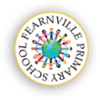

Reception Information Sheet

Spring 2020



**Reminders:**

* Don’t forget to give us your email address so you can access Tapestry observations.
* Please remember to bring book bags to school.
* Practice high frequency words with your child.
* Remember we use cursive handwriting.
* If your child wear glasses please remember to send them with your child each morning.
* Attendance matters make sure to send your child to school every day.

Fearnville Primary School

Fearnville Drive

Bradford

BD4 8DX

Tel: 01274 664661

## **Reception**

**Teachers:** Miss Khan and Miss Sattar

**Early Years Practitioners**: Mrs Dickerson, Mrs Scott, Mrs Brown

[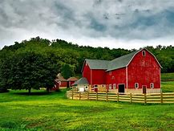](https://www.bing.com/images/search?view=detailV2&ccid=hooUntKQ&id=B484F01E96BD1127EDE9E2E46DA722B5C227A517&thid=OIP.hooUntKQVzmRvpUu5MJMzAHaFj&mediaurl=https://www.agri-pulse.com/ext/resources/images/Agriculture-photos/Farmscapes/Farm1.jpg?height%3d635%26t%3d1509734744%26width%3d1200&exph=627&expw=836&q=farm&simid=608006637959513416&selectedIndex=0)

**Communication and Language**

Through fun and adventurous activities, children will explore different mini beasts and where they are found. This will then enable them to understand the importance of care and routine for these animals. Do you have any pets at home? Could your child bring a picture of your pet?

**Our theme this half term is…**

**At the farm!**

**Expressive Arts & Design**

By exposing your child to design and 3D junk modelling will give them the opportunity to become creative architects and show them how to use materials effectively, thinking about which tools are appropriate in joining different materials, for example treasury tags, glue, split pins etc.. [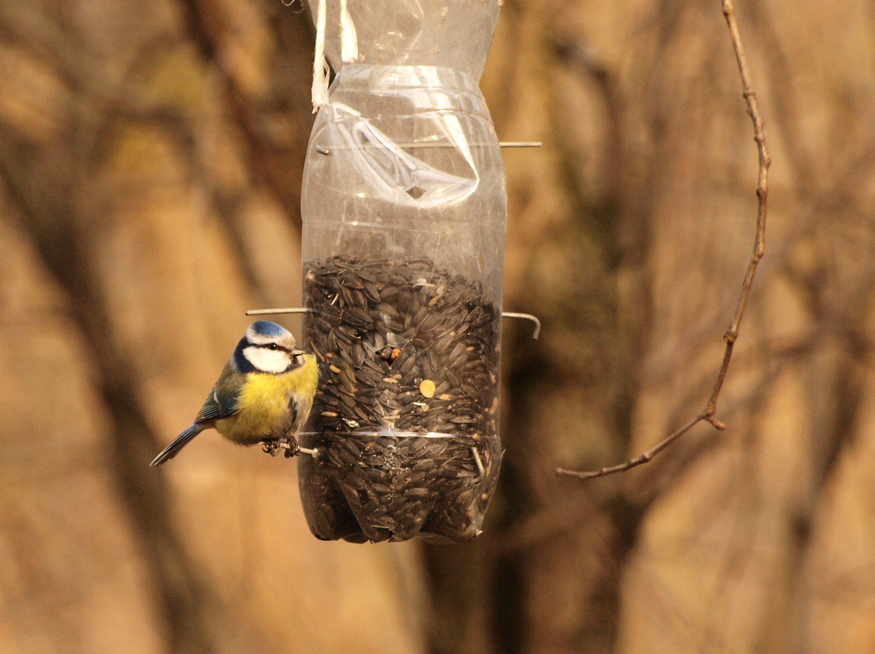](https://www.google.co.uk/url?sa=i&url=https://www.thefascinatingworldofforestry.com/d-i-y-series-making-an-eco-friendly-bird-feeder/&psig=AOvVaw269xwKCgIy4FiZOSKRGMbq&ust=1580401220667000&source=images&cd=vfe&ved=0CAIQjRxqFwoTCPjxwsSbqecCFQAAAAAdAAAAABAh)

**Diary Dates**

**Stay and plays will be every first Tuesday**

**Tuesday 4th February 2020**

**Tuesday 3rd March 2020**

**Understanding the World**

Learning through discovery is key in early years, therefore our children will explore and discover the life cycles of different animals and how they differ. Be prepared for your children to become mini farmers as we are going to be planting many vegetables and crops for your children to experience and eat. This will prep children for their future and equip them with essential life skills.

[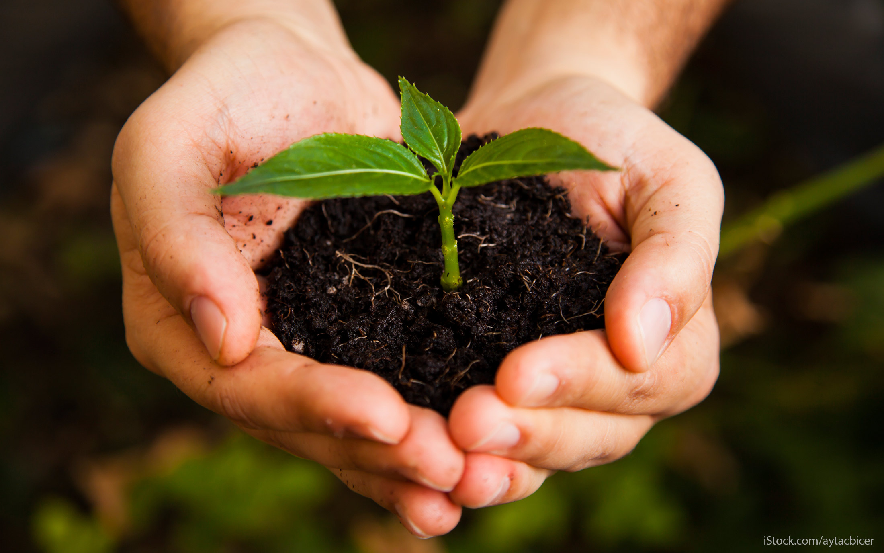](https://www.google.co.uk/url?sa=i&url=https://www.gobankingrates.com/saving-money/savings-advice/how-save-million-dollars/&psig=AOvVaw1MCZC0knDYWd0dgL6ytf20&ust=1580401468603000&source=images&cd=vfe&ved=0CAIQjRxqFwoTCLj2oLecqecCFQAAAAAdAAAAABAR)

**Maths**

Within our maths focus, children will understand the importance of money and how money can be used for many things including buying and selling. Your children will become mini shopkeepers (using pounds not dollars) and will deepen their understanding in doubling, sharing and adding. This can be supported at home by collecting receipts with your child during shopping trips and talking about how much items cost.

|  |
| --- |
|  |

**Physical Development**

It is vital that children understand the benefits of physical activity for their bodies and how to play safely with their peers. Through exciting activities children will learn how to negotiate space successfully and how to perform basic travelling movements. Our new outdoor area is perfect to enhance all these skills.

**Personal, Social and Emotional**

During this half term we are going to be learning about animals and the world around us, by exploring animals from different environments including under the sea, the desert, etc.. and how these animals are similar and different. Children will also look at the importance of keeping our environment clean, so that animals and people are safe. Our children will become litter detectives so they know how to help look after our environment.

**Literacy**

We are starting to look at phase 3 phonics. Within phase 3 you are introduced to digraphs. A digraph is a sound that is made up from two letters, for example, ‘sh’ ‘ch’ ‘th’ etc.. It would be really appreciated if you could support your child with this and practice cursive letter formation and the high frequency words.