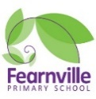

**SATS 2022 - Information for Parents**

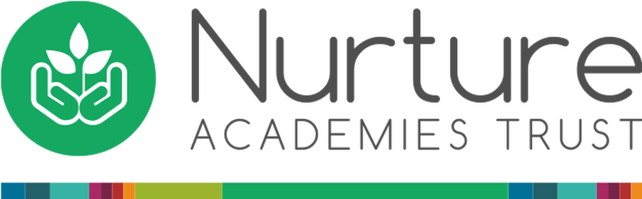

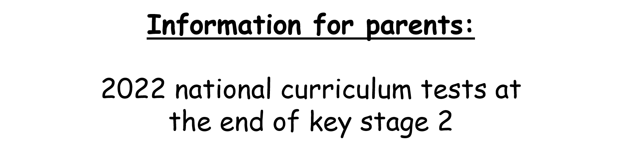

 

**Your child will be taking the national curriculum test (SATS) in May 2022**

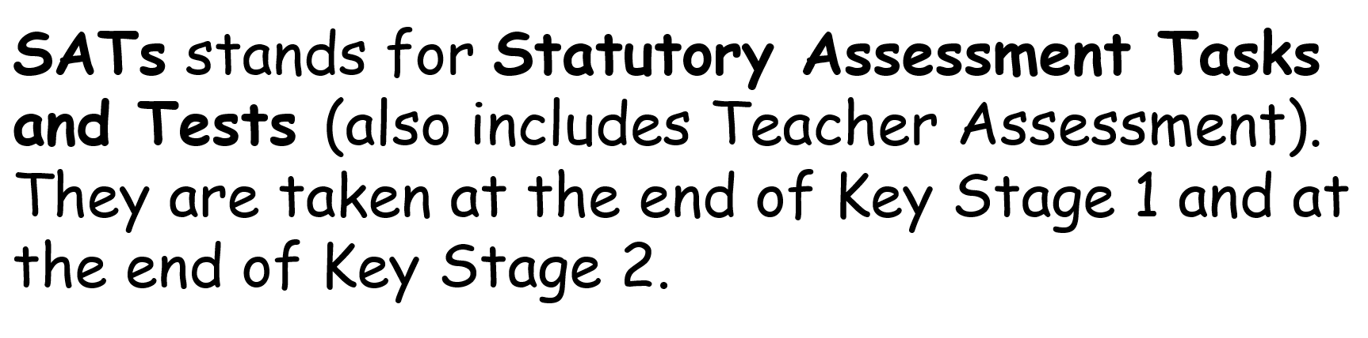



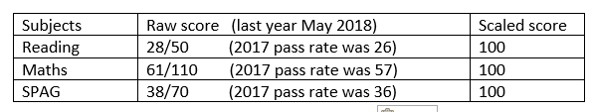

**The raw score pass rate changes every**

**year, so this year it could be higher.**

**You will be given your child’s raw score (the actual number of marks they get), alongside their scaled score and whether they have reached the expected standard set by the Department for Education (‘NS’ means that the expected standard was not achieved and ‘AS’ means the expected standard was achieved).**

The range of scaled scores available for each KS2 test is:

* **100+ is the expected scaled score that can be awarded.**
* **80 is the lowest scaled score that can be awarded.**
* **120 is the highest scaled score that can be awarded.**

**Breakfast during SATs Week Monday – Thursday 8.15am**

Your child will receive a free breakfast consisting of:

Cereal, toast and juice

All Year 6 staff will be present during breakfast.

All children must attend everyday.

**The keystage 2 tests for Year 6 pupils**

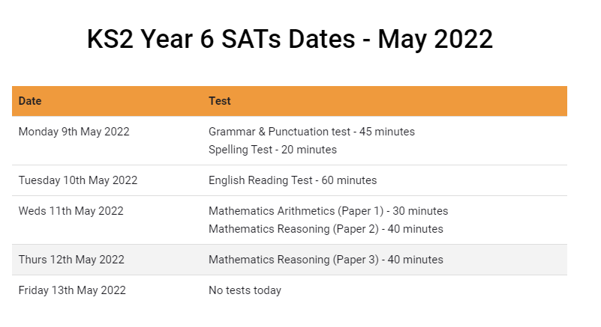

**Useful Websites**

http://www.woodlandsjunior.kent.sch.uk/revision/index.html

http://www.icteachers.co.uk/children/children_sats.htm

http://www.parkfieldict.co.uk/sats/

http://www.emaths.co.uk/index.php/4students/pastpapers/ks2satpapers

*You can access lots of past test papers on this site.*

http://www.compare4kids.co.uk/maths.php

http://www.bbc.co.uk/schools/revision/

For more details you can visit www.gov.uk/STA

You can have a look at a sample of the tests your child will take if you wish or you can have a look at the published samples on

