How to access work set on Purple Mash
Log onto Purple Mash
Click 2Dos
Select a task
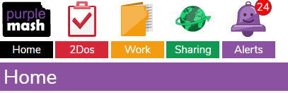

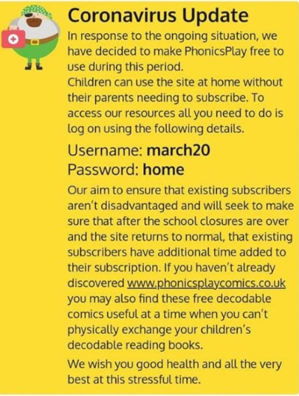

Please refer to the school website for updates e.g. access to free websites for learning

