Long Term Plan
2022-2023

Year 1 Curriculum Overview
 | Autumn 1 | Autumn 2 | Spring 1 |  | Spring 2 | Summer 1 |  | Summer 2
Title | Our School |  | The Great Outdoors |  |  | Castles
Themes Hooks and Visits | Local area walk  School -Local area hunt  Forest school experience (Trust school visit) |  | Lister Park  Tong Garden Centre  Bush craft  School grounds development with volunteers |  |  | Skipton Castle  A Royal banquet
Inspiring Careers | Ex Fearnville Pupil (Kirsty Todd)  Site Manager  Trust CEO/Teacher |  | Community Police Officer  Engineer  Parks & Recreation Officer-Bradford council |  |  | Castle Tour Guide  Local MP  Caterer/event planner
Fearnville 50 Fantastic  Feats | Litter picking – Autumn 1  Attend forest school - Autumn 2 |  | Walk in the woods – Spring 1  Planting a tree – Spring 1  Visiting a mosque – Spring 2 |  |  | Party with your friends - summer 1  Taste new food - summer 1  Learn a dance – summer 2  Visit a castle – summer 2
English | Texts  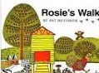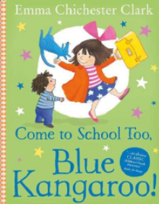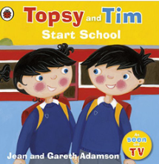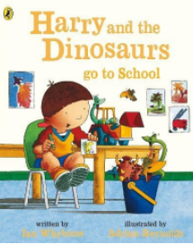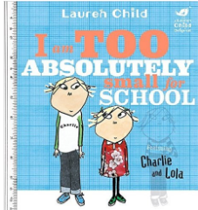  Rosie’s Walk (Pat Hutchins)  Come to School too, Blue Kangaroo!  (Emma Chichester Clarke)  Charlie and Lola: I Am Too Absolutely Small for School  (Lauren Child)  Harry and the Dinosaurs go to School  (Ian Whybrow & Adrian Reynolds)  Topsy and Tim: Start School  (Jean & Gareth Adamson) |  | Texts  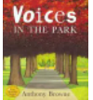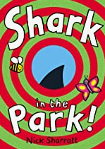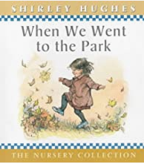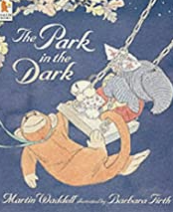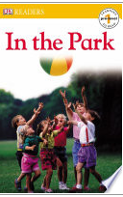  Voices in the park (Anthony Browne)  Shark in the park (Nick Sharratt)  We went to the park (Shirley Hughes)  The park in the dark (Martin Waddell)  In the park (Dorling Kindersley) |  |  | Texts  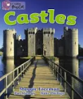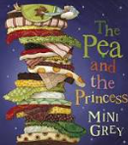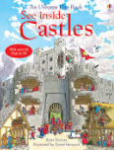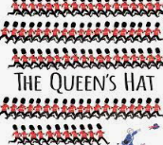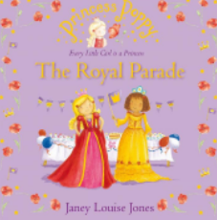  Castles (Maggie Freeman)  Princess and the Pea (Mini Grey)  See inside the castles (Katie Daynes)  The Queen’s Hat (Steve Anthony)  Princess Poppy-The Royal parade  (Janey Louise Jones)
Maths | Number to 10: Place value  Number bonds: Addition & Subtraction  Addition & Subtraction within 10: Addition & Subtraction  Shape: 2D/3D and pattern |  | Numbers to 20: Place value  Addition & Subtraction within 20  Length  Mass |  |  | Numbers to 40: Place Value  Multiplication  Division  Time  Money  Addition & Subtraction within 20
Science | Animals including humans  Talk about & describe the human body and senses  Materials  Identify & name every day materials (classroom objects/school building) Identify & compare suitability-Recycling in school | Seasonal changes – observe and describe | Animals including humans  Identify animals in the locality e.g. foxes, badgers,  Sort, classify, describe | Seasonal changes – observe and describe |  | Plants  Observe closely, identify and name common plants  Describe, draw and keep records | Seasonal changes – observe and describe
Art | Painting  Name & mix colours, shades, tones | Printing  Use hard and soft materials to create mono-prints | Collage  and using a combination of materials -using real life pictures of local parks  create collages with natural materials e.g .leaves, twigs  Textiles  Apply shapes and decoration with glue |  |  | Drawing  Lines and shapes from observations | Sculpture  experiment and construct castles joining recycled materials
D.T. | Textiles  Sewing- shape using a template, join using a running stitch, colour and decorate textiles  classroom bunting | Materials  cutting, shaping and joining | Food-  picnic at the park – prepare a healthy picnic and identify food sources.  Use tools and techniques safely |  |  | Construction  Apply knowledge of materials to make a structure stiffer/more stable | Evaluate  Describe what went well, make changes and suggest what can be improved
Geography | Investigating places - Our School  GSF 4 Use Simple Fieldwork and Observational Skills to Talk About the Local Area  GSF 3 Recognise landmarks  HPG 1 Seasonal and daily weather patterns |  | Investigating places -Bradford  GSF 4 Use Simple Fieldwork and Observational Skills to Talk About the Local Area  GSF 3 Recognise landmarks  What outdoor activities does Bradford offer? |  |  | Investigating places - Castles around the UK  LK2 Characteristics of the UK  GSF1,2 Use maps, atlases and basic geographical vocabulary  PK 2 Similarities and differences (Bradford/Skipton)
History | HE 2,3  OC1, 2, 4  CU 3,4,5 Place artefacts on a time line  KU 1 Recount changes within living memory:  HI 1 School past and present |  | HE 1,2 CU2,5 Observe evidence (photographs) to ask and answer questions about the past.  HI1 OC3,4 Find out about what life was like in the past using pictures, stories and artefacts  How did Bradford children in the past spend their time? |  |  | Knowledge and understanding of events, people and changes in the past -Queen Elizabeth & Castles  HE 1,2 OC 1,2,3,4  KU 1,2 HI1  CU 1,2,3,4,5
Computing | e-safety  Information literacy  Media  Data handling | Data handling  Media  Info Literacy  e-safety  Computer Science | Data handling  Media  Computer science | Media  Info Literacy |  | Computer science  Media  e-safety | Computer Science  Media
Spanish | Greetings  Name  Counting  Body parts  colours | Label pencil case  Label rooms  Days of the week  2D shapes  Christmas objects | Food  Family  Numbers  Colours | Clothes  Hair/eyes  Spanish culture |  | Objects  Maths  Weather  Seasons  Animals | Animals  Plurals  Famous art
PE | Dance | Gymnastics | Ball games | Ball games |  | Dance- medieval dance | Gymnastics
Outdoor  PE | Ball skills | Ball skills | Team games | Team games / tactics |  | Athletics | Athletics
PSHE | Jigsaw – Being Me in My World | Jigsaw – Celebrating differences | Jigsaw – Dreams and goals | Jigsaw – Healthy Me |  | Jigsaw – Relationships | Jigsaw – Changing me
Music | Charanga  Introducing Beat  How can we make friends when we sing together? | Charanga  Adding Rhythm & Pitch  How does music tell stories about the past?  Christmas / Nativity songs | Charanga  Introducing Tempo & Dynamics  How does music make the world a better place? | Charanga  Combining Pulse, Rhythm & Pitch  How does music help us understand our neighbours?  Find a Little Seed |  | Charanga  Having Fun with Improvisation  What songs can we sing to help us through the day? | Charanga  Explore Sound & Create a Story  How does music teach us about looking after our planet?
RE | RE new Bradford syllabus curriculum  Can you tell what somebody believes by what they look like? | RE new Bradford syllabus curriculum  Can you tell what somebody believes by what they look like? | RE new Bradford syllabus curriculum  What is special to faith communities? | RE new Bradford syllabus curriculum  What is special to faith communities? |  | RE new Bradford syllabus curriculum  How does what believers do show what they believe? | RE new Bradford syllabus curriculum  How does what believers do show what they believe?

