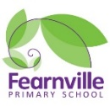

Year 1 Information Sheet

Spring 2023



**Reminders:**

1UC and 1S class change books in school on Fridays.

Spellings homework sent out every Friday and tested the following Friday.

1UC PE on Tuesdays

1S PE on Fridays

## **Year 1**

Teacher: Mrs Ullah-Critchley & Miss Sattar

Teaching Assistant: Mrs Barrett and Mrs Dickerson

Fearnville Primary School

Fearnville Drive

Bradford

BD4 8DX

Tel: 01274 664661

**English** 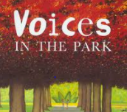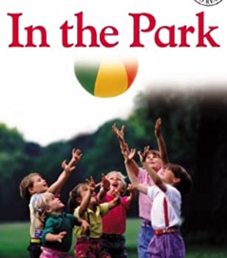

We will begin the New Year with a lively and fun topic on **The Great Outdoors** in Bradford. As part of our on-going learning about the local area and where we live, we will look at Lister Park which is the location of a famous museum in Bradford called Cartwright Hall. We will read and respond to English texts with park settings and look closely at this as well as the characters in the stories. We will also look at features of non-fiction texts. We put a lot of hard work in last term to develop our fluency in reading so this will now help us to answer comprehension questions in detail.

**Diary Dates**

We will update you with diary dates you need to know of through letters sent home with children or a text message from school. Please speak to Mrs Ullah-Critchley or Miss Sattar if you have any queries.

**Science**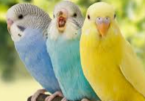

Our topic on Animals will allow us to observe nature in local parks and the animals that inhabit there. We are hoping to find out about how animals are classified by their features and other scientific vocabulary to describe them. We will be taking part in bird watching and naming local and British birds. Maybe this is something you can do at home. too.

**Theme**

Continuing with the local theme, we will learn about the great outdoors in Bradford and locate them on maps. We are hoping to visit Lister Park and look at art by Hockney in Cartwright Hall . We also hope to visit local woodlands and take part in bush crafts and how we can improve local park playgrounds. Last terms work on maps will help us go on scavenger hunts and talk about improving local parks. 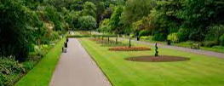

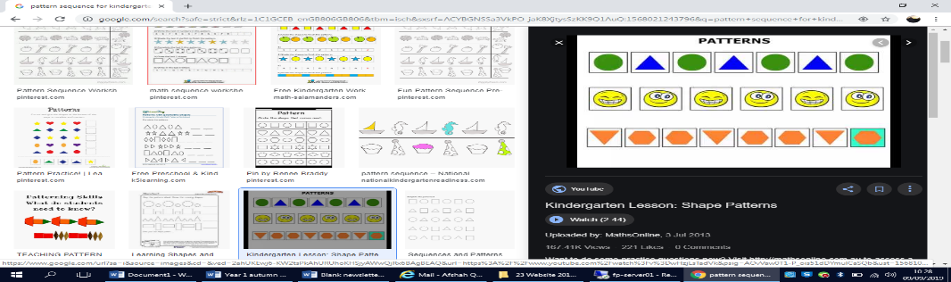 **Maths**

We will learn to name and describe the properties of 2D and 3D shapes. We will also recognise, find and name a half as one of two equal parts of an object, shape or quantity as well as quarters. We want to become super mathematicians so we will continue to solve problems including addition and subtraction using concrete (real) objects and pictorial representations with numbers up to 20. We will develop our investigative skills in maths and see if we can explain our answers.