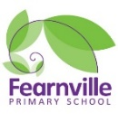

Year 1 Information Sheet

Summer 2022



**Reminders:**

Madrid and Paris class change books in school on Mondays & Fridays.

Spellings homework sent out every Friday and tested the following Friday.

PE on Tuesdays

## **Year 1**

Teacher: Mrs Ullah-Critchley & Miss Sattar

Teaching Assistant: Mrs Barrett and Mrs Ruberry

Fearnville Primary School

Fearnville Drive

Bradford

BD4 8DX

Tel: 01274 664661

**English** 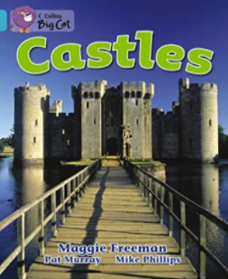 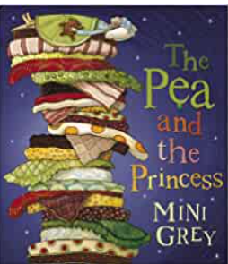

Lords, ladies and noble folk!  Let us take you on a journey to medieval England.  A time of castles, kings and queens, knight, peasants, dungeons and DRAGONS!!

As part of our topic on 'Castles' we will learn all about how people lived in castles, what they wore, what they ate and much much more! We all also learn about famous people who shaped history in Britain, including St George and our beloved Queen Elizabeth II.

In English, we will be reading and responding to ‘The Princess and the Pea’ and comparing other traditional stories we know as well as writing instructions for medieval recipes and poetry! We will also look at features of non-fiction texts when learning about features and designs of castles around the world.

**Diary Dates**

The children will be visiting Skipton Castle as part of their work on this theme. We will communicate with parents nearer the time of the trip. We will update you with diary dates you need to know of through letters sent home with children or a text message from school. Please speak to Mrs Ullah-Critchley or Miss Sattar if you have any queries.

**Theme**

In History we will learn to name the different parts of castles and how and why they were built.  We will also name some of the famous castles in England and learn about the people who lived in them. We hope to visit Skipton Castle.

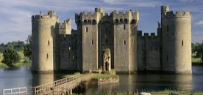

**Science**

We will learn about everyday materials which are used to make common and everyday objects e.g. wood, stone, glass, plastic, metal, fabric, etc. We will carry out fair tests to find which treasures float and sink based on the materials they are made out of.



**Maths** 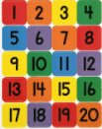

We want to become super mathematicians so we will continue to solve problems including addition and subtraction using concrete (real) objects and pictorial representations with numbers up to 50. We will develop our investigative skills in maths and see if we can explain our answers. We will also compare and measure the length and height of objects and practise using the language associated with measures.