

Year 1 Information Sheet

Autumn 2019



**Reminders:**

Madrid and Paris class change books in school on Fridays.

Spellings homework sent out every Friday and tested the following Friday.

## **Year 1**

Teacher: Miss Ullah & Miss Shabir

Teaching Assistant: Mrs Barrett and Miss Naylor

Fearnville Primary School

Fearnville Drive

Bradford

BD4 8DX

Tel: 01274 664661

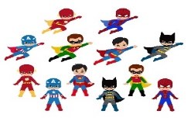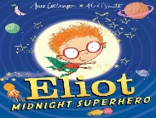

**English**

*Is it a bird? Is it a plane? No! It is our new topic SUPER ME!*

In English, we will be reading and responding to ‘Eliot the Midnight Super Hero’ who is an everyday superhero helping people. We will compare real life super heroes from comics and books and what qualities and super powers they have. We will also think about what makes us special and write about our own superpowers!

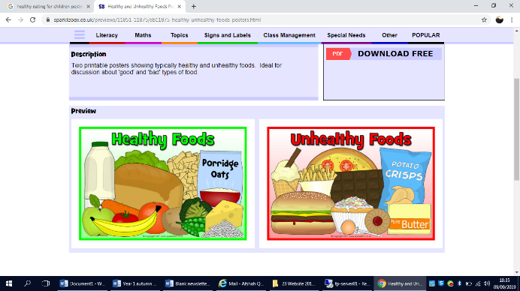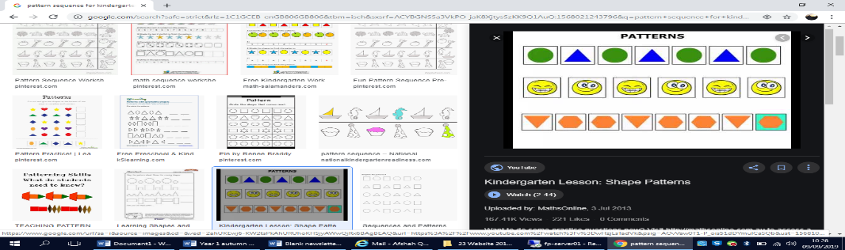

Topic

This half term our children are going to be *faster than a streak of lightening, more powerful than a pounding surf and mightier than a roaring hurricane!* Yes! We are going to be *super* in every way possible: Super Learners! Super Healthy! Super Scientists! Super Writers! Super Mathematicians! Super Stars!

As part of our topic on 'Super Me' we will learn all about famous super heroes, everyday heroes who help us, what it means to be a hero and all the super qualities we have which makes us just *SUPER!*

**Maths**

We will learn about place value and look for and investigate patterns in a sequence of numbers. To help us with this we will be counting forwards and backwards beginning with 0 or 1 from any given number. We will also learn about adding 1 more, 1 less and ordering numbers by their place value. We want to become super mathematicians so we will continue to solve problems including addition and subtraction using concrete (real) objects and pictorial representations. We will develop our investigative skills in maths, and see if we can explain our answers.

Science

We will learn to name body parts and what it means to be healthy and exercise, as well learning to name the senses. We will investigate what happens when we are will, how germs get inside our bodies and how to protect our bodies.



**Diary Dates**

We will update you with diary dates you need to know of through letters sent home with children or a text message from school. Please speak to Mrs Ullah or Miss Shabir if you have any queries.