

Year 1 Information Sheet

Autumn 2020

**Reminders:**

Madrid and Paris class change books in school on Fridays.

Spellings homework sent out every Friday and tested the following Friday.

## **Year 1**

Teacher: Mrs Ullah-Critchley & Miss Sattar

Teaching Assistant: Mrs Barrett and Mrs Kauser



Fearnville Primary School

Fearnville Drive

Bradford

BD4 8DX

Tel: 01274 664661

**English** 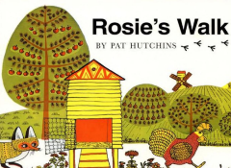

We will begin our school year with a lively and fun topic on Our School & the Local Area! There will be LOTS of opportunities for fieldwork and observational skills and to study the Geography of our fantastic Fearnville school grounds and the surrounding areas.

In English, we will be reading and responding to ‘Rosie’s Walk.’ A story about a hen who goes on a walk around her local farmyard but unaware a sly and sneaky fox is following her. What will happen next? We will also plan a route map for the story character to take a walk around our school, label maps, write captions and give directions for others to follow.

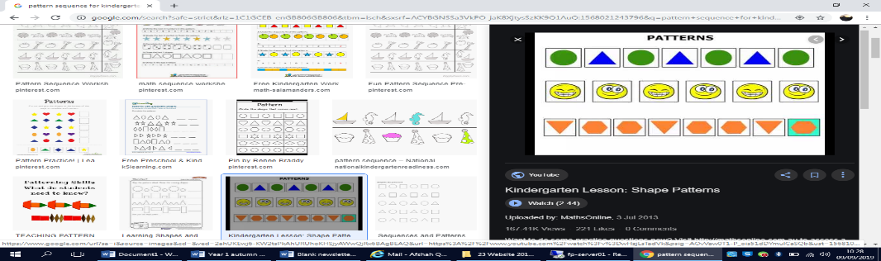

**Maths**

We will learn about place value and look for and investigate patterns in a sequence of numbers. To help us with this we will be counting forwards and backwards beginning with 0 or 1 from any given number. We will also learn about adding 1 more, 1 less and ordering numbers by their place value. We want to become super mathematicians so we will continue to solve problems including addition and subtraction using concrete (real) objects and pictorial representations. We will develop our investigative skills in maths and see if we can explain our answers.

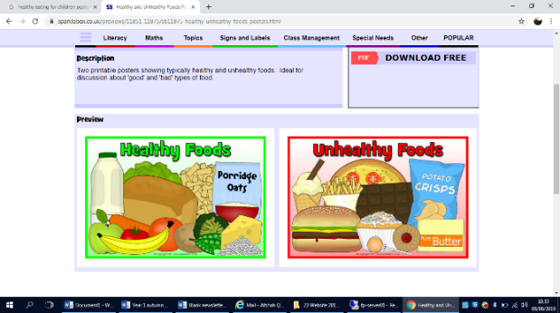

**Science**

We will learn to name body parts and what it means to be healthy and exercise, as well learning to name the senses. We will investigate what happens when we are ill, how germs get inside our bodies and how to keep ourselves safe.

**Theme**

This half term we are going to explore our school grounds and surrounding areas using fieldwork, orienteering and maps. We will also compare and learn about schools Now and how they were Then (in the past).



**Diary Dates**

We will update you with diary dates you need to know of through letters sent home with children or a text message from school. Please speak to Mrs Ullah-Critchley or Miss Sattar if you have any queries.