Long Term Plan
2022-2023

Year 2 Curriculum Overview
 | Autumn 1 | Autumn 2 | Spring 1 |  | Spring 2 | Summer 1 |  | Summer 2
Title | Fire Fire! |  | Chocolate |  |  | At the Seaside
Theme Hooks & Visits | Fire station visits  Re-enactment of the great fire  Nell bank  Drama-Gingerbread man investigation |  | Chocolate tasting  Experimenting with materials  York-The chocolate story  Chocolatier |  |  | Trip to seaside  Picnic at City beach  Bus stop tour around Bradford  Observing the lifecycle ducks  ‘holiday’ pictures hall exhibition
Inspiring Careers | Firefighter  Baker |  | Chocolatier  Artist |  |  | Pilot/Airhostess  Veterinarian
50 Fearnville Feats | Baking  Visit a Cathedral |  | Grow vegetables  Bug hunt  Chocolate factory visit |  |  | Treasure hunt  Seaside visit  Take care of animals
English | Genres  Diary  Instructional texts  Recount  Letter  Texts  Who was: Samuel Pepys? (Paul Harrison)  Dragon Post (Emma Yarlett)  Instruction texts  Class Novel: Vlad and the GFOL (Katie Cunningham)  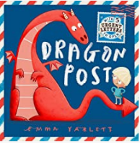  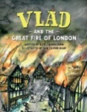 |  | Genres  Narrative (description)  Explanation  Non-chronological report  Poetry  Texts  Chocolate Cake Poem (Michael Rosen)  My Country – Brazil (Annabel Savery)  The story of chocolate (Katie Daynes)  Smart about chocolate, a sweet history (Sandra Markle)  Class Novel: Charlie and the chocolate factory  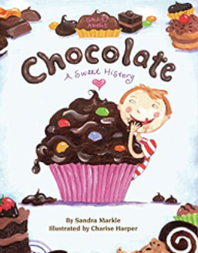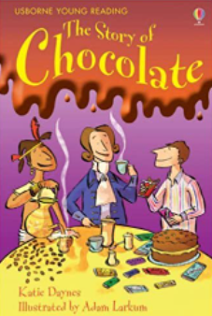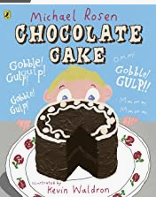 |  |  | Genres  Recount  Postcards/letters  Non-chronological report  Leaflets  Texts  Lighthouse Keepers Lunch (David & Ronda Armitage)  At the Beach (Roland Harvey)  Pirates of the Scurvy Sands (Jonny Duddle)  Poems about the seaside (Brian Moses)  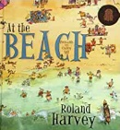  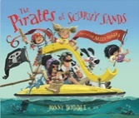  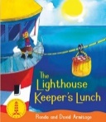  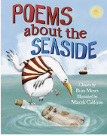
Maths | Domains  Place Value  Addition  Subtraction  2D Shape |  | Domains  Multiplication  Division  Statistics  3D Shape  Money |  |  | Domains  Fractions  Measurement:  Length and Height  Time  Mass, Capacity and Temperature  Geometry: Position and Direction
Science | Living things and their  Habitats  Living, dead, never lived  What is a habitat?  Interdependency and food chains  Animals including humans  What humans need to survive |  | Materials  Comparing  Suitability  Compare and use everyday materials | Plants  What do plants need and how do they grow?  -Plant diaries |  | Animals including humans  What things animals need to survive  Animals and their offspring  -ducklings
Art | Painting  Primary and secondary colours (hot and cold colours) | Collage  The Great Fire of London  Collect, sort and group materials  Fold, crumple, tear and overlap | Print  Look at Brazilian flag and others to show the varied use of colours and designs. Design their own flag.  Repeating patterns/overprinting | Textiles  Cut and shape fabric  Join materials using glue or a stitch  Apply decoration |  | Drawing  Vincent Van Gogh  Lines, shape, patterns and shapes  copying and free drawing | Sculpture  Malleable media/recycled, natural manmade materials  Seaside souvenir
D.T. | Construction  Tudor Houses  Apply knowledge of materials to make a structure stiffer/more stable |  | Food  Create a basic recipe  Use tools and techniques safely  Chocolate Bars  Evaluate  Describe what went well, make changes and suggest what can be improved |  |  | Textiles  Sewing- shape using a template, join using a running stitch, colour and decorate textiles  Materials  cutting, shaping and joining
Geography | Investigating places - London  GSF1 Use maps, atlases and basic geographical vocabulary  GSF 3 Recognise landmarks, human/physical features  LK2 Characteristics of the UK  HPG 1, 2, 3 |  | Investigating places -Brazil  GSF1 Use maps, atlases and basic geographical vocabulary  GSF 3 Recognise landmarks, human/physical features  LK1 Name and locate the worlds continents and oceans  PK 1, 2 Similarities and differences  HPG1 seasonal and weather patterns Bradford/Brazil |  |  | Investigating places - Seaside  GSF1 Use maps, atlases and basic geographical vocabulary  GSF 2 Use compass directions  GSF 3 Recognise landmarks, human/physical features  GSF 4 Simple fieldwork/observations  LK2 Characteristics of the UK  PK 2 Similarities and differences
History | Recall facts before living memory-The Great Fire of London, why did people act the way they did?  HE 1,2,3 OC 1,2,3,4  KU 1,2 HI1  CU 1,2,3,4,5 |  | Chocolate story-Find out about what life was like in the past using pictures, stories and artefacts (old chocolate bar wrappers)  HE 1,2,3 OC 1,2,3,4  KU 1,2 HI1  CU 1,3,4,5 |  |  | Holidays past and present  HE 1,2,3 OC 1,2,3,4  KU 1,2 HI1  CU 1,2,3,4,5
Computing | E-safety  Passwords  Computer Science  Understanding and planning commands  Media  Organise and communicate ideas, make improvements  Data handling  Represent information accurately, interpret data |  | Information literacy  Use search engines, recognise and interact with webpages  Media  Record, locate and review sounds, improve digital creations using music and/or sound  E-Safety  Understand own online presence  Computer Science  Use algorithms. Write, test and debug simple programmes  Data handling  Sort and answer questions |  |  | Computer science  Control devices and understand the wider picture of technology  Data handling  Use a flow chart to answer yes/no questions  Media  Create images and animations using a variety of applications  E-Safety  Keeping safe online  Information literacy  Use child friendly search engines
Spanish | Animals |  | In our Classroom |  |  | Out and About
PE | Hit, Catch, Run  Develop hitting skills  Practice bowling skills | Dance  Balance, choreograph and  Perform | Gymnastics  Perform basic actions and sequences.  Improve strength and flexibility | Run, Jump, Throw  Develop power, agility, coordination and balance.  Throw a variety of objects and negotiate obstacles |  | Send and Return  Play a variety of racket games such as tennis and badminton | Attack, Defend, Shoot  Play a variety of ball games using a range of skills and recall
PSHE | Being me in my world  Who am I and how do I fit? | Celebrating difference  Respect for similarity and difference. Anti-bullying and being unique | Dreams and Goals  Aspirations, how to achieve goals and understanding the emotions that go with this | Healthy Me  Being and keeping safe and healthy |  | Relationships  Building positive, healthy relationships | Changing Me  Coping positively with change
Music | Fire Fire Everywhere  The Great Fire of London | Ho Ho Ho  Christmas Music | Hands, Feet, Heart  World Music | I Wanna Play in A Band  Rock Music |  | Zoo Time  Keeping a beat | Friendship Song  Composition
RE | Can you tell what someone believes in by what they look like? |  | What is special to faith communities? |  |  | How does what believers do, show what they believe?

