

Year 2 Information Sheet

Summer 2022

**Reminders:**

PE is **Tuesday**. Children need to come to school in their uniform and will get changed into their PE kit.

Bookbags to be brought into school and returned home daily.

## **Year 2**

Teacher:

Rome: Mrs Hawkshaw

Budapest: Miss Clayton

Teaching Assistant:

Rome: Mrs Cunnett

Budapest: Ms Naylor



Fearnville Primary School

Fearnville Drive

Bradford

BD4 8DX

Tel: 01274 664661

**English**

This term we will be using the texts “The Lighthouse Keeper’s Lunch” by Ronda and David Armitage, “Poems about the Seaside” by Brian Moses and “At the Beach” by Roland Harvey. We will begin to consolidate our knowledge of the Year 2 learning objectives in readiness for Year 3. As with the Autumn and Spring term, each new book will start with a “hook day” where children can explore the classroom and practice their oracy skills to predict and explain what the text might be about. This unit of English will tie in nicely with our overarching theme of “The Seaside” where we will use our visit to the seaside as a writing stimulus. We will be writing our own seaside poetry and send postcards to our linking school, Byron Primary.

**Maths**

This term we will begin consolidating our knowledge of the Year 2 curriculum, ready for Year 3. This includes measurement, time, statistics, fractions and shape. We will continue to focus on the 4 operations; addition, subtraction, multiplication and division during our learning. Children will sit KS1 SATs during May. Please ensure your child attends school every day.

**Science**

In Science, our learning focus will be habitats and life cycles. We have recently hatched duck eggs to support our learning of life cycles.

**Theme**

Our theme this half term is “The Seaside”. We will learn about maps and the human and physical features of where we live and those at the seaside. We will consider what a trip to the seaside looked like in the 1900’s and compare that to today. We will also visit the seaside to support our learning.

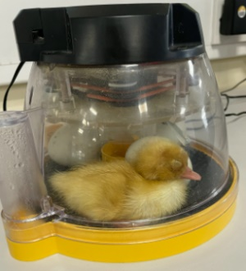

**Diary Dates**

School opens Wednesday 4th May and closes for this half term on Friday 27th May.   
School opens Monday 6th June and closes for summer on Thursday 21st July.

School closed for training day on Monday 11th July.