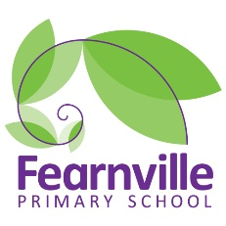
Long Term Plan
2022-2023

Year 4 Curriculum Overview
 | Autumn 1 | Autumn 2 | Spring 1 |  | Spring 2 | Summer 1 |  | Summer 2
Title | Egyptians |  | Rivers deep Mountains high |  |  | Vikings
Theme, hooks and visits | Egyptian day.  Leeds City Museum to visit Nesyamun |  | River and Cow and Calf rocks (Ilkley)  Malham cove (white cliffs) |  |  | Yorvik  Royal Armouries Viking zoom experience (possible Viking day)
Inspiring careers | Engineering/Archaeologist |  | Water engineer (Yorkshire water school visit) / cartographer |  |  | Museum curator/Carpenter
50 Fearnville Feats | Visit a Gurdwara |  | Grow own plant/ dress as a character/ litter picking /residential/ young voices / |  |  | Make a bird feeder/ naming bird in the wild
English | 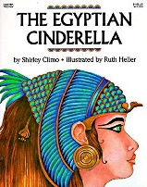  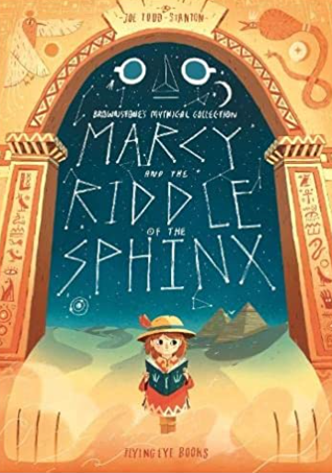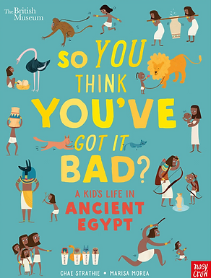  Texts  Egyptian Cinderella- Shirley Climo  Marcy and the riddle of the sphinx- Joe Todd Stanton  So you think you’ve got it bad? A kids life in Ancient Egypt - Chae Strathie & Marisa Morea  Genre  Narrative-Graphic novel style  Non-chronological reports  Instructional texts  Historical recount: diary |  | 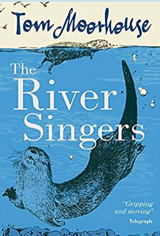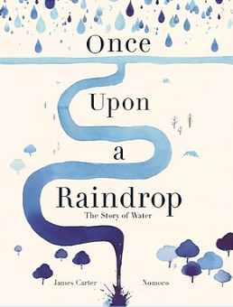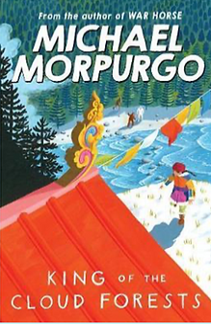  Texts  The River Singers-Tom Moorhouse  Once upon a raindrop-James Carter & Nomoco  King of the cloud forests- Michael Morpurgo  Genre  Narrative-Description  Poetry: Water  Explanation  Discussion-balanced argument |  |  | 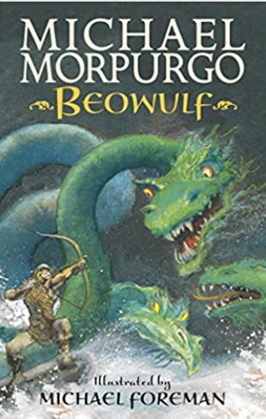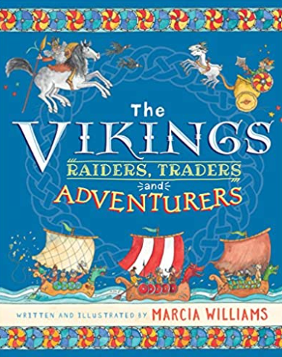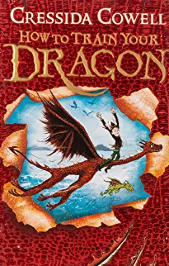  Texts  How to Train your Dragon-Cressida Cowell  Beowulf- Michael Morpurgo  The Vikings-Raiders, Traders and Adventurers-Marcia Williams  Genre  Narrative-Adventure  Playscript  Newspaper Report  Persuasive text (How to train your dragon)
Maths | Domains  Number: Place value.  Number: Addition and subtraction.  Measurement: Length and perimeter.  Number: Multiplication and division. |  | Domains  Number: Multiplication and division  Measurement: Area  Number: Fractions  Number: Decimals |  |  | Domains  Number: Fractions  Measurement: Money  Measurement: Time  Statistics: Graphs and charts  Geometry: shape, position and geometry
Science | Living things and their habitats | Animals including humans | States of matter  (Water Cycle) | Sound |  | Electricity | revision
Art | Drawing  D4 experiment with different grades of pencil to achieve varied tone | Sculpture-Papier Mache sarcophagus  3D3 use papier mache to create simple 3D effects.  3D5 create textures and patterns in malleable materials including clay. | Textiles & Collage -Use collage techniques to build a mountain landscape.  C1 experiment with a range of collage techniques such as tearing, overlapping and layering to create images and represent textures. |  |  | Painting & Printing  PR1 create printing blocks using relief or impressed method.  PR2 develop print techniques i.e. mono-printing, block printing, relief or impressed method.
D.T. | Food -Evaluate different foods and recreate  an Egyptian meal |  | Textiles- Sewing |  |  | Construction-  Design and make a Viking Longboat
Geography | Location Knowledge  LK 1/5  Place knowledge PK2  Human and physical geography HPG2  Geographical Skills and Fieldwork GSF1  Where was Ancient Egypt and why did the cities move with the Nile? |  | Location Knowledge  LK2/4  Place knowledge PK 1/2  Human and physical geography HPG1  Geographical Skills and Fieldwork GSF 2/3  How are mountains formed and what is life like in the mountains? What is the water cycle? What are the features of a river and where are some famous rivers? |  |  | Location Knowledge LK3  Place knowledge PK2  Human and physical geography HPG2  Geographical Skills and Fieldwork  GSF1/2  Why did the Vikings fight over England? Where did they live?
History | Historical enquiry  HE 1/2  Organisation and Communication OC1  Historical Interpretation HI1  Chronological Understanding CU 1/2/3  Knowledge and Understanding KU1/2/3  Who were the Ancient Egyptians? How did they live? |  | Historical enquiry  HE 1/2  Organisation and Communication OC1  Knowledge and Understanding KU1 |  |  | Historical enquiry  HE 1/2  Organisation and Communication OC1  Historical Interpretation HI1  Chronological Understanding CU 2/3  Knowledge and Understanding KU1/2/3  Who were the Vikings? How did they live?
Computing | Coding and Online Safety | Online Safety and Spreadsheets | Spreadsheets and writing for difference audiences | Logo and Animation |  | Effective Search and Hardware Investigators | Making Music
Spanish | Life in Spain (fruit and veg foods revision of Y1, Spanish songs and stories, Regions and history of Spain, where Spanish is spoken around the world, jobs revision of Y3 all about me, tourism revision of Y1 holidays, school in Spain revision Y2 in our classroom, Seasons Y1 revision of holidays) | Life in Spain (fruit and veg foods revision of Y1, Spanish songs and stories, Regions and history of Spain, where Spanish is spoken around the world, jobs revision of Y3 all about me, tourism revision of Y1 holidays, school in Spain revision Y2 in our classroom, Seasons Y1 revision of holidays) | Life in Spain (fruit and veg foods revision of Y1, Spanish songs and stories, Regions and history of Spain, where Spanish is spoken around the world, jobs revision of Y3 all about me, tourism revision of Y1 holidays, school in Spain revision Y2 in our classroom, Seasons Y1 revision of holidays) | Life in Spain (fruit and veg foods revision of Y1, Spanish songs and stories, Regions and history of Spain, where Spanish is spoken around the world, jobs revision of Y3 all about me, tourism revision of Y1 holidays, school in Spain revision Y2 in our classroom, Seasons Y1 revision of holidays) |  | Story unit – repetitive question focus – bilingual book ‘Where is my little crocodile?’ (recap animals, directions, size) | Review of previous learning from Aut/Spring Last week Sum 2 Spanish festival focus: San Fermin
PE | Games – hockey | Dance | Ball Games – team work, skills needed, tactics | Gymnastics Invasion |  | Athletics | Ball Games – tennis
PSHE | Zones of Regulation.  Jigsaw: Being me in my world | Jigsaw: Celebrating differences | Jigsaw: Dreams and Goals | Jigsaw: Healthy Me |  | Jigsaw: Relationships | Jigsaw: Changing me.
Music | Charanga: Mama Mia | Charanga: Glockenspiel | Charanga : Stop: A rap unit about bullying. | Charanga: Lean on me: using Bill Withers to learn about the different dimensions of music. |  | BBC School Radio: Viking saga songs. | Charanga: Blackbird
RE | What do different people believe about God?  Islam, Christianity, Hinduism  -Different religions sharing common features expressed in various ways  -Details of significant stories |  | How do faith communities demonstrate what is sacred?  Islam, Christianity, Hinduism  -Special and significant things in their lives  -Understanding of values and attitudes in teaching and beliefs |  |  | How do believers use symbolism to show their beliefs?  Islam, Christianity, Hinduism  -Details of significant stories  -Connections between identity and experience between others

