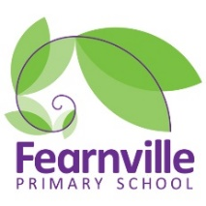
Long Term Plan
2022-2023

Year 5 Curriculum Overview
 | Autumn 1 | Autumn 2 | Spring 1 |  | Spring 2 | Summer 1 |  | Summer 2
Title | Lost in Space |  | It’s all Greek to me! |  |  | Coming to England
Theme Hooks & Visits | Trip to Science/Media Museum: Planets and Moon Workshop  Wonder Dome- West Yorkshire mobile planetarium  Schools workshops.com-Spaceman |  | Ancient Greek Day  Careers Session – IntoUniversity  Schools workshops.com-Ancient Greece |  |  | Engineering Day - IntoUniversity  Overnight Liverpool Trip  https://www.nstgroup.co.uk/liverpool-primary-school-trips
Inspiring Careers | Scientist  Astronomer |  | Travel agent  Archaeologist |  |  | Royal Navy  Journalist
50 Fantastic Feats | Reading a map – Orienteering  Watch a pantomime  Learn to swim |  | Learning to plan an instrument  Learn to swim  Meet an author |  |  | Going to the theatre  Going to a sporting event – Triathlon  Go on a boat  Learn to swim  Countryside Day - Harrogate
English | Texts  Hidden Figures-Margret Lee Shetterly  The Jamie Drake Equation-Christopher Edge  George’s secret key to the universe- Lucy & Steven Hawking  Genres  Instructional writing  Newspaper Article  Persuasive Letter  Character Description  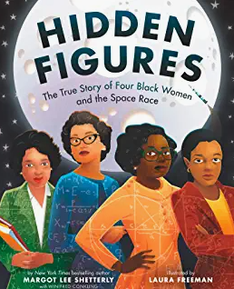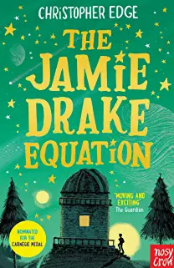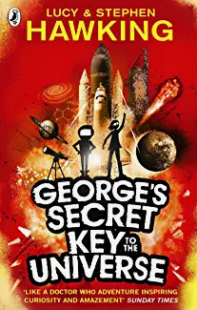 |  | Texts  Beast of Olympus: Beast Keeper- Lucy Coates  Percy Jackson and the Lightning Thief-Rick Riordan  Greek Myths-Marcia Williams  Genre  Narrative  Brochure  Fact files  Play script  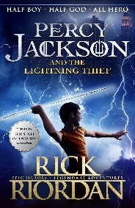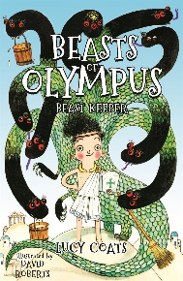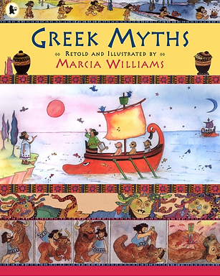 |  |  | Texts  Coming to England-Floella Benjamin  The place for me (Windrush) KN Chimbiri  Journeys- Dan Lyndon-Cohen  Genre  Descriptive Writing  Poetry  Biography  Diary Entry  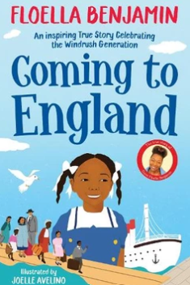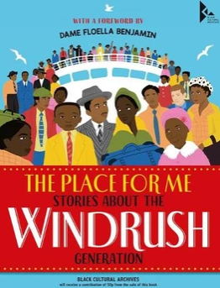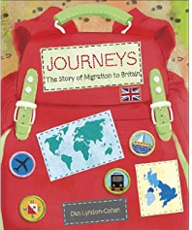
Maths | Domains  Number: Place value  Number: Addition and subtraction  Statistics  Number: Multiplication and division  Measurement: Perimeter and Area |  | Domains  Number: Multiplication and division  Fractions  Number and decimals and percentages |  |  | Domains  Number: decimals  Geometry- properties of shapes  Geometry: Position and direction  Measurement: Converting units  Measurement: Volume
Science | Earth and Space | Forces& Magnets | Properties and Changes of Materials | Animals, including humans (PSHE links to puberty) |  | Living things and their habitats
Art | Painting & Printing  Understand how shadows are created when drawing  To learn what is Value as an element of Art.  To learn how to create an illusion of spherical object in Art by using shadows |  | Drawing  Use sketch books to record their observations and review their ideas.  Demonstrate how to improve their art and design | Sculpture-Greek Vases  Use sketch books to record their observations and review their ideas.  Demonstrate how to improve their art and design. |  | Textiles-Cushion  Use sketch books to record their observations and review their ideas.  Demonstrate how to improve their work.
D.T. | Rockets – linked to science  Use research and develop design criteria to inform the design of innovative, functional, appealing products that are fit for purpose  Generate, develop, model, and communicate their ideas through discussion, diagrams (cross-sections and exploded) and prototypes.  Select from and use a wider range of tools and equipment to perform practical tasks.  Select from and use a wider range of materials and components based on their functional properties and aesthetic qualities.  Consider the views of others to improve their work. |  | Food- Evaluate different foods and recreate  a Greek meal  Talk about and use the principles of a healthy and varied diet.  Prepare dish using further techniques.  Talk about seasonality of food. |  |  | Textiles-Cushion  Use research and develop design criteria to inform the design of innovative, functional, appealing products that are fit for purpose  Generate, develop, model, and communicate their ideas through discussion, diagrams (cross-sections and exploded) and prototypes.  Select from and use a wider range of tools and equipment to perform practical tasks.  Select from and use a wider range of materials and components based on their functional properties and aesthetic qualities.  Consider the views of others to improve their work.
Geography | Location Knowledge LK 1/3  Place knowledge PK1/2  Geographical Skills and Fieldwork  GSF 2/3/5  Countries involved in the space race-Europe, North America, Russia |  | Location Knowledge LK 1/2  Place knowledge PK1/2  Human and physical geography HPG1/2  Geographical Skills and Fieldwork  GSF 1/4/5  Investigating places-Greece |  |  | Location Knowledge LK 1  Place knowledge PK2  Human and physical geography HPG2/3/4  Geographical Skills and Fieldwork  GSF 1/4/5  Describe geographical diversity across the world
History | Historical enquiry  HE 1/2/3  Organisation and Communication OC 1  Historical Interpretation HI 1/2/3  Chronological Understanding CU 2/3  Knowledge and Understanding KU 1/4  History of Space travel |  | Historical enquiry  HE 1/2  Organisation and Communication OC 1  Chronological Understanding CU 1/2/3  Knowledge and Understanding KU 3/4/5  Ancient Greece |  |  | Historical enquiry  HE 1/2/3  Organisation and Communication OC 2  Historical Interpretation HI 1/2/3  Chronological Understanding CU  Knowledge and Understanding KU 1/2/4  Migration
Computing | Computer Science, Esafety, Information Literacy | Computer Science, Esafety, Information Literacy | Computer Science, Esafety | Computer Science, Esafety, Data Handing, Media |  | Computer Science, Information Literacy, Esafety, Data Handing, Media | Computer Science, Esafety, Media
Spanish | Food |  | Days and Seasons |  |  | Family
PE | Athletics | Dance | Gymnastic | Junior Jam: Football |  | Junior Jam: Cricket | Junior Jam
PSHE | Zones of Regulations  Being Me in My world | Celebrating difference | Dreams and Goals | Healthy Me |  | Relationships | Changing Me
Music | Charanga: Learn and Perform Living on a Prayer | Christmas Performance | Charanga: Learn and Perform Make you feel My love | Junior Jam: Garage Band |  | Junior Jam: Podcast | Junior Jam:
RE | Why there different beliefs about God?  Christianity, Islam and Sikhism |  | Why are certain people, places and time sacred? Christianity, Islam and Sikhism |  |  | Why do people need to express their beliefs? Christianity, Islam and Sikhism

