

Year 6 Information Sheet

Autumn 2021



**Reminders:**

**Children must wear school uniform with black school shoes.**

## **Year 6**

Teachers: Mrs Qadoos, Mrs Khan and Mrs Kauser

Teaching Assistants: Miss Qaddus, Mrs Maclean, Mrs Suthers

Fearnville Primary School

Fearnville Drive

Bradford

BD4 8DX

Tel: 01274 664661

**English**

This term we will be writing a range of texts including narratives, non-chronological reports, diaries and newspaper reports. We will begin by innovating the story of Aladdin and look at various stories from the Arabian Nights in more detail during our reading sessions





**Maths**

This half term we will:

* Recognise and describe number patterns.
* Recognise negative numbers in contexts such as temperature.
* Partition and round whole numbers to the nearest 10, 100 and 1000. Round decimals to the nearest whole number and the nearest tenth.
* Multiply and divide numbers by 10, 100 and 1000.
* Use multiplication facts to 10 x 10 to find related multiplication and division facts, including decimals.
* Develop more efficient written methods for +, - , x and :- of whole numbers and decimals.

**Theme**

Our theme this term is called ‘The house of wisdom.’ We will be studying the ancient Islamic civilisation and investigate the statement,

‘Modern civilisation owe a lot to the early Islamic civilisation. True or False?’

**Science**

In Science, we will be taking an enquiry-based approach to the study of light and electricity. We will conduct a range of investigations over the term, to gain an in-depth study, building upon children’s prior knowledge.

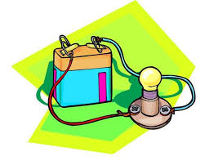

**Diary Dates**

P.E: Wednesday- Children to come into school wearing their P.E kits.

Online safety session: 21.09.21

School Photo day: 07.10.21

Into University week beginning: 01.11.21