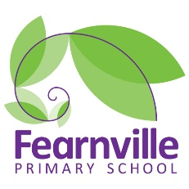
Long Term Plan
2022-2023

Year 6 Curriculum Overview
 | Autumn 1 | Autumn 2 | Spring 1 |  |  |  | Spring 2 | Summer 1 |  | Summer 2
 | Welcome to Yorkshire! |  | Rainforest |  |  |  |  | Britain at War
Theme Hooks and visits | Team building residential  Worth Valley railway  Trip to Haworth- Bronte Parsonage, workshops  Into University project |  | Animal workshop in school visit  Residential (TBC)  Places of worship- Sikh Temple |  |  |  |  | Armley Mills  Eden Camp  Evacuee day in school  Murton Park
Inspiring Careers | Rail engineer  Museum curator  Archivist  Tour guide |  |  | Conservationist  Fundraiser  Animal/Zoo keeper |  |  |  | Armed forces officer  Air force pilot  Nurse
Fearnville  50 Feats | Watch a pantomime  Go on a train |  |  | Dress up as a character  Complete a residential  Packing a suitcase |  |  |  | Party with your friends  Take part in a performance  Visit a Synagogue
English | Texts:  The Brontes- Anna Doherty  Jane Eyre- Stephanie Baudet  Railway Children- E Nesbit  Genre:  Narrative- story  Narrative- setting descriptions  Autobiography of Brontes  Explanation text- Tourist brochure  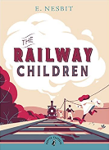  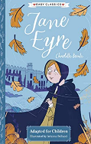  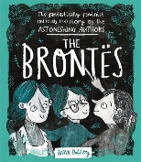 |  | Texts:  The Explorer-Kathrine Runndell  Rainforests-DK Eyewonder  Journey to the river sea-Eva Ibbotson  Genre:  Poetry- Rainforest  Persuasive letters- deforestation  Non- chronological report- The Amazon  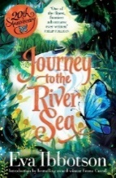  Playscript- Journey to the river sea  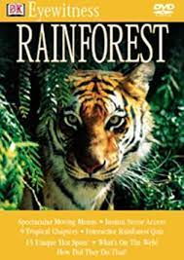  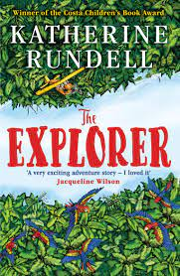 |  |  |  |  | Texts:  Letters from the lighthouse-Emma Carroll  Goodnight Mister Tom- Michelle Magorian  Rose Blanche- Ian McEwan  Genre:  News report- The blitz  Letters- Evacuee  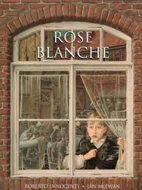  Balanced argument- Should children be evacuated  Diary  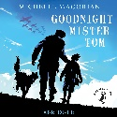
Maths | Number  Four operations  Fractions  Decimals |  | Review SATSs papers  Recap Number, the four operations  Statistics  Geometry  Percentages  measurement,  perimeter and area |  |  |  |  | Algebra  Ratio  Statistics  Geometry  Investigations  Fractions/number
Science | Electricity | Evolution and inheritance | Animals including humans |  |  |  |  | Living things and their habitats | Light
Art | Textiles & Collage- landscapes of moorlands and Haworth using different materials such as charcoal etc to create different effects and shade.  Create their own logo for Seabrook crisps – create a collage of their ideas. |  | Sculpture- using recycled, natural and manmade materials |  | Drawing – observational drawing of the landscape using pencil |  |  | Painting & Printing – Use different tones and shades, use different brushes to create different effects.
D.T. | Food – develop a modern day ‘Yorkshire’ recipe book  Celebrate the diversity of Yorkshire  Create their flavour, packet and logo for Seabrook crisps |  | Textiles- Create a rainforest animal by sewing – using their fine motor skills. Using different colours. |  |  |  |  | Construction- Air raid shelter made out of appropriate materials – children need to ask questions e.g. is it waterproof? Is it structurally sound etc.
Geography | Location Knowledge LK 2  Place knowledge PK1/2  Geographical Skills and Fieldwork  GSF 1/2/3/5  Comparing Yorkshire |  | Location Knowledge LK 1/3  Place knowledge PK1  Human and physical geography HPG1/2/3/4  Geographical Skills and Fieldwork  GSF 1/4  The rainforest |  |  |  |  | Location Knowledge LK 1/2/3  Place knowledge PK2  Human and physical geography HPG 2  Geographical Skills and Fieldwork  GSF 1/4
History | Historical enquiry  HE 1/3  Organisation and Communication OC 1  Historical Interpretation HI 2/3  Chronological Understanding CU 2/3  Knowledge and Understanding KU 1/3/4/5  Life for the Bronte sisters in Victorian England |  | Historical enquiry  HE 3  Organisation and Communication OC 2  Historical Interpretation HI 1/2/3  Knowledge and Understanding KU 1/2  The disappearing rainforest |  |  |  |  | Historical enquiry  HE 1/2/3  Organisation and Communication OC 2  Historical Interpretation HI 1/2/3  Chronological Understanding CU 2/3  Knowledge and Understanding KU 1/2/3/4/5  Britain at War
Computing | - Coding-CS27  - Data handling-DH20  - Media-M30  - Online Safety-ES23  - Information literacy- IL17 | - Coding-CS27  - Data handling-DH21  - Media-M31  - Online Safety-ES24 | - Coding-CS28  - Data handling-DH22  - Media-M32  - Online Safety-ES24  - Information literacy-IL18 |  |  | - Coding-CS28  - Data handling-DH23  - Online Safety-ES25  - Information literacy-IL19 |  | - Coding-CS29  - Online Safety-ES25 | - Coding-CS29  - Data handling-DH24  - Media-M33  - Online Safety-ES26
Spanish | Visiting places in a town |  | Visiting places in a town |  |  |  |  | Story unit – Unit of work on Gazpacho for Nacho by Tracey Kyle bilingual book (recap food, family, instructions) | Review of previous learning from Aut/Spring  Last week  Spanish festival focus: Esta major de gracia festival
PE | Athletics | Dance | Gymnastics |  | Rounders |  |  | Orienteering | Tag Rugby
PSHE | Zones of regulation  Being Me in My World | Celebrating Differences | Dreams and Goals |  | Healthy Me |  |  | Relationships | Changing Me
Music | Charanga  Unit: Happy  Style: Pop/Motown | Charanga  Unit: Classroom Jazz 2  Style: Jazz, Latin, Blues | Charanga  Unit: Benjamin Britten- A new Year Carol  Style: Benjamin Britten (western classical Music), Gospel, Bhangara |  | Charanga  Unit: You’ve Got a friend  Style: The music of Carole King |  |  | Charanga  Unit: Music and Me  Style: Contemporary, music and identity | Charanga  Unit: Composition  +  Music End of Year production
RE | Why are there different beliefs about God? (Beliefs and authority) |  | Why are certain people, times and places sacred? (Worship and spirituality) |  |  |  |  | Why do people need to express their beliefs?  (Values and society)

