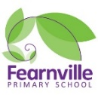

Spring 2023

Year 6 Information Sheet



## **Year 6**

Teacher: Miss Knowles & Mr Rajan

Teaching Assistant: Ms Maclean & Mrs Brooks

**Reminders:** ● Please ensure your child wears their school uniform every day and brings their PE kit on the PE day. ● Reading books and Records should come to school every day. Please update the reading record, every time you read with your child ● Please make sure your child doesn’t bring any unnecessary items to school. Fidget toys are not required in school.

Fearnville Primary School

Fearnville Drive

Bradford

BD4 8DX

Tel: 01274 664661

**English**

This term we will be writing a range of texts based on Eva Ibbotson’s book Journey to the river sea, Kathrine Runndell’s The Explorer and DK Eyewonder’s Rainforests

Our reading will link to our topic, which is based on the Amazon Rainforest.

The genre we will be focusing this half term are Dialogue, Non-Chronological Report, Persuasive letter and Poetry.

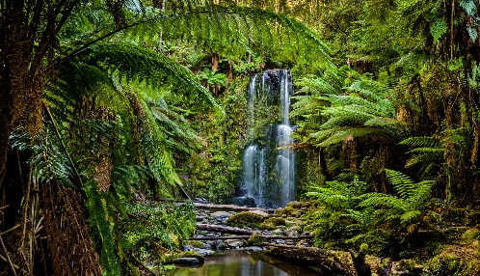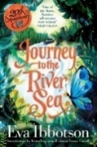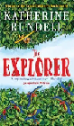

**Science**

In Science, we will be learning how human circulatory system works and describe the functions of its different parts. We will explore what entails a healthy lifestyle and how diet and exercise impacts this. We will be also looking at what happens to the food after we eat it and how the nutrients are transported around our body.

**Diary Dates**

Trip to Tropical World - TBA

Trip to Sikh Temple - TBA

**Theme**

Our topic this term is called ‘Rainforests.’

We will be studying the rainforest and investigate the statement, ‘The Rainforest makes no difference to us. True or False?’

**Maths**

This half term we will:

* Look at Fractions, both multiplying and dividing and finding fractions of an amount
* Learning about the concept of Ratios and solve problems based on Ratios.
* Understand Algebra and explore how Algebra can be utilised to solve tricky mathematical problems with ease.