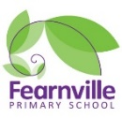

Spring 2021

Year 6 Information Sheet



**Reminders:**

Online learning is now compulsory. Please ensure children are logging in everyday to access their learning. Further information on remote learning is available on the school website.

## **Year 6**

Teacher: Miss Kauser & Miss Qadoos

Teaching Assistant: Ms Qaddus & Ms Maclean

Intervention Teacher: Mrs Rashid

Fearnville Primary School

Fearnville Drive

Bradford

BD4 8DX

Tel: 01274 664661

**English**

This term we will be writing a range of texts based on Michael Murpurgo’s book ‘The Giant’s Necklace.’ The genres we will be focusing on are: narratives, diary entry, letter and a brochure. Our reading will link to our topic, which is based on the rainforest.



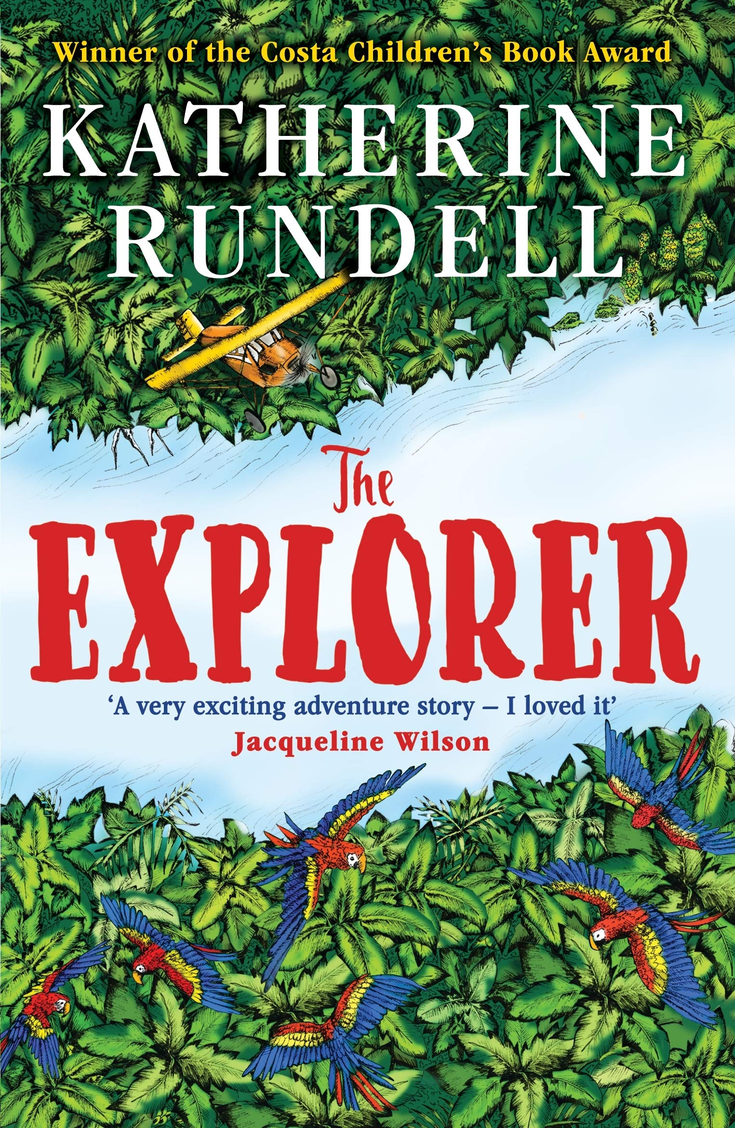

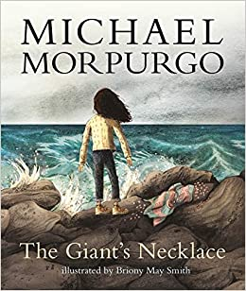

**Maths**

This half term we will:

* Look at number facts; Prime numbers, square numbers, factors and multiples
* Time: Learn to read time, 24 hours clock and revisit roman numerals
* Shape: naming and identifying properties of 2d and 3d shapes, vertices, working out the area and circumference of shapes, measure and compare missing lengths.

**Topic**

Our topic this term is called ‘Globetrotters.’

We will be studying the rainforest and investigate the statement, ‘The Rainforest makes no difference to us. True or False?’

**Science**

In Science, we will be learning about living things and their habitats. The children will be able to describe how living things are classified into broad groups according to common observable characteristics and based on similarities and differences, including microorganisms, plants & animals. They will also give reasons for classifying plants and animals based on specific characteristics.

**Diary Dates**