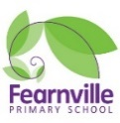

Year 6 Information Sheet

Summer 2022

**Reminders:**

P.E is twice a week:

Wednesday PM for both classes

Friday **AM**- Berlin

Friday **PM-** London

P.E kits need to be brought into school- White shirt, black bottoms and black shoes.

## **Year 6**

Teachers: Mrs Qadoos, Mrs Khan and Mrs Brooke

Teaching Assistant:

Miss Qaddus, Mrs McClean



Fearnville Primary School

Fearnville Drive

Bradford

BD4 8DX

Tel: 01274 664661

**English**

This term in English we will be focusing on the novel *The Giant’s necklace* by Michael Morpurgo and *Boy 87*. We will be writing a:

* Diary entry
* Cornwall brochures
* Writing a letter
* Narratives based on the animation ‘The Piano’
* Narrative on ‘Boy 87’

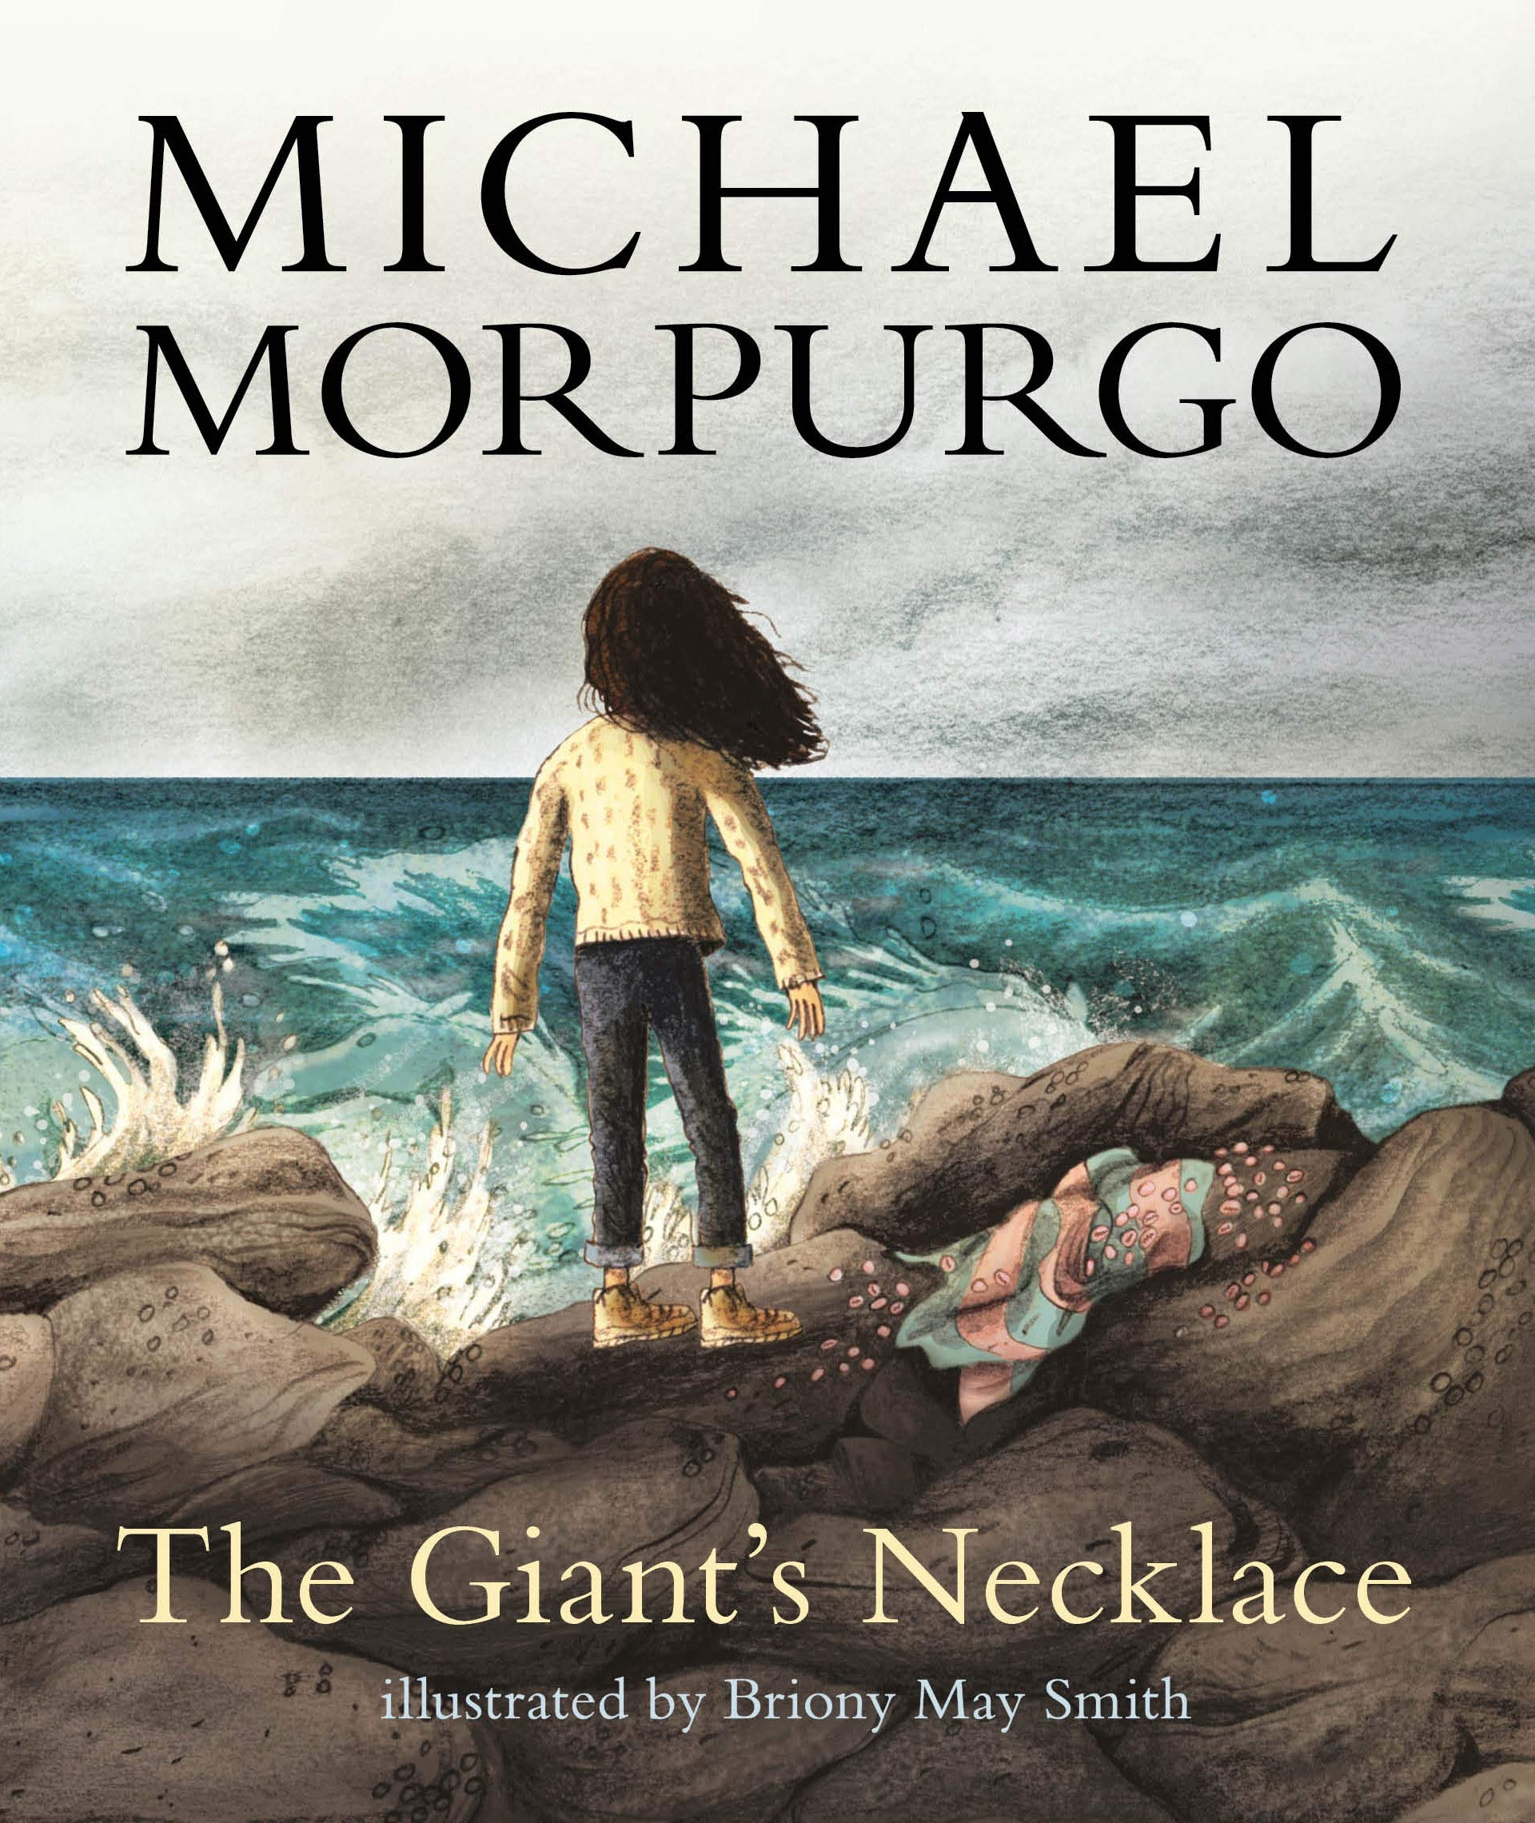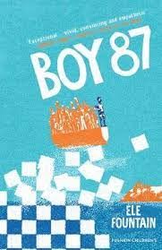

**Maths**

In maths we will be looking at ratio, properties of shape and statistics (graphs, pie charts and line graphs). Children will also need to consolidate previous learning by continuing to practise their timetables, with their division facts, as well as their four operations. (addition, subtraction, multiplication and division).

**Theme**

This term our theme is **“World War 2”**

Our enquiry question is:

**‘Has WW2 had an impact on us today?’**

Each lesson we will be building upon our knowledge of the war and work towards developing our opinions linked to our over-arching question.

**Science**

Our science this term is:

**‘Evolution and inheritance’**

We will be looking at the enquiry question:

‘What impact have Charles Darwin and Mary Anning had on science today?’

We will also be investigating fossils and learning more about ‘the Big Bang theory’

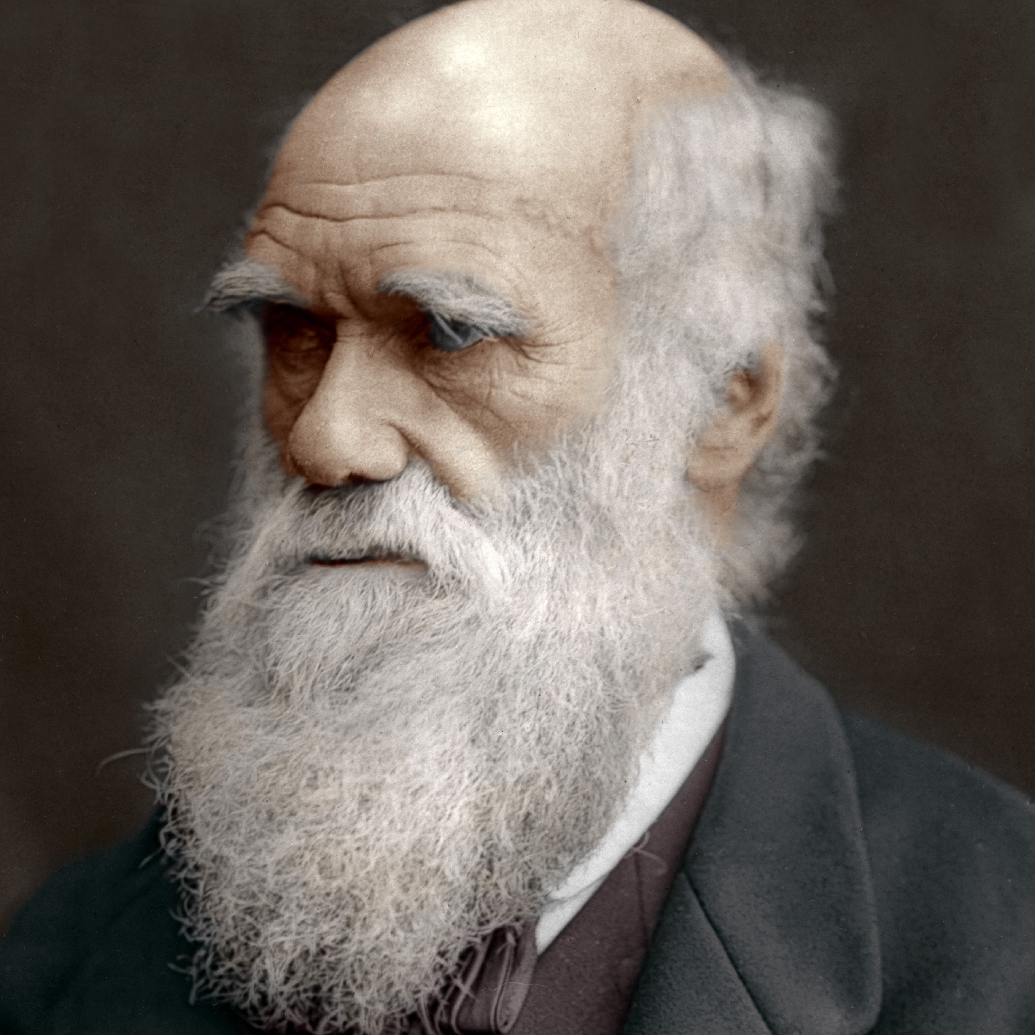 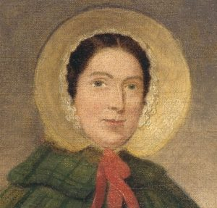



**Diary Dates**

* Parents SATS meeting: Wednesday 4th May 2022
* Eid parties: Wednesday 4th May 2022
* National Media Museum- Berlin: 24th May 2022 and London 27th May 2022
* SATS Week beginning: Monday 9th May 2022