

Year 6 Information Sheet

Summer 2021



**English**

This term we will be writing a range of texts based on Michael Murpurgo’s book ‘The Giant’s Necklace.’ The genres we will be focusing on are: narratives, diary entry, letter and a brochure. Our reading will link to our topic, which is based on the World War 2.

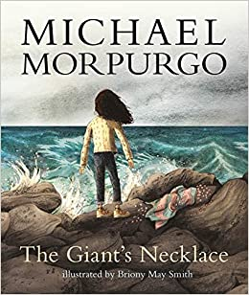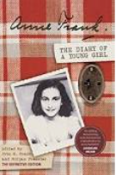

Fearnville Primary School

Fearnville Drive

Bradford

BD4 8DX

Tel: 01274 664661

## **Year 6**

Teacher: Miss Kauser & Miss Qadoos

Teaching Assistant: Ms Qaddus & Ms Maclean

Intervention Teacher: Mrs Rashid

**Reminders:**

Remember to read at home 3x every week and record this in your reading record as they will get a raffle ticket each week to go in the prize draw.

Spellings to be learnt at home

Practice times table on TT Rock Star and begin using Numbots.

**Diary Dates-** PE every Wednesday afternoon

Monday 3rd May – May Day - School Close Friday 14th May – Training Day – School Closed

Monday 31st May – Monday 6th June – Half Term – School Closed

Thursday 23rd July – School Closed for summer

**Science**

In Science, we will be learning about Evolution and Inheritance.

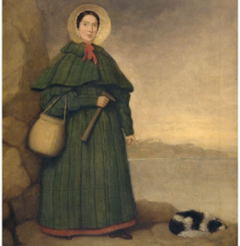 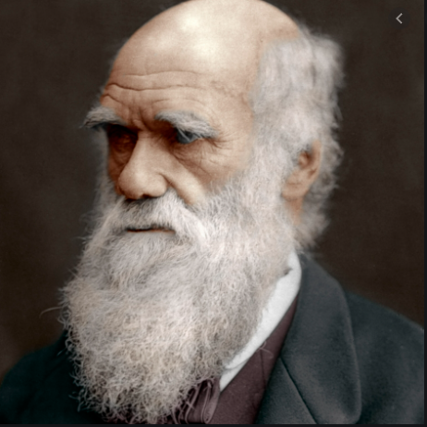

The children will begin investigating the statement, ‘What impact have Charles Darwin and Mary Anning had on science today?’

**Theme**

Our topic this term is called

‘World War 2.’

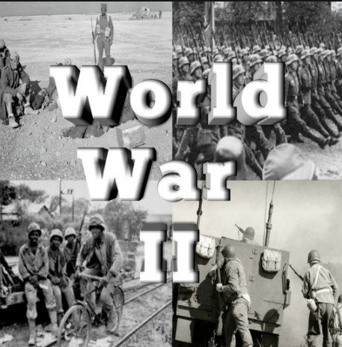

We will be studying World War 2 and investigate the statement, ‘When and why did the war begin and how did the war end?’

**Maths**

This half term we will:

* Look at Geometry; naming and identifying properties of 2d and 3d shapes, vertices, working out the area and circumference of shapes, measure and compare missing lengths.
* Algebra; Find a rule – one step, find a rule – two step, forming expressions, substitution formulae, solve simple one-step equations, solve two-step equations and find pairs of values enumerate possibilities
* Ratio; Using ratio language, ratio and fractions, introducing the ratio symbol, calculating ratio, using scale factors, calculating scale factors and ratio and proportion problems.