Purple mash
Does it work on phone and tablets?
Yes it does but on phones in particular the layout changes so you can’t see the options (eg the 2Dos) at the top you need to click the three white lines on the black background.
Does everything work on tablets?
All new software developments are always tablet friendly and Purple Mash are working to convert older software titles into a tablet friendly format where possible. The vast majority of content does work on tablets. Once you are logged in, Purple Mash will detect that you are using a mobile device and only display compatible tools.
How do 2Dos work?
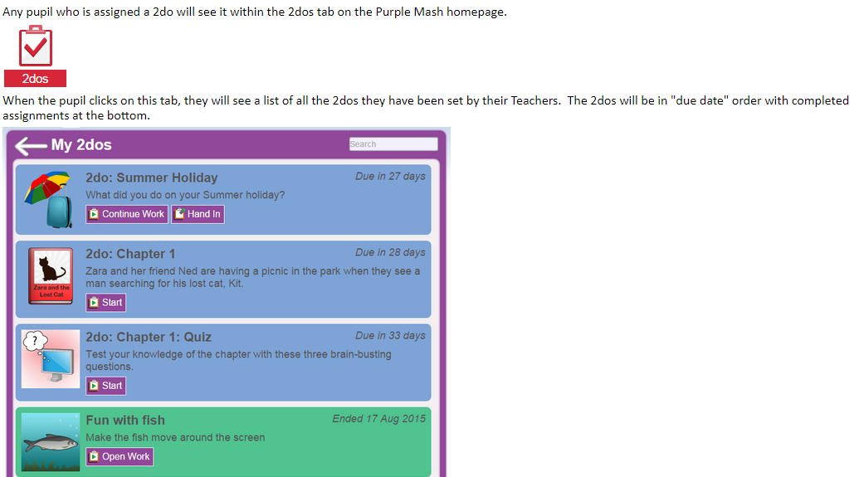
What about feedback to the child?
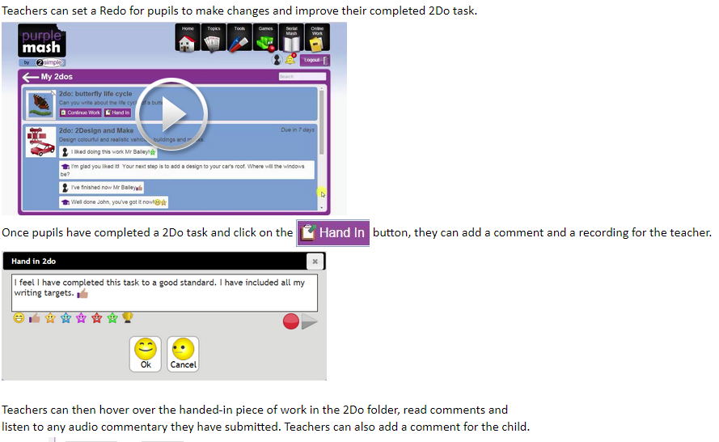
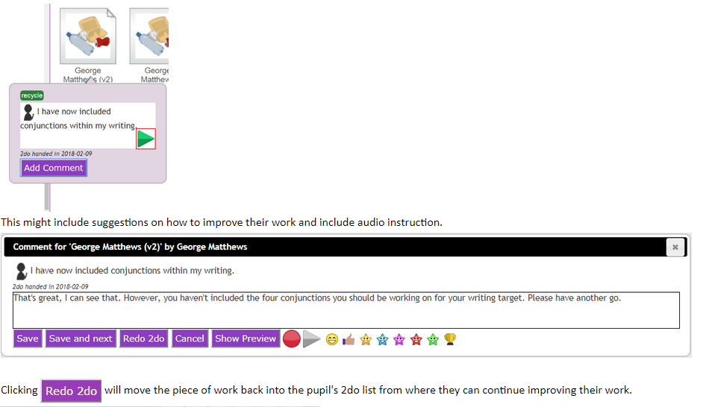
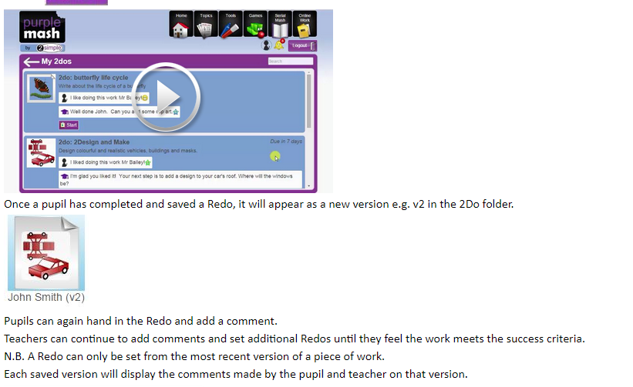
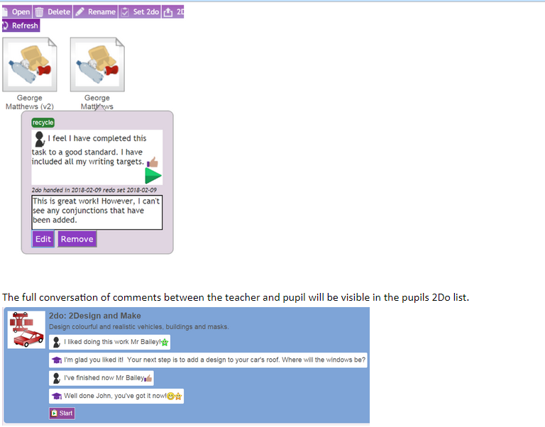
Where can I find more information on 2Dos?
https://static.purplemash.com/manuals/2dos/index.html

