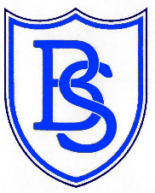

This January marked the National Autistic Society’s 60th birthday. To celebrate this, as a school we are going to challenge you to complete 6 activities, for 60 seconds each, over 6 days and get your friends and family to sponsor you. Your Class Teacher will give you time each day in class from 28th March until 1st April to complete these. Then on 2nd April, make sure you complete them again at home. All the sponsor money will go to supporting children with Autism at the Federation of Boldmere Schools.
Your challenge for 6 days is:
60 seconds of STAR JUMPS
60 seconds of RUNNING ON THE SPOT
60 seconds of STILLNESS/MEDITATION
60 seconds of JUMPING ON THE SPOT
60 seconds of HOPPING
60 seconds of STILLNESS/MEDITATION

Name ……………………………… Class…………………………………..
Name of sponsor | Money per day | or Total contribution | Amount collected

