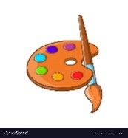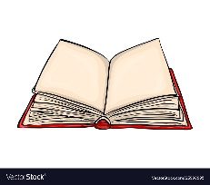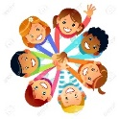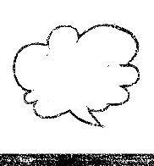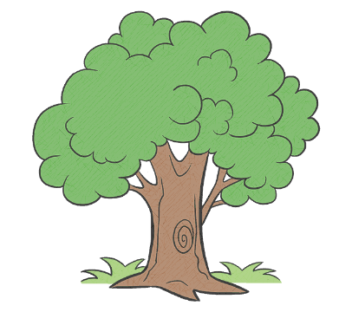

Understanding the World

Children are learning to:   
Understand that some places are special to members of their community.  
Recognise that people have different beliefs and celebrate special times in different ways.  
Recognise some similarities and differences between life in this country and life in other.  
Explore the natural world around them.   
Comment on images of familiar situations in the past.

Mathematics

Children are learning to:

Explore numbers.

Recognise, count, form and order numbers to 5,10,20.  
To 20 and beyond – Building numbers beyond 10, counting patterns beyond 10. Spatial reasoning, match, rotate and manipulate.   
First, then, now – adding more, taking away. Spatial reasoning – compose and decompose.

Expressive Arts and Design  
Children are learning to:

Explore and engage in music making and dance, performing solo or in groups.  
Develop storylines in their pretend play.  
Listen attentively, move to and talk about music, expressing their feelings and responses.  
Explore, use and refine a variety of artistic effects to express their ideas and feelings.  
Return to and build on their previous learning, refining ideas and developing their ability to  
represent them.  
Create collaboratively, sharing ideas, resources and skills.

Literacy   
Children are learning to:

Recognise, write and match the different letter sounds.

Form the letters of their own names.  
Read simple phrases and sentences made up of words with known letter–sound correspondences and, where necessary, a few exception words.  
Blend sounds into words, so that they can read short words made up of known letter-sound correspondences.  
Form lower-case and capital letters correctly.  
Spell words by identifying the sounds and then writing the sound with letter/s.   
Read a few common exception words matched to the school’s phonic programme.  
Read simple phrases and sentences made up of words with known letter–sound correspondences and, where necessary, a few exception words  
Write short sentences with words with known letter-sound correspondences using a capital letter and full stop.

Personal, Social and Emotional Development  
Children are learning to:

Continue to follow rules, understanding why they are important.

Select and use activities and resources with help.

Show confidence in asking adults for help.

Play with one or more other children, extending and elaborating play ideas.

Share or take turns with others with adult guidance and understand ‘yours’ and ‘mine’.

Identify and moderate their own feelings socially and emotionally.   
Show resilience and perseverance in the face of challenge.  
Know, identify and talk about the different factors that support their overall health and wellbeing; physical activity, healthy eating, tooth brushing, sensible amounts of ‘screen time’, having a good sleep routine, being a safe pedestrian.

Communication and Language  
Children are learning to:

Communicate through Makaton signs and visual aids, as well as developing spoken language.  
Ask questions to find out more and to check they understand what has been said to them.   
Engage in non-fiction books.  
Use new vocabulary in different contexts.  
Retell a story, once they have developed a deep familiarity with the text, some as exact repetition and in their own words.   
Listen to and learn rhymes, poems and songs.

Giraffes Curriculum Overview

Summer 1

Down on the Farm

Our value this half term is Co-operation!

Physical Development  
Children are learning to:  
Revise and refine the fundamental movement skills they have already acquired: rolling, crawling, walking, jumping, running, hopping, skipping, climbing.

Develop their small motor skills so that they can use a range of tools competently, safely and confidently.

Confidently and safely use a range of large and small apparatus indoors and outside. (Tennis skills)

Develop the foundations of a handwriting style which is fast, accurate and efficient.