Maths

Money

Count money – pence

Select money

Compare money

Make the same amount in different ways

Find the total

Find the difference

Find change

Solving money word problems

Two-step money problems

Multiplication and Division

Recognise and make equal groups

Add equal groups

Multiplication sentences using the x symbol

Multiplication sentences from pictures

Use arrays

Make arrays

Make doubles

2, 5 and 10 times tables.

Make equal groups – sharing, grouping

Divide by 2, 5 and 10

Odd and even numbers

TT Rockstars-Time tables

English

Reading

Fiction: Retelling familiar stories (Meerkat Mail, The Emperor’s Egg)

Non-fiction: The Emperor’s Egg

Guided reading: developing understanding, comprehension, fluency and prediction skills.

Develop pleasure in reading, motivation to read, vocabulary and understanding by listening to, discussing and expressing views about a wide range of stories.

Writing

Postcards – Writing from different locations in different continents.

Descriptive language – describing settings and characters. Use of adjectives and using expanded noun phrases.

Non-fiction: Instructions—including imperative verbs

Punctuation

Consolidate full stops, capital letters, question marks and exclamation marks.

Use of apostrophe for contractions

Grammar

Co-ordination: using or, and, but

Sub-ordination: using when, if, that, because.

Handwriting –ensure letters are consistent in sizes.

LK Curriculum Overview

Spring 1 – Around the World



Geography

Revisit naming and locating the world's seven continents and five oceans.

Know the location of hot and cold areas of the world in relation to the Equator and the North and South Poles – compare different continents and weather.

To devise simple maps and use and construct basic symbols in a key. Use locational and directional language to describe the location of features and routes on a map.

To use fieldwork and observational skills to study the geography of my school and its grounds.

Identify the key human and physical features of its surrounding environment.

.

PSHE – Dreams and goals

Stay motivated when doing something challenging.

Keep trying even when it is difficult – persevering.

Work well with a partner or in a group and cooperate to create an end product.

Have a positive attitude.

Help others to achieve their goals.

Choosing a realistic goal and think about how to achieve it.

Work hard to achieve their own dreams and goals.

Value: Honesty

PE WBA-Ryan

Ball skills. Master basic movements including running, jumping, throwing, and catching, as well as developing balance, agility, and co-ordination, and begin to apply these in a range of activities. Participate in team games, developing simple tactics for attacking and defending

Daily Morning Walk

The aim of the daily morning walk is to improve

Physical social and emotional and mental health and we being. Children can walk or jog for 15 minutes a day.

History

Know facts about significant people beyond living memory –Robert Falcon-Scott discovering Antarctica, Christopher Columbus.

Begin to order events in a historical story using dates.

Understand some of the ways in which we find out about the past and identify different ways in which it is represented.

Find out about the past from different sources – video footage, newspaper articles, eye witness statements, photographs.

Art and Design

Develop a wide range of art techniques in using colour, line, shape and form.

Colour wash to create background colour and colour and detail – background wash

Different textured materials can create a 3Deffect –collage of African Art silhouette picture, rainforest collage picture. Use different materials and techniques effectively to create pictures. Collage Select, cut, glue and manipulate (e.g. scrunch up paper) different materials to create different texture, shape and form

Know about the work of a range of artisits – Wassily Kandinsky and Henri Rousseau.

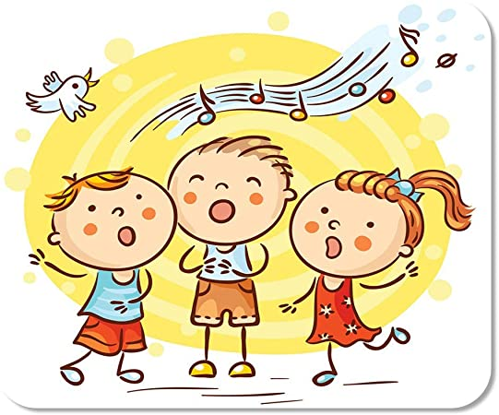

Science

Science: *Investigating materials*.

Design a simple investigation to find an answer to a question.

Gather and record data to answer questions.

Explore the properties of materials and discuss the suitability for different uses, including wood, metal, plastic, glass, brick, rock, paper and cardboard linked to their properties.

Music

# Develop knowledge of tempo, pitch and dynamics.

Listen with concentration and understanding to a range of high-quality live and recorded music. – Listen to songs from around the world.

Use their voices expressively and creatively by singing songs, chants and rhymes.

**Production – Singing Showcase-Year 3**

Computing

Give and follow written instructions.

Program a beebot to do a task.

Look at someone else’s program and tell you what will happen.

Use programming software to make objects move.

Confidently use the shift key to add punctuation/capitals whilst maintaining a speed of 10 words a minute

Touch typing

RE –Stories

Learning about the meaning behind fables, the stories Jesus told, and stories from other faiths.

Understand that some stories have a moral, an inner meaning or a message.

The story of Baisakhi and the meaning behind it.