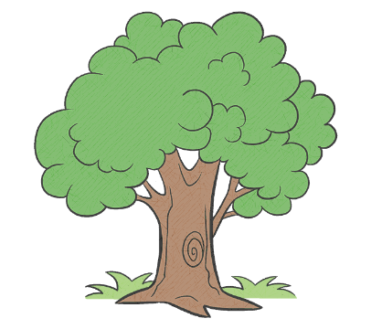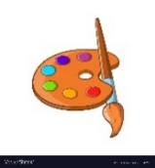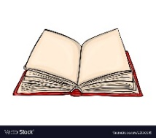

Mathematics  
Children will:

* Displays fast recognition of up to three objects without having to count them individually.(subitising)
* Recites numbers past 5
* Can say one number for each item in order 1,2,3,4,5.
* Knows that the last number reached when counting a small set of objects tells you how many there are in total. (cardinal principle)
* Can show ‘finger numbers’ up to ten.
* Know that numbers identify how many objects are in a set.
* Can link numerals and amounts, showing the right number of objects to match the numeral up to 5.
* Is able to extend and create ABAB patterns, eg stick, leaf, stick leaf. Printing on Christmas folder
* Notices and corrects an error in a repeating pattern.

Physical Development  
Children can:

* Use large muscle movements to wave flags and streamers, paint and make marks. Ribbon dancing, chalks outside, painting on the easel.
* Begin to use one-handed tools and equipment e.g. making snips in paper with scissors. fire work paintings using dish brushes, Christmas craft using scissors
* Use a comfortable grip with good control when holding pens and pencils. Name writing practise including tracing letters.
* Shows a preference for a dominant hand

Nursery Curriculum Overview

Autumn 2

Celebrations

Our value this half term is Kindness

Communication and Language  
 Children will:

* Listen to other people’s talk with interest, including stories and rhymes and will express personal preferences.
* Talk about their needs, feelings, ideas and express likes and dislikes.
* Shift from one activity to another when the adult has their attention i.e. “Jason, it’s time to stop now. We are tidying up”.
* Understand simple who?, what?, where? questions.
* Be able to use pronouns - ‘me’, ‘him’, ‘she’.
* Be able to use prepositions – ‘in’, ‘on’, ‘under’.

Literacy

Children will:

* Listen to and join in with stories and one to one, and in small groups.
* Look at books independently **and** handles books carefully
* Have favourite books, and seeks them out to share with an adult, with another child or to look at alone.

Story shed, reading den, library.

* Hold books the correct way up and turn pages.
* Sometimes give meaning to marks as they draw and paint. Writing and posting letters to Father Christmas. Writing opportunities constantly available through continuous provision. E.g. writing shopping lists in domestic roleplay.
* Writing names on Christmas cards, differentiated to the needs of individual children.

Expressive Arts and Design  
Children will:

* Is able to remember and sing entire songs. Christmas songs for performance.
* Enjoy joining in with singing and ring games. Outdoor provision.
* Explores colour and colour mixing. Fireworks paintings.
* Explores different materials freely, in order to develop his/her ideas about how to use them and what to make. Child initiated work in the creative area.
* Takes part in simple pretend play, using an object to represent something else though they are not similar.

Understanding the World  
Children will:

* + - * Is beginning to make sense of his/her own life-story and his/her family’s history.
* Is continuing to develop positive attitudes about the differences between people.
* Remember and talk about significant events in their own experience. Talks about what he/she sees, using a wide vocabulary.
* Talk about the differences between materials and changes he/she notices Clay poppies, baking.

Personal, Social and Emotional Development  
Children will:

* Increasingly follows rules, understanding why they are important.
* Can select and use activities and resources with help.
* Shows confidence in asking adults for help.

Christmas production

* Develop sense of responsibility and membership of a community. eg working together to tidy up.
* Plays with one or more other children, extending and elaborating play ideas.
* Sometimes manage to share or take turns with others with adult guidance and understand ‘yours’ and ‘mine’.

PSHE Jigsaw Scheme

Throughout our topic ‘Celebrations’ we will be exploring, Diwali, Remembrance and Christmas.