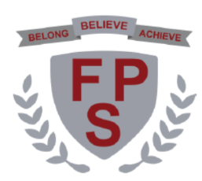
Long term plan
Year 1

 | Autumn 1 | Autumn 2 | Spring 1 | Spring 2 | Summer 1 | Summer 2
Science | Spiral: Seasonal changes, materials, plants, animals including humans
History | My life so far |  | Explorers |  | 1960’s to now
Geography | Weather |  | My school |  | The UK and its countries
Art | Drawing: ‘The Dot’ |  | Sculpture: Rainbow Fish |  | Painting: Seaside landscapes
DT | Smoothies |  | Wheels and axels |  | Puppets
PE | ABC Fundamentals  Target games | Dance | Gymnastics | Striking and Fielding | Invasion games | Athletics  Team building
Computing | Computer Systems and networks – Technology Around Us | Creating Media – Digital Painting | Creating Media – Digital Writing | Data and Information – Grouping Data | Programming A – Moving a Robot | Programming B – Introduction to Animation
RE | Questions that puzzle us | Why does Christmas matter to Christians? | How and why are some books holy? | Why does Easter matter to Christians? | Beginning to learn Sikhism | Beginning to learn Sikhism
Music | My musical heartbeat | Dance, sing and play! | Exploring sounds | Learning to listen | Having fun with improvisation | Let’s perform together!
PSHE | Friendships |  | Belonging |  | My wider world
