ANCIENT MAYA- BEST SITES!!
Briony’s BEST Tours!!

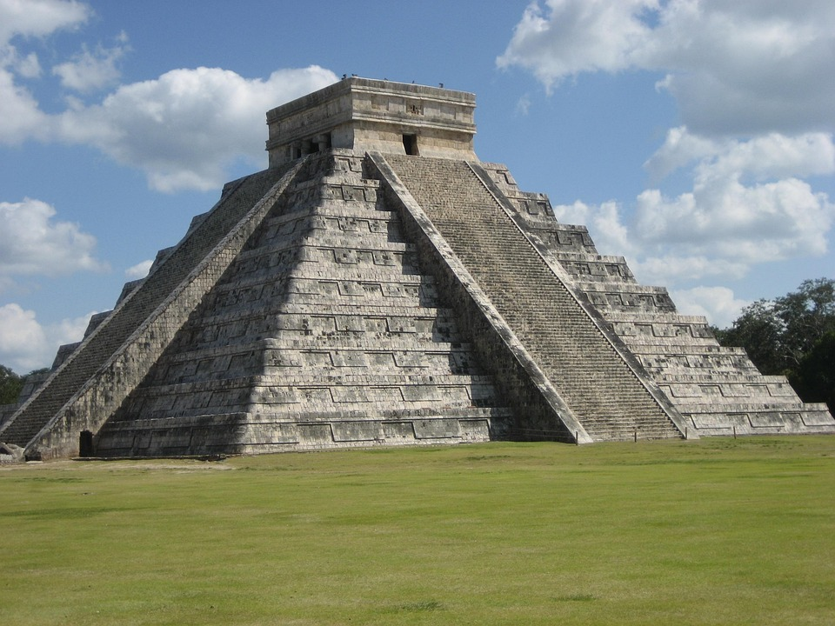

Credit Bing Images
Come Today Don’t Delay the Ancient Mayans Await You!!!
  - Uxmal
Historical Importance:
T
he city Uxmal was especially important to the Mayans between 600 to 900 AD. The beautiful city was well known for its rounded and decorative buildings. There is one thing that still amazes tourists today is that the Mayans were incredible architects.
Highlights:
- There is one place that wows the visitors and this building is called the pyramid of magician https://en.wikipedia.org/wiki/Pyramid_of_the_Magician
- Many people enjoy to explore the Nunnery Quadrange this was built around a large courtyard with 4 lovely carved buildings
- Another must – see is Governors Palace which was famous in the Mayan world for its long-decorated stone wall.
Did you know?
- Going back to the pyramid of magician this actually built in five different stages
- Legend has it that a dwarf used magic to create the pyramid in only one night!
- The city Uxmal unlike any other city’s has no nearby castle so instead rainwater was collected by local people
Top Tip: Make sure to bring a torch if you are staying in the evening and bring warm and cool clothes!!!
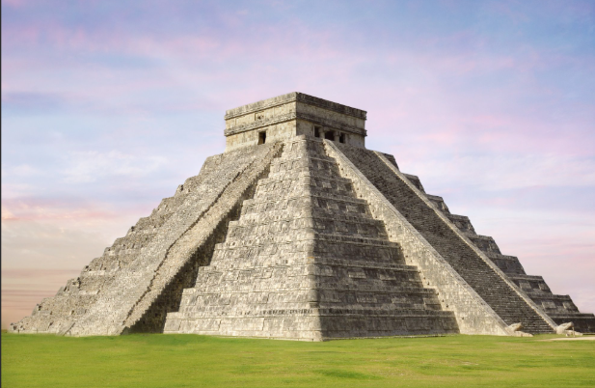 Credit Bing Images

Caracol

Historical Importance
T
he city Caracol was once one of the largest Mayan cities. It was very powerful with strong armies and a very large population of 100,00 people! This city lasted until 650 AD. But this city had a lot of wars with other Mayan cities like Tikal.

Tour Highlights
- The city’s main structure was Caana means sky place.
- It was the tallest building in Building in Belize
- You can also visit the ceremonial plazas where lots of people gathered

Did You Know?
- Caracol eventually defeated Tikal in a huge battle in 562 AD
- Caracol had its own system of stone roads named sacebob
- Farmers at Caracoll built clever terraces on hillsides to grow
Maize

TOP TIP: Make sure to bring water and your own food especially sun protection.

