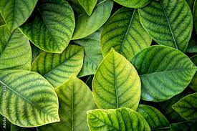
Ancient Maya – places to visit
The Gecko Maya
Historians

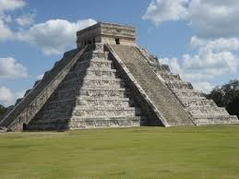
Maya will interest any person in any world.

Credit First photo Mayan Building Pxhere – July 2013
Credit second photo Top world Images – October 2018

Come today don’t delay come to maya the greatest place.

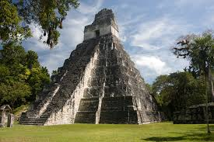
Uxmal

Historical importance
U
xmal was an important Maya city, especially 600 to 900ce. It was known for its beautiful buildings and clever designs. Other Maya city’s had lots of straight lines, but Uxmal’s buildings are rounded and decorated unlike other cities.
Highlights
- The pyramid of the magician is the most famous building, with a unique oval shape
- the legend says, it was magically built overnight
- Also explore the Nurrery Quadrilateral, which is made up of four intracell carved buildings around a humungous court yard
- Another must see is the Governor’s Palace, with the longest decorated stone wall in the Maya civilization
Did you know?
- The great old pyramid of the magician was actually built in five different stages over loads of years
- There’s a local legend that says a dwarf used magic to build the pyramid in just one night and became the city ruler
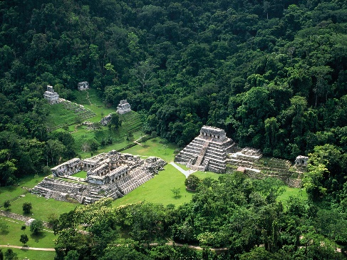
- Unlike other cities Uxmal not nearby cenote, so the people had to collect rain water
Additional information
- Uxmal is located in northern Mexico
- Near the city of Merida
- The sight takes about two hours to explore

Top Tip: Visit in the late afternoon to avoid the extreme heat
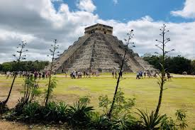
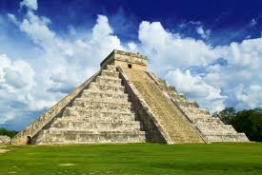
All pictures– National Geographics


Caracol
Historical Importance
Caracol was the largest Maya city in what now is Belize. It was one of the most powerful strong army and a population over 100,000 people- more than Belize city today! The was strongest at 650ad and often went to war with Tikal.

Tour Highlights
- The main structure of Caracol is Caana, which means “Sky Palace.”
- It’s the tallest man-made building in the country of Belize and has amazing views of the jungle surroundings.
- You can also visit the ceremonial plazas where people gathered and played ball games in the courts

Did you know?
- Caracol defeated Tikal in an enormous battle on 562ad.
- The surprised victory made Caracol more powerful and feared
- One of the city’s most famous leaders was Lord Kan the 2, who led the city through its most successful time.
Additional Information
Location: Belize
Entry cost: 12£
Found: found in the jungles in Belize

Top Tip: Bring Sunscreen

