Ancient Maya Tours
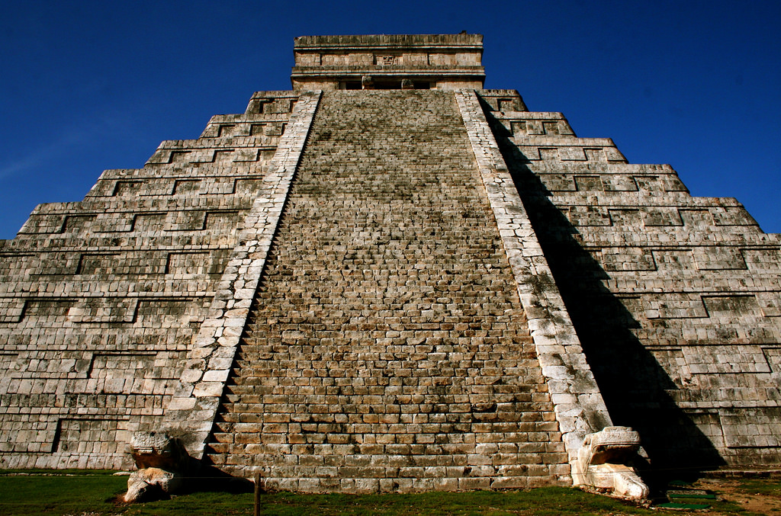

Credit: World History Encyclopedia
Estate Maya Tours

Do you need a relaxing getaway?
Book Today, Don’t Delay!

Tikal
Historical Importance

- When ancient Maya ruled over Tikal they were the largest and most powerful city state.
- Tens of thousands of people lived at the city.
- In the city there were plenty of tall temples, palaces, tombs and plazas.
- Many Maya politics involved wars with rival cities such as Caracol.
- This was one of the main cities of learning and religion, the Maya priests in the city often studied the stars and kept detailed records.
Tour Highlights

- Tourists are able to explore the temple I which is known as the Great Jaguar, it was built as the tomb for a king.
- Temple IV is the largest Maya temple to exist!
- The heart of the city is surrounded by temples and atone monuments.
- They used older pyramids to study the stars.
Did You Know

- The city was hidden under layers of thick jungle which stopped explorers reaching the city till the late 1800s.
- The area is full of amazing animals such as the howler monkey.
- Tikal was very advanced for its time.
- Chocolate beans (cacao pods) were used as money.
- Tikal was ruled by powerful kings who helped the city gain power.
Additional Information

T
ikal is found in a rainforest called Peten which is located in Northern Guatemala.
Wear comfortable shoes because the tour could take a while.
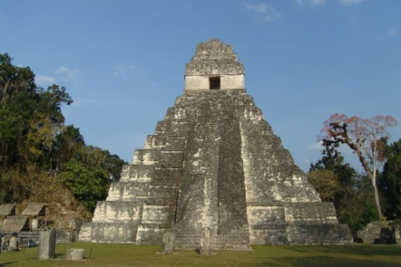
The jungle is very dense, hot and humid.
Admission money: £25 per person ( includes a guide) or £20 per person ( no guide)

Top Tips
Start early because the shops open at 8 o’clock and there is lots to do before it gets hot.

Credit: WikiTravel
Chichen Itza

Historical Importance

Chichen Itza was one of the most powerful city states!
The centre was used for religion, trade, science and politics.
They used their knowledge to build advanced structures for astronomy.
Thousands of people lived in the city and thousands of tourists visited.
Tour Highlights
The most famous landmark in Chichen Itza is called El Castillo, which is a huge pyramid.
It has 365 steps leading up to it 1 for each day of the year.
The most popular game in ancient Maya was called pok-ta-pok.
There was the temple of warriors with stone carvings and was also used a place to sacrifice.
Did You Know?
On the Spring and Autumn equinoxes the sun casts a shadow on the pyramid which makes it look like a snake is wriggling down the steps.#
Chichen Itza is longer than two football pitches.
It is thought that the losing captain could be sacrificed.
Additional Information
A full visit on the site takes around 2-3 hours!
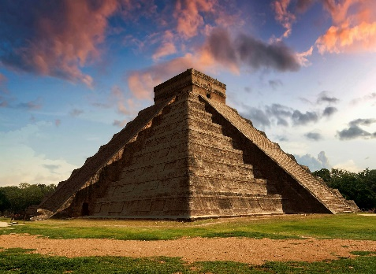
Come early before it gets warm and it is less crowded.
Credits: Tzikal.com
Admission money: £35 pounds per person

