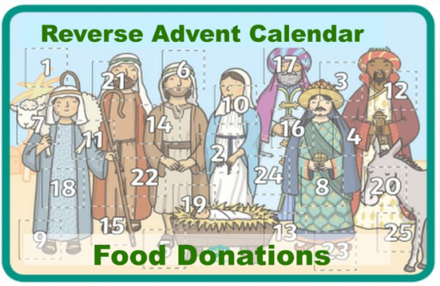 Please can you help?
This list is from the charity Readifood (https://readifood.org.uk) and is aimed to make up a food parcel over the 24 days of Advent, these quantities will make a single size parcel but we hope each class can make several parcels as the quantities can be increased to create a parcel for more people.
- A Box of Tea Bags.
- A Tin of Soup.
- A Tin of Tomatoes.
- A Box of cereal.
- A carton of Long-Life (UHT) Milk.
- A Tinned Pie or Tin of Vege Curry.
- 2 Tins of Baked Beans.
- 2 Tins of Fish (Tuna, Sardines).
- A Bag for Life. Now you can start packing up your food parcel in this bag.
- A Tin of Spaghetti.
- 2 Tins of vegetables.
- A Tin of Potatoes.
- A Tin of Hot Dogs, Minced Beef or Macaroni Cheese.
- A Tin of Big Soup.
- 2 Tins of Fruit.
- A Tin of Corned Beef or Ham.
- 500g bag of Pasta.
- Jar of Pasta Sauce.
- Tin of Rice Pudding.
- Jar of Jam.
- 1kg Bag of Rice.
- Jar of Coffee.
- 1 packet of Biscuits.
- £2-£5 Donation to help with the Distribution of this Food Parcel.

If you forget to bring an item on one day, you can of course bring it the next day. Thank you because every little act of kindness will help people have hope at Christmas.

Please can you help?
This list is from the charity Readifood (https://readifood.org.uk) and is aimed to make up a food parcel over the 24 days of Advent, these quantities will make a single size parcel but we hope each class can make several parcels as the quantities can be increased to create a parcel for more people.

- A Tin of Tomatoes.
- A Box of cereal.
- A carton of Long-Life (UHT) Milk.
- A Tinned Pie or Tin of Vege Curry.
- 2 Tins of Baked Beans.
- 2 Tins of Fish (Tuna, Sardines).
- A Bag for Life. Now you can start packing up your food parcel in this bag.
- A Tin of Spaghetti.
- 2 Tins of vegetables.
- A Tin of Potatoes.
- A Tin of Hot Dogs, Minced Beef or Macaroni Cheese.
- A Tin of Big Soup.
- 2 Tins of Fruit.
- A Tin of Corned Beef or Ham.
- 500g bag of Pasta.
- Jar of Pasta Sauce.
- Tin of Rice Pudding.
- Jar of Jam.
- 1kg Bag of Rice.
- Jar of Coffee.
- 1 packet of Biscuits.
- £2-£5 Donation to help with the Distribution of this Food Parcel.

If you forget to bring an item on one day, you can of course bring it the next day. Thank you because every little act of kindness will help people have hope at Christmas.

