With Christmas less than a month away, you may just need a bit of quiet time to bring those noise levels down! What better way to do this than by reading a good book? Twinkle have put together a list of 5 books for primary children to read alone or with the family:
The Girl Who Saved Christmas by Matt Haig
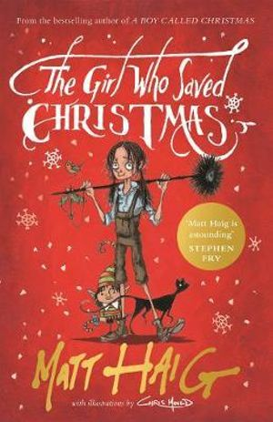
This magical story focuses on the adventure of Amelia, whose belief in miracles caused enough magic to enable Santa’s first ever present delivery on his sleigh. Later in her life, Amelia needs a wish granting, but her spirits are fading. Sensing something is wrong with his original inspiration, Santa sets out on a rescue venture to help save Amelia and restore her magic again!
This is the sequel to the hugely popular book The Boy Who Saved Christmas, suited to seven year olds and upwards.

Letty’s Christmas (Our Australian Girl Series) by Alison Lloyd
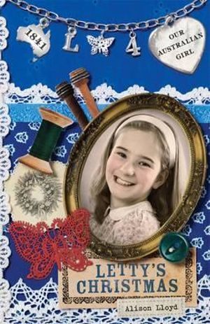
Set in 1841, this story follows Letty, a young girl who is forced to leave her job on the sheep-run as a severe drought has brought hard times to the area. The story follows Letty and the Grey family as they travel across the Blue Mountains, encountering difficult events along the way. Will Christmas be sad and lonely, away from her home and family? Find out by reading this fourth and final book in the Our Australian Girl series about Letty.
Ideally suited to readers aged 7 years and over, this book addresses the life of an early settler and the changes she experiences, making it a good basis for a discussion based on history, immigration and climate issues, like drought.

The Nights Before Christmas by Tony Ross (Illustrator)
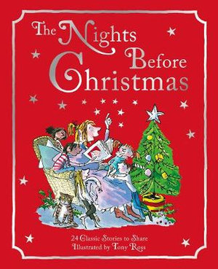
This anthology of traditional Christmas tales is a wonderful book to read over advent, as its collection of twenty-four different stories and poems mean that you can share a story each night leading up to Christmas. Extracts from classic books such as A Christmas Carol and Little Women are mixed in with yuletide poems and carols, creating a diverse Christmas book to treasure for middle to upper primary students.

One Christmas Wish by Katherine Rundell
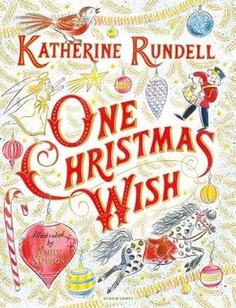
Left at home on Christmas Eve with a babysitter, lonely Theo makes a wish on an odd-looking star outside his window. His wishes for some friends to play with are soon granted when the Christmas decorations begin to unravel from the Christmas tree and come to life!
A relatively short read, this story is a good one to engage your readers from eight years and upwards, teaching them about treasuring the people and values that really matter at Christmas.

Christmas In Kangaroo Land by Adla M. Hannon
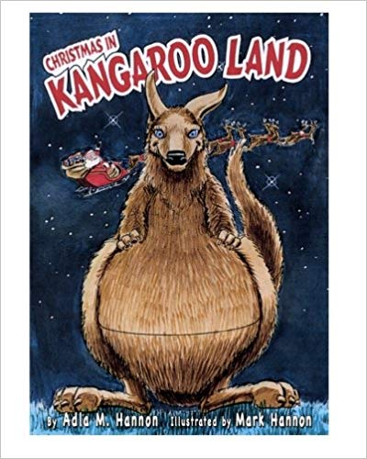
In this story we follow the adventures of the kangaroos in Kangaroo Land on Christmas Eve. A meteor hits Santa Claus on his journey, causing him to make an emergency landing in outback Australia. Luckily, the mother kangaroos are at hand with their pouches to help carry Santa’s presents to their correct destinations!
A magical read for seven year olds and over, this story is a great tale about an Aussie Christmas!

