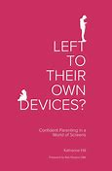
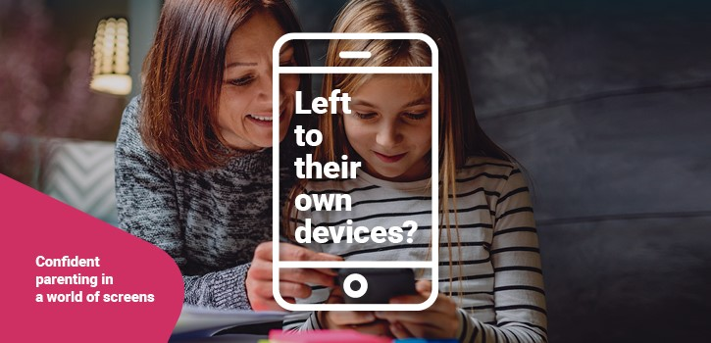
In a society that is predominantly digital, our children are growing up with a world of online possibility at their fingertips. It’s an exciting world for them to explore, but also a potentially dangerous one. As parents and carers it’s natural to want to protect our children from these dangers. So how can we ensure that our children are safe without preventing them from accessing the many advantages?
Katharine Hill’s book Left To Their Own Devices?, aimed at parents of toddlers to teenagers, uses everyday examples, humour and reflection to help us navigate this complex issue with chapters on:

- Limiting screen time
- Digital footprints
- Online bullying
- Safety/Explicit content filters

If you would like to borrow a school copy, please let Mrs Weston know as we are operating a loan system from the office.
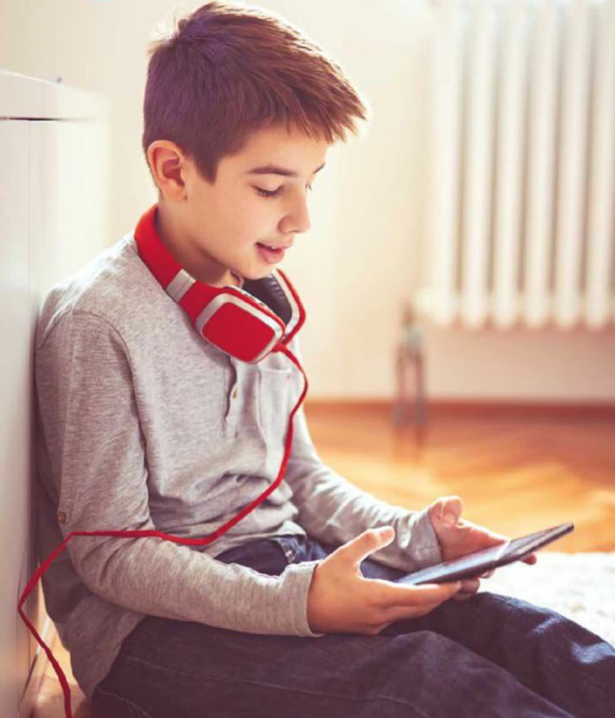
Name | Date borrowed | Date returned

Waiting list

