Welcome to Oak Class
Welcome to Oak Class, we hope that you have all had a great summer holiday. We have a busy and exciting half term ahead. Please continue to support your child at home by asking questions about their school day, listening to your child read daily and assisting with any homework.
Miss Shatford will be teaching Oak Class everyday and Mrs Reeves on a Tuesday afternoon. We also have Mrs Grundy, Mr Nicholls and Mrs Bramwell throughout the week.
Reading through this together will help to prepare your child for their learning this half term.
If you have any concerns, please come in to see us or contact us via email or Dojo. cshatford@fleetwoods.lancs.sch.uk
Kind regards
Oak Class team
English  Our first topic is based on a fiction (narrative) book called ‘Last stop of Market Street’ where children will be building up to children writing their own sentences and learning new vocabulary to create our own plot/story. We will also be reading different fiction books to support our reading and learn new techniques to develop our reading skills.  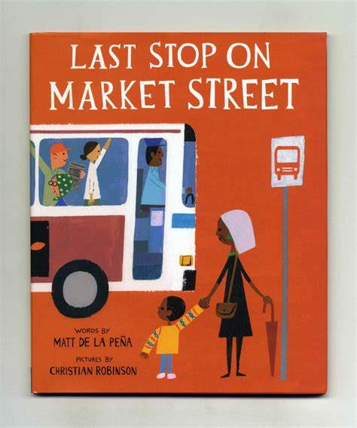  Phonics  During this first half term, all children will be learning phonics/key spelling patterns and rules in line with their current ability. Year 1s and some Year 2s will be recapping phase 4 for the first 4 weeks before moving onto Phase 5. | Oak Class  Newsletter  Autumn 1  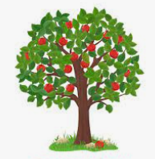 |  | Maths  In maths this half term, we will begin developing our place value knowledge. We will be sorting and counting objects, understanding ordering numbers (forwards and backwards). We will be using part-whole models to help partition numbers and use number lines to compare numbers.  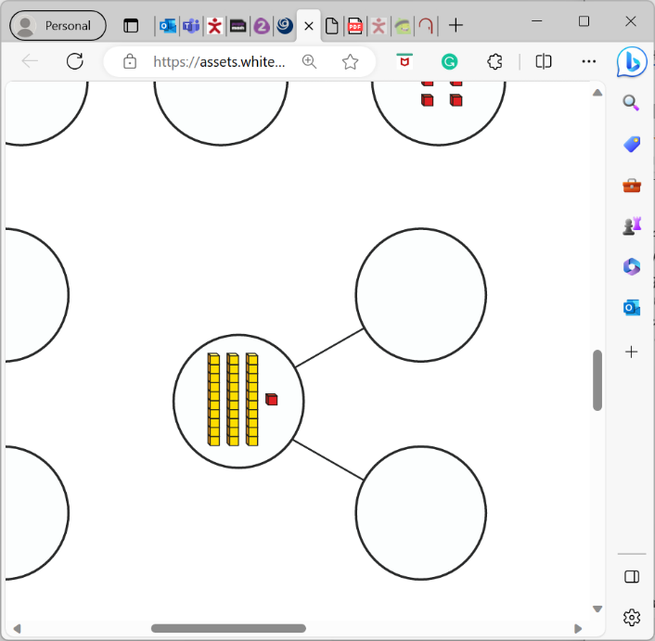  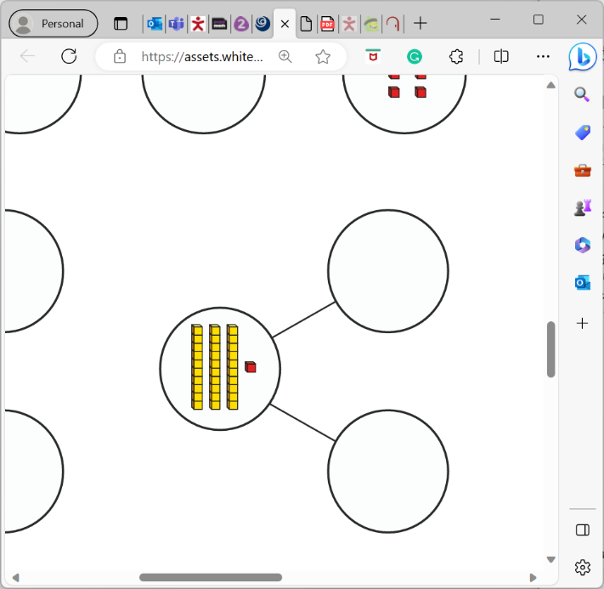  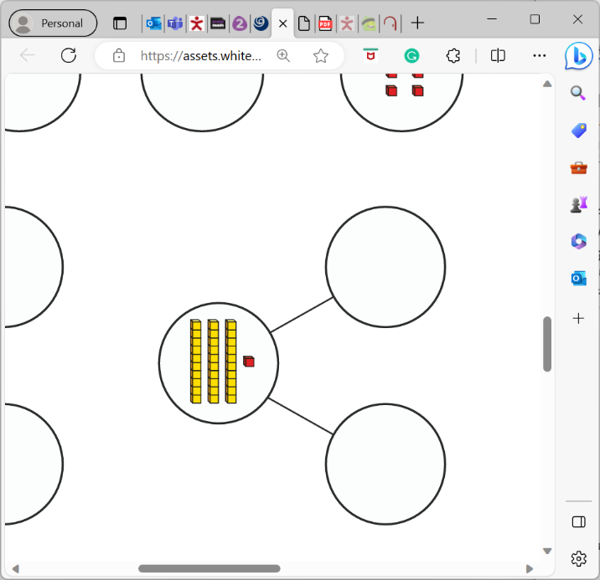  We will be starting addition and subtraction up to 20 learning different methods and number bonds to 10 and 20.  Art  In Art, we will be looking at two main artists: Georgia O’Keeffe and Picasso throughout our painting unit. We will be learning the primary and secondary colours and mixing different colours. We will be looking at gradients making lighter and darker colours creating different paintings such as flowers, sunsets and flowers.
Notices:
- Book swap is on Tuesdays.
- PE on Tuesdays and Thursdays.

RE
In RE this half term, we will be learning to understand why Christians say thank you to God at harvest time and learn about the Jewish festival of harvest. This will link with our harvest service at St Oswalds church.

Worship:
Worship over this half term will be based around our values ‘kindness and courage’. There will be 3 whole class worships a week, and 2 class worships.
We have a ‘VIP award’ which will be awarded on Friday’s celebration assembly for a pupil who has shown they can promote our school values and the VIP goal of the week.
Science  Our first exciting topic in science is animals’ needs for survival. We will recap animal classifications and look at what they need to survive in their habitat.  We will be moving on to human growth and health learning about exercise, hygiene and teeth. We will be doing lots of fun investigations and scientific tests during this unit. | Computing  Our first topic will be around basic skills on computers, learning where the most used keys are on the keypad and how to safely open and close documents and websites.  After this, we will complete a unit on online safety. Children will understand how to be safe online and safe searching. They will complete tasks to show what is and isn’t safe and what to do when something unexpected online happens. |  | PE  1 x PE lessons with Miss Reeves doing gymnastics. This will be on a Tuesday.  1 x PE lesson with Miss Shatford focusing on fundamental motor skills. This will be on a Thursday.  Please come to school in PE kit and appropriate footwear.  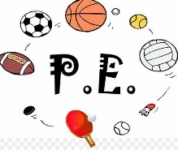
Geography  Miss Reeves will be teaching continents, oceans and the UK. Children will learn songs and rhymes to help remember the continents and oceans. We will be looking at cities, towns and villages in the United Kingdom.   | PSHE  We will be looking at our ourselves and relationships with others, focusing on feelings. It is important for children to know what to do when they have different feelings (both positive and negative feelings), so children will learn what to do when they experience different feelings in school and at home. |  | Music  Our first unit in Music is based on the song hands, feet, heart by Joanna Mangona – celebrating South African music! It is a topic on hip-hop music, listening to a range of songs from that genre. We will be using instruments and learning a new song to perform in our last lesson (there will be a video on dojo of our singing at the end of the unit).
Class Dojo  Class Dojo is a great way for us to keep you updated with day-to-day classroom life and also for you to send messages and pictures to share.  If you have an urgent message, please ring the office as we may not be available to check the Dojo messages during the school day. If your child is ill or a message regarding attendance, please ring the office as soon as you can.  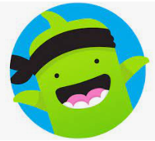 |  | Reading  Reading remains such an important part of your child’s education. We want every child to have a love for reading!  Please continue to listen to your child reading regularly this half term too- reading at home will support your child’s learning and will help to reinforce their phonics knowledge too.  Please look after all books at home and keep them safe in your reading bag. Children will be bringing home 5 books a week but please don’t feel like you must read 5 books a week. They will just swap the books they have read.    

