Welcome to Oak Class
Welcome to Oak Class, we hope that you have all had a great summer holiday. We have a busy and exciting half term ahead. Please continue to support your child at home by asking questions about their school day, listening to your child read daily and assisting with any homework.
Miss Shatford will be teaching Oak Class on Mondays, Tuesdays, Thursdays and Fridays, and Mrs Potter on a Wednesday. Mrs Brakewell will be supporting Oak Class every day.
Reading through this together will help to prepare your child for their learning this half term.
If you have any concerns, please come in to see us or contact us via email or Dojo. cshatford@fleetwoods.lancs.sch.uk mpotter@fleetwoods.lancs.sch.uk cbrakewell@fleetwoods.lancs.sch.uk
Kind regards
Oak Class team
English  Our first topic is based on a fiction (narrative) book ‘The Storm Whale’ where children will be building up to children writing their own sentences and learning new vocabulary to create our own plot/story.  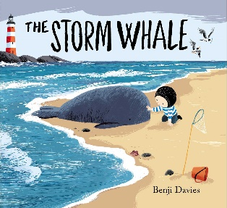  Phonics  During this first half term, all children will be learning phonics/key spelling patterns and rules in line with their current ability. Year 1s and some Year 2s will be recapping phase 4 for the first 4 weeks before moving onto Phase 5. | Oak Class  Newsletter  Autumn 1  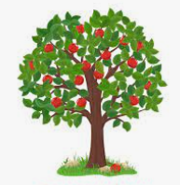 |  | Maths  In maths this half term, we will begin developing our place value knowledge. We will be sorting and counting objects, understanding ordering numbers (forwards and backwards). We will be using part-whole models to help partition numbers and use number lines to compare numbers.  Art  In Art, we will be using digital media to design a poster for promoting a local business (walking alpacas). We will be getting an exciting visit from the alpacas themselves, inspiring us to create our designs.
RE

In RE this half term, we will be learning to understand why Christians say thank you to God at harvest time and discuss about him being a creator of the world.

Worship:
Worship over this half term will be based around our values ‘kindness and courage’. There will be 3 whole class worships a week, and 2 class worships. The school have introduced a ‘VIP award’ which will be awarded on Fridays for a pupil who has shown they can promote our school values and the VIP goal of the week.
Science  We will be learning about humans, and all about the human body. We will be learning about the different parts of the body and being able to label where they are. We will be focusing on our 5 senses, performing tests to see how our senses work. | Computing  Our first topic is grouping and sorting both on and off the computer. This will involve making criteria to understand what group an object should go in. We will be starting a pictograms unit afterwards creating our own pictogram after completing a class survey to show the results. |  | PE  1 x PE lessons with coach Ryan focusing on striking and fielding.  1 x PE lesson with Miss Shatford focusing on fundamental motor skills.
Geography  Our first topic is ‘Around the World with the Go Jetters’. We will be learning about the different continents and oceans, and where they are on a world map. We will be learning about the United Kingdom, naming the 4 countries part of the UK, and using a compass to describe where places are. | PSHE  We will be looking at our ourselves and relationships with others, focusing on feelings. It is important for children to know what to do when they have different feelings (both positive and not so good feelings), so children will learn what to do when they experience different feelings in school and at home. |  | Music  Our first unit in Music is based on the song Hey You! It is a topic on hip-hop music, listening to a range of songs from that genre. We will be using instruments and learning a new song to perform in our last lesson (there will be a video on dojo of our singing at the end of the unit).
Class Dojo  Class Dojo is a great way for us to keep you updated with day-to-day classroom life and also for you to send messages and pictures to share.  If you have an urgent message or a message regarding attendance, please ring the office as we may not be available to check the Dojo messages during the school day. |  | Reading  Reading remains such an important part of your child’s education. We want every child to have a love for reading!  Please continue to listen to your child reading regularly this half term too- reading at home will support your child’s learning and will help to reinforce their phonics knowledge too.
Lunchtime prayer  Thank you for the world so sweet.  Thank you for the food we eat.  Thank you for the birds that sing.  Thank you for everything.  Amen |  | Home time prayer  Lord, keep us safe this night.  Secure from all fears.  May angels guard us while we sleep.  Till morning light appears.  Amen.

