Welcome to Ash Class
Welcome to Ash Class and for some, Fleetwood’s Charity Primary. I hope you have had a lovely summer holiday and ready for Reception/Year 1. We have a busy and exciting half term ahead. Please continue to support your child at home by asking questions about their school day, listening to your child read daily and assisting with any homework. Homework is not expected to be completed by Receptions but is encouraged and will get rewarded for completing.
Miss Shatford will be teaching Ash Class every day. We also have Mrs Roberts, Miss Gemma, Mr Nicholls and Mrs Bramwell throughout the week.
Reading through this together will help to prepare your child for their learning this half term.
If you have any concerns, please come in to see us or contact us via email or Dojo. cshatford@fleetwoods.lancs.sch.uk
Kind regards
Ash Class team
English  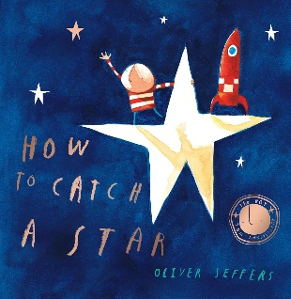  We will be starting the year with the colour monster who went to school and special me.  Our main book this half term is How to catch a star by Oliver Jeffers. We will be reading it together, discussing the story and drawing pictures to match the storyline.  Year 1s will start to use their phonics to spell words and write captions. They will understand that finger spaces are needed and capital letters at the beginning of captions.  Phonics  During this first half term, receptions will be starting phase 2 sounds and tricky words. They will be learning how these letters are formed.  Year 1 will be recapping Phase 3 sounds throughout this half term. Children will be confident in all these sounds as well as tricky words within this phase. | Ash Class  Newsletter  Autumn 1  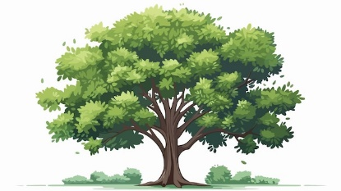 |  | Maths  Year 1:  Year 1 will be focusing on place value within 10, confidently sorting, representing and counting objects. They will be ablet o count forwards and backwards within 10 and compare groups and numbers. They will start to use the number line and order both objects and numbers.  At the end of the half term, we will be moving on to adding and subtracting within 10, recognising parts and whole and writing number sentences.  Reception:  We will be starting a topic on matching, sorting and comparing both objects and amounts. We will be confident in counting to three and representing 1, 2 and 3. Children will know 1 more and 1 less than 3.  Towards the end of the half trm, we will be looking at composition of 1,2 and 3 and representing numbers to 5.  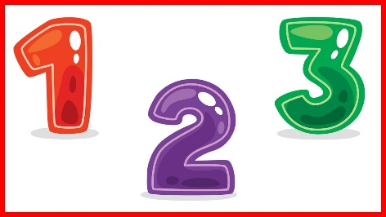
Notices:
- Book swap is on Mondays, Wednesdays and Fridays.
- Forest is on Monday
- PE on Wednesday.

RE
In RE this half term, we will be exploring the stories that Jesus told and know that he told them to teach us about God. We will be learning where we find the stories and who he told them to.

Worship:
Worship over this half term will be based around our school Christian values. There will be 3 whole school worships a week, and 2 class worships.
We have a ‘VIP award’ which will be awarded on Friday’s celebration assembly for a pupil who has shown they can promote our school values and the VIP goal of the week.
Science  We will be learning about humans, focusing on the human body. We will be learning about the different parts of the body and labelling where they are.  We will be exploring scientifically using our five senses. Children will learn key vocabulary for each sense and perform tests both indoors and outdoors. | Computing (Year 1)  Our first topic will be around basic skills on computers, learning where the most used keys are on the keypad and how to safely open and close documents and websites.   |  | PE  1 x PE lesson on an introduction to PE with a focus on fundamental motor skills.  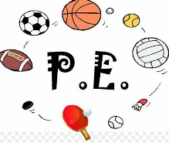
Geography  Our first topic is ‘Around the World with the Go Jetters’. We will be learning about where our school is and where it is on a map, where we live and continents/oceans on our planet.   | PSHE  We will be looking at our ourselves and relationships with others, focusing on feelings. It is important for children to know what to do when they experience different feelings (both positive and negative feelings) and how to help themselves.  We will discuss who we can talk to and who makes us feel safe. |  | Art  In Art, we will be using a range of resources and medias to create collages. We will be looking at the artist Michael Albert to inspire our own artwork including rainbows, faces, buildings and using what we can find outside.  If anybody has any old catalogues at home, please feel free to bring them in.
Class Dojo  Class Dojo is a great way for us to keep you updated with day-to-day classroom life and also for you to send messages and pictures to share.  If you have an urgent message, please ring the office as we may not be available to check the Dojo messages during the school day. If your child is ill or a message regarding attendance, please ring the office as soon as you can.  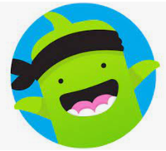 |  | Reading  Reading remains such an important part of your child’s education. We want every child to have a love for reading!  Please continue to listen to your child reading regularly this half term too- reading at home will support your child’s learning and will help to reinforce their phonics knowledge too.  Please look after all books at home and keep them safe in your reading bag. Children will be bringing home 5 books a week but please don’t feel like you must read 5 books a week. They will just swap the books they have read.    

