Welcome to Ash Class
Welcome to Ash Class and, for some of you, welcome to Fleetwood’s Charity Primary School! We hope you have had a wonderful summer holiday and are feeling excited and ready for Reception and Year 1. We have a busy and exciting half term ahead, filled with lots of fun, learning and new experiences. We really appreciate your continued support at home. Please encourage your child to talk about their school day, read regularly and complete any homework that is sent home. Homework is not compulsory for Reception children, but it is encouraged, and children will be recognised and rewarded for their efforts. We look forward to working together to make this a happy and successful start to the school year!
Miss Shatford will be teaching Ash Class every day. We have Mrs Roberts Monday to Thursday, Miss Gemma everyday but Wednesday and Miss Brown on Fridays. Miss Gemma and Miss Brown will be leading Ash on Friday afternoons.
Reading through this together will help to prepare your child for their learning this half term.
If you have any concerns, please come in to see us or contact us via email or Dojo. cshatford@fleetwoods.lancs.sch.uk
Kind regards
Ash Class team
English  Our first focus book will be ‘The Colour Monster’, where we will develop our reading and writing skills while exploring different feelings and emotions. We will work on sentence structure and adjectives, building confidence in expressing our ideas.  Later in the half term, we will explore ‘Ruby’s Worry’, creating our own fictional worries through drawing and writing. The children will develop their skills in drawing, retelling and creating their own stories.  Throughout Autumn, our focus will be on developing strong foundational skills, with a particular emphasis on handwriting. We will practise letter formation, finger spaces and full stops, before progressing to using capital letters.  Phonics  During this first half term, receptions will be starting phase 2 sounds and tricky words. They will be learning how these letters are formed.  Year 1 will be recapping Phase 3 sounds throughout this half term. Children will be confident in all these sounds as well as tricky words within this phase. | Ash Class  Newsletter  Autumn 1  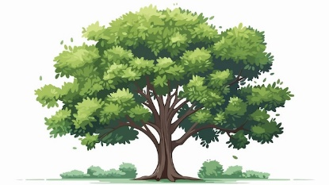 |  | Maths  Year 1:  This half term, Year 1 will be developing their understanding of place value within 10. They will confidently sort, represent and count objects, as well as count forwards and backwards within 10. Children will compare groups and numbers and begin to use a number line to order numbers and objects.  Towards the end of the half term, children will begin exploring addition and subtraction within 10. They will learn to recognise parts and wholes and begin to represent their thinking using number sentences.  Reception:  This half term, Reception will begin exploring matching, sorting and comparing objects and amounts. Children will develop confidence in counting to 3 and representing the numbers 1, 2 and 3 in different ways. They will also explore the concepts of 1 more and 1 less within 3.  Towards the end of the half term, children will explore the composition of 1, 2 and 3, developing an understanding of how numbers can be made from smaller parts. They will then begin to represent numbers to 5 in different ways.  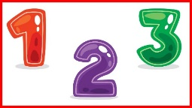
Notices:
- PE is on Monday
- Forest on Wednesday.

RE
In RE this half term, we will be exploring Harvest and learning why Christians give thanks during this special time. We will discover where different foods come from and develop our cooking skills through practical activities, including making our own bread.

Worship:
Worship over this half term will be based around our school Christian values. There will be 3 whole school worships a week, and 2 class worships.
We have a ‘halo award’ which will be awarded on Friday’s Time to Shine assembly for a pupil who has shown they can promote our school values and Christian values that week.
Science  We will be learning about humans and the human body, exploring the different parts of our bodies and learning how to identify and label them. We will also investigate our five senses and discover how they help us understand and explore the world around us.  The children will learn key scientific vocabulary for each sense and take part in a range of practical investigations and simple tests, both indoors and outdoors. | Computing (Year 1)  Our first topic will focus on basic computer skills. The children will learn where to find commonly used keys on the keyboard and how to safely open and close documents and websites.   |  | PE  1 x PE lesson on an introduction to PE, focusing on fundamental motor skills.  1 x Forest session with Mrs Pollard.  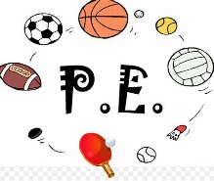
Geography  Our first topic is ‘Map Explorers’! We will be exploring where we live and learning about the United Kingdom and its four countries. The children will discover how to read maps using keys and symbols, while exploring physical features in our local area and across the UK.   | PSHE  We will be exploring our feelings and relationships with others, learning to recognise and talk about different emotions. We’ll discuss ways to help ourselves when we experience big feelings and identify trusted adults and people who make us feel safe. |  | Art  We will explore printing and repeating patterns, inspired by William Morris and his nature-based designs and Andy Warhol. Using inspiration from the outdoors, we will experiment with a range of printing tools and materials, including rollers, printing blocks, potatoes and corks, to create our own patterns and designs.
EYFS Theme  Our exciting theme this half term is ‘Marvellous Me!’ We will be encouraging our Reception children to explore what makes them special, unique and wonderful.  We’ll begin by learning all about ourselves, exploring our body parts and discovering the features that make each of our faces unique. We’ll also be finding out more about our five senses, linking our learning to Science as we investigate how we use our senses to explore and understand the world around us.  As the weeks progress, we’ll broaden our learning to explore our families, our school and our local community, helping children to develop a greater understanding of themselves and the people and places that are important to them.  Through stories, songs, conversations and hands-on experiences, we’ll celebrate our similarities and differences and develop our understanding of just how wonderfully unique we all are!  We can’t wait to see our Reception children shine as they discover what makes them truly marvellous! |  | Reading  Reading remains such an important part of your child’s education. We want every child to have a love for reading!  Please continue to listen to your child reading regularly this half term too- reading at home will support your child’s learning and will help to reinforce their phonics knowledge too.  Please look after all books at home and keep them safe in your reading bag. Children will be bringing home 5 books a week but please don’t feel like you must read 5 books a week. They will just swap the books they have read.    

